Melton Neighbourhood Plan 2016-2029 Consultation Statement

June 2016

Contents

1 consultation process 1
2 Key responses from consultation 4
3 regulation 14 pre-submission consultation 6
4 amendments following ………. submission 8

Appendix A Community Engagement Strategy
Appendix B November 2012 Page in Melton Messenger
Appendix C April 2013 - Flyer sent to all households with Melton Messenger
Appendix D Welcome Handout / Questions Asked and Feedback Report for 29th June 2013 Open Session
Appendix E Fete Handout July 2013
Appendix F November 2013 Page in Melton Messenger
Appendix G Public Consultation Poster / All Questions Asked / Feedback Report for July 2014 Open Sessions
Appendix H Household Questionnaire
Appendix I Business Questionnaire
Appendix J Feedback / Statistical Report for Household Questionnaire
Appendix K Feedback / Statistical Report for Business Questionnaire
Appendix L March 2016 Melton Messenger Call to Action for Open Days
Appendix M Welcome Handout at March Open Sessions
Appendix N Feedback Report from March Open Sessions
Appendix O Maps showing where residents marked for development / or not.

consultation process

Introduction
- This Consultation Statement has been prepared to fulfil the legal obligations of the Neighbourhood Planning Regulations 2012 in respect of the Melton Neighbourhood Plan (MNP).
- The legal basis of this Consultation Statement is provided by Section 15(2) of Part 5 of the 2012 Neighbourhood Planning Regulations (as amended), which requires that a consultation statement should:
- contain details of the persons and bodies who were consulted about the proposed neighbourhood development plan;
- explain how they were consulted;
- summarise the main issues and concerns raised by the persons consulted; and
- describe how these issues and concerns have been considered and, where relevant addressed in the proposed neighbourhood development plan.
- The policies contained in the MNP are as a result of considerable interaction and consultation with the community and businesses within the parish. Work has involved community groups over approximately three years, as well as surveys, public meetings and events. This has been overseen and coordinated by firstly Melton Parish Council, secondly the Planning Committee of Melton Parish Council and thirdly the MNP Working Group, which was formed to lead the MNP at the beginning. In the latter stages of the MNP process a Consultant was employed to put the Plan together, using the evidence we gathered from our consultation. Views and interactions from this entire process led to the Vision and Objectives in the MNP, and subsequently therefore form the basis for the key policies set out in the MNP.

Organisational structure of the MNP
- The MNP has been prepared after extensive community involvement and engagement. The MNP has reflected the views of the community and expressly of the need for a small amount of affordable development principally to address local needs, along with the provision of community infrastructure. Traffic was the principal issue for most people and the MNP seeks to address this along with supplying the small amount of housing that is deemed necessary.
- The structure put in place was a Working Group comprised mainly of residents with a few Parish Councillors. The Working Group was overseen by the Planning Committee of Melton Parish Council, who in turn reported to the Full Council. The Working Group also worked closely with Planning Aid who helped and advised on major points in the process. The Working Group was, periodically, split into smaller groups who looked at specific key areas such as business, residential development, rural issues, traffic and transport etc.
- The Working Group changed somewhat over the period of time it took to complete the MNP but originally comprised 10 volunteers from the community and 6 members of the Parish Council Planning Committee. At one point we had 18 community volunteers and a Working Group of 24 people in total. The Planning Committee oversaw the process and met regularly once a month and the Full Council also had a regular report on the MNP, in both cases all updates and discussions were also minuted. There is more detail about the Working Group on the Melton Neighbourhood Plan website (http://www.meltonneighbourhoodplan.co.uk/#!documents/g8va6). This includes all of the minutes of meetings held throughout the preparation of the Neighbourhood Plan.
Melton Neighbourhood Plan TIMELINE
Date | Action | Notes
2005 | Meeting for residents at St Andrews Church asking them to look at Site Specific Allocations Map from SCDC and mark where they did and didn’t want housing. | Area around the Station / brownfield preferred.
September 2010 | Affordable Housing Needs Survey completed for Melton Parish by Melton Parish Council (MPC) | A need for 14 affordable houses was identified and MPC asked Community Action Suffolk (CAS) to help them identify an ‘exception site’ in Melton for these. After much discussion and time it transpired that CAS were unable to help.
March/June 2012 | MPC Planning Committee and then Full Council agree to do a Neighbourhood Plan (NP) for Melton and set up Terms of Reference
June 2012 | Initial Working Group (WG) is formed, initially comprising 7 residents and 4 Councillors
October 2012 | Project Plan and Draft Budget sent to WG and MPC
October 2012 | Formal Submission to do a NP first submitted by hand to Suffolk Coastal District Council (SCDC)
November 2012 | Call to Action Page in Melton Messenger
11th December 2012 | NP Working Group Meeting
11 January 2013 | Formal Submission to do a NP re-submitted by email to Suffolk Coastal District Council (SCDC)
9th April 2013 | NP Working Group Meeting
April 2013 | SCDC acknowledge Formal Submission for NP
April 2013 | NP Leaflet goes to every household alongside Melton Messenger magazine
18th April 2013 | NP website launched
8th May 2013 | NP Grant Application sent and received
May 2013 | Letter sent to all Businesses in Melton asking them to get involved in NP
June 2013 | Young Persons Questionnaire advertised in Melton Messenger, on Notice Boards, shops, Fete, School, Church etc | Made available to fill in online.
June 2013 | Open Day
July 2013 | SCDC and other Parish meeting
July 2013 | NP Display at Melton Fete
19th September 2013 | NP Working Group Meeting
30th October 2013 | Joint Planning Aid / Working Group meeting
November 2013 | Call to Action Page in Melton Messenger
December 2013 | SCDC / Joint Parish meeting
January 2014 | Area Designation finally agreed by SCDC
January 2014 | Household Questionnaire sent to every Household in Melton
January 2014 | Business Questionnaire and letter sent to every Business in Melton
April/June 2014 | Request for feedback sent to Safer Neighbourhood Team and Farlingaye School
27th May 2014 | Working Group Meeting
July 2014 | Letter to Landowners
July 2014 | Letter to Businesses
July 2014 | NP Display at Melton Fete
July 2014 | Open Days
July 2014 | Planning Aid Workshop with Working Group
October 2014 | Planning Aid Workshop with Working Group
March 2015 | Character Assessment Workshop with Planning Aid / Working Group
23rd June 2015 | Working Group Meeting
September 2015 | Working Together Letter sent by MPC
November 2015 | SCDC Planning Liason Meeting
March 2016 | 3 Open Days
May 2016 | APM and AGM
Alongside the above events the following communications were included throughout this process:
- Regular Reports and Updates through Melton Messenger Magazine, which goes to every household once a month.
- Reports / Updates and Calls to Action on E-News which goes to approx. 150 Melton residents who have signed up to this service.
- Posters displayed on Parish Notice Boards, in St Andrews Church, at the Fish and Chip Shop, Butcher, Pub etc.
- Email updates and Calls to Action to those who signed up to this at events or via the website. 215 people.
- Leaflets sent to households
- Website running throughout process with regular updates
- Handouts / Displays at Fetes and Annual Parish Meetings
- Involvement of Melton Primary School
- Updates at every Full Council Meeting and Planning Committee meeting – Minutes published online

Public events and other consultation activities
- Following on from the timeline given above, these are the main surveys and consultation activities undertaken:
- A Neighbourhood Plan Open Session, June 2013
- A Neighbourhood Plan Questionnaire to Households and Businesses, January 2014
- A Neighbourhood Plan Questionnaire to Businesses, January 2014
- Two Neighbourhood Plan Open Sessions, July 2014
- Three Neighbourhood Plan Open Sessions, March 2016
- The June 2013 Neighbourhood Plan Open Session was the first opportunity for the community to come and give its views about the future development of the parish. The event was advertised via the following methods:
- The Parish Council (http://melton-suffolk-pc.gov.uk/) and MNP websites (http://www.meltonneighbourhoodplan.co.uk/)
- The village newsletter (Melton Messenger) which is distributed to all households each month
- Village e-newsletter (E-News)
- Emails from individual members of the BPC and the MNP Group to other members of the village
- Posters on the village noticeboards, lining the streets, in shops and the pub and Fish and Chip shop
- At this Open Session, a series of exhibition boards were presented with various question headings e.g. What is your opinion on new housing developments in Melton? / What is your opinion on facilities for Young people in Melton? / What is your opinion about traffic and transport? etc along with a map of the parish showing the settlement boundaries, footpaths, conservation area etc and also a general Parish map where people could put a red or green sticker depending on how they felt about housing being put there (see Appendix O). Parishioners were invited to write their ideas and comments on post-it notes to say what they felt was important in the parish and in answer to the questions posed. Members of the MNP Working Group, Parish Councillors and representatives from Planning Aid were present to talk people through the concept of the Neighbourhood Plan and to answer any questions. The welcome handout, text that was provided on the exhibition boards and a full feedback report is shown in Appendix D.
- In January 2014 the Household Questionnaire was distributed to every household in the parish via a mailing company. A stamp-addressed envelope was provided with each copy. Parishioners were given approx. six weeks (till 1st March) to complete and return the questionnaire and as an incentive every returned copy entered the household into a Prize Draw for £100.
- In January 2014 a letter was sent to every business in the parish, mailed out by the Clerk of the Parish Council. The business was asked to complete their Business Questionnaire online and they were given a link to the ‘Survey Monkey’ questionnaire we had set up. As an incentive we offered free advertising in the completed MNP, once published, to those who completed one.
- Following the results of both Questionnaires two further open sessions were held in July 2014 to get feedback from the community. We set up display boards as before and asked them to comment on Key Issues and Focus Points that had come out of the analysis done. The welcome handout, text for displays and full feedback analysis is contained in Appendix G.
- 2015 was a slow year for the MNP and things were delayed form progressing due to changes in Parish Councillors overseeing the process, a huge amount of work that had to be done by the Parish Council to fight a big planning application and also an inability to engage with specific landowners due to the move of the SCDC main office building to a crucial site in Melton. A Consultant was engaged however and work was able to start on the initial Draft MNP.
- In March 2016 we held three Open Sessions at Melton Primary School so that the community could look at the DRAFT MNP and it’s proposed policies as well as look at a potential development proposal for 50 affordable houses and community facilities. Again display boards were set up showing the Vision, Mission, Objectives and main Policies and their backgrounds and why we had proposed them. A big section was dedicated to the new development proposal on the Carter/Warburg site and as part of that the Pitstop Out of School Club and their Community Farm had a stand, as they were part of the development proposal. Appendix M and N show the Welcome Handout and Feedback from these three sessions.

Stakeholder consultations
- Throughout the process, The MNP Group worked with Suffolk Coastal District Council (SCDC].
Meetings were held at various intervals with officers from SCDC to address matters pertaining to, the progression of the MNP and these included two meetings which also included neighbouring NP Groups from Woodbridge Town, Martlesham and Great Bealings.
- The MNP Group submitted a formal Scoping Report regarding the need for a Strategic Environmental Assessment (SEA) of the draft MNP in December 2015. SCDC provided its formal response …………………... TBC
- Other consultees that the MNP engaged with included:
- Suffolk County Council Highways Department
- Local landowners
- Owners of local businesses and retail stores serving the local area
- Melton Primary School
- Local Parish Councils within an approx. 5 mile radius

Engaging with hard-to-reach groups
- Throughout the process, the MNP Working Group was aware that, particularly in a rural area such as Melton, there was the potential for engagement to fail to reach certain groups. The Group reviewed not just the feedback from the main sources of engagement (the Open Sessions and the Questionnaires) to ascertain whether there were any particular sections of the community that were being under-represented. However, it was felt that this was not the case and that a reasonable cross-section of the community had given their views. A presence at the Melton Village Fete in 2013 and 2014, the Young Persons Questionnaire sent in June 2013 and engagement with the Primary School was also good way to engage with typically hard-to-reach groups such as young working families.
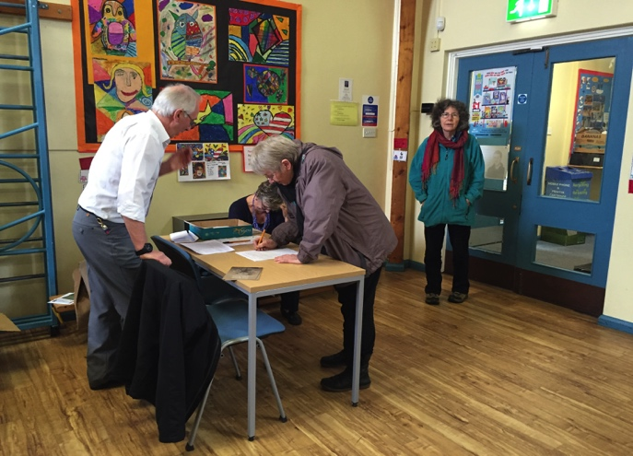
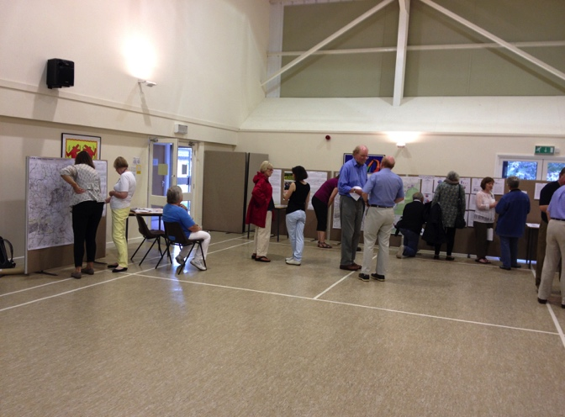
It was also felt that the scope of our general engagement and communications was sufficient to capture all age groups in the area.
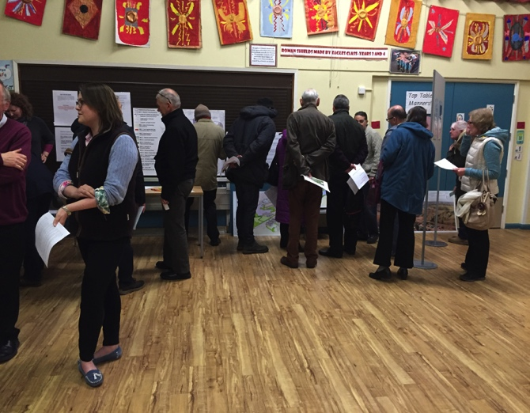
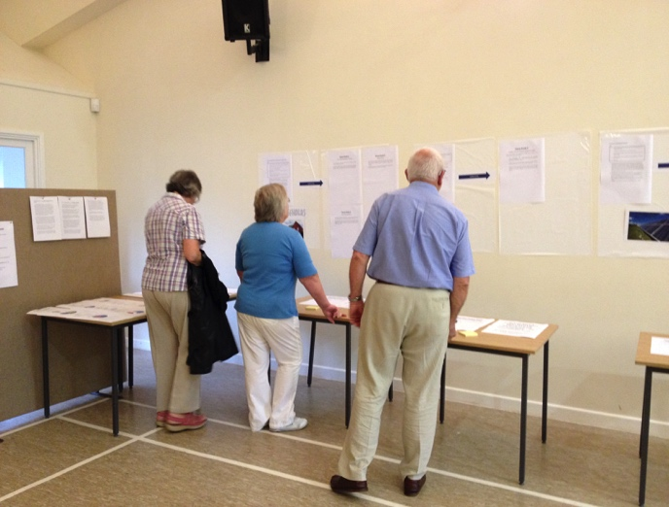

Key responses from consultation

2013 Open Session
- The Neighbourhood Plan Open Session in June 2013 produced a range of responses on various topics. In summary, the main points raised were:
- Traffic was the major worry for most people, especially along the A1152 / Woods Lane / Station Road. A bypass off the peninsular to the A12 often mentioned.
- Small developments, but no more big estates
- Many comments about Green spaces needing protection and better use of the river frontage
- Lack of Parking a big issue especially in the village centre
- More Allotments wanted
- Type of housing development preferred: Affordable housing
- More employment needed: Yes but for small local businesses
- Village facilities for young and old needed, play spaces, outdoor exercise equipment, meeting places etc
- Other priorities: Request for cycle paths and better joining of footpaths and bridleways
- Overall vision for Melton: Need to maintain rural village aspects, protect its historic character and prevent Melton becoming a suburb of Woodbridge
- A general map of the Parish giving people an opportunity to mark where they would and wouldn’t want to see new houses or development showed a preference for the sites around the Station.

Household Questionnaire
- The Neighbourhood Plan questionnaire had a 25% response (448 returned) from all households in Melton. The full report is in the Appendix but these are the following key messages that came out:
- 14% of respondents said that they wanted more affordable houses and to protect Melton from overdevelopment.
- 13% wanted to specifically encourage affordable housing development, 10% small business premises, 17% small residential development, 12% special needs housing and 9% community facilities.
- 49% felt there was Too Much Development and Inadequate Infrastructure
- 23% felt there was an opportunity for an increased sense of community.
- 72% felt that the A1152 had serious traffic problems that needed addressing.
- 60% did not think there were enough facilities for young people.
- 24% wanted a day room or some social place for elderly residents to meet regularly.
- 91% felt that the design criteria for new houses was very important.
- 45% felt that views across the river contributed significantly to the character of Melton.
- 52% wanted better footpath maintenance.
- 21% wanted to re-build the Pavilion on the playing fields and create a new and better Village Hall.
- 18% wanted development on part of the Carter site and land around the Station. 13% wanted development on the Warburg land next to the Carter site. 10% wanted to re-develop the site where Avocet House stands.
- The land along Woods Lane got the most votes for NO development with sites on that stretch getting 11%.
- The priority for restrictions to development in Melton were to stop large retail and commercial sites (like Tesco) and large dense estates.
- Better Footpath maintenance, cycle lanes, allotments, public loos, facilities for old and young were also highly favoured again by many respondents.
- 41% wanted to see controlled expansion of Melton over the next 10-20 years.

Business Questionnaire
- The Business Questionnaire was sent to 111 identified businesses in Melton and had 17 responses (15% response rate) and the key issues which came out of it were:
- 81% expected to create job opportunities in the future.
- Traffic flow through the village did not appear to affect them much in terms of business success BUT there were still a lot of comments about congestion and issues with traffic on Woods Lane, Dock Lane and parking around the school.
- Better Wi-Fi and Mobile Phone signals were needed
- 56% felt positive about new business developments in Melton and how it would affect them

July 2014 Open Sessions
- The majority of those who attended the July 2014 Open Sessions agreed with the Focus Points and Key Issues we had put to them. Further comments on these were as follows:
- Small scale affordable housing would be welcome but sustainability needed to be looked at carefully
- The same map from the Questionnaire which showed specific sites where landowners had approached SCDC for comments / permission to build was presented and people were given the opportunity to put red dots where they didn’t want houses and blue where they did. This again showed a preference for the sites around the Station / Girldestones / Carter / Warburg land. There was also some preference shown for land above St. Audreys, near Ufford. See Appendix O.
- More parking needed in Melton and all new houses need sufficient off-street parking
- Wildlife corridors linking different villages, tree preservation and protection of current green spaces still very important to a lot of people
- Allotments still a constant request
- More requests to look at ways of diverting traffic off peninsular (Rendlesham area) onto the A12 and away from Melton

March 2016 Open Sessions
- The following issues were raised at the March 2016 Open Session (where approx.. 150 residents attended) in respect of the draft Neighbourhood Plan policies and the proposed Carter/Warburg development:
- The proposed development was generally seen as positive by those not living nearby and by some living nearby. Those who were negative about it were mainly from the St Andrews Estate next door and were concerned with traffic issues and specifically with the access being through the current St Andrews Estate. Therefore this access point was changed.
- The idea of having the lake, café, allotments and community farm and green space was very positively received.
- Traffic in Melton in general was still the major issue for most people and Station Road was highlighted, especially in light of the proposed development site and potential increase to traffic from there.
- There were a number of very negative comments about the BMX/skatepark idea so it was felt this would be too controversial and was taken out of the Draft MNP.
- Many people commented on how much they liked the houseboats and so this policy was re-visited but it was felt that it was a policy to restrict new boats only and not get rid of what was already there. Therefore this policy was kept.
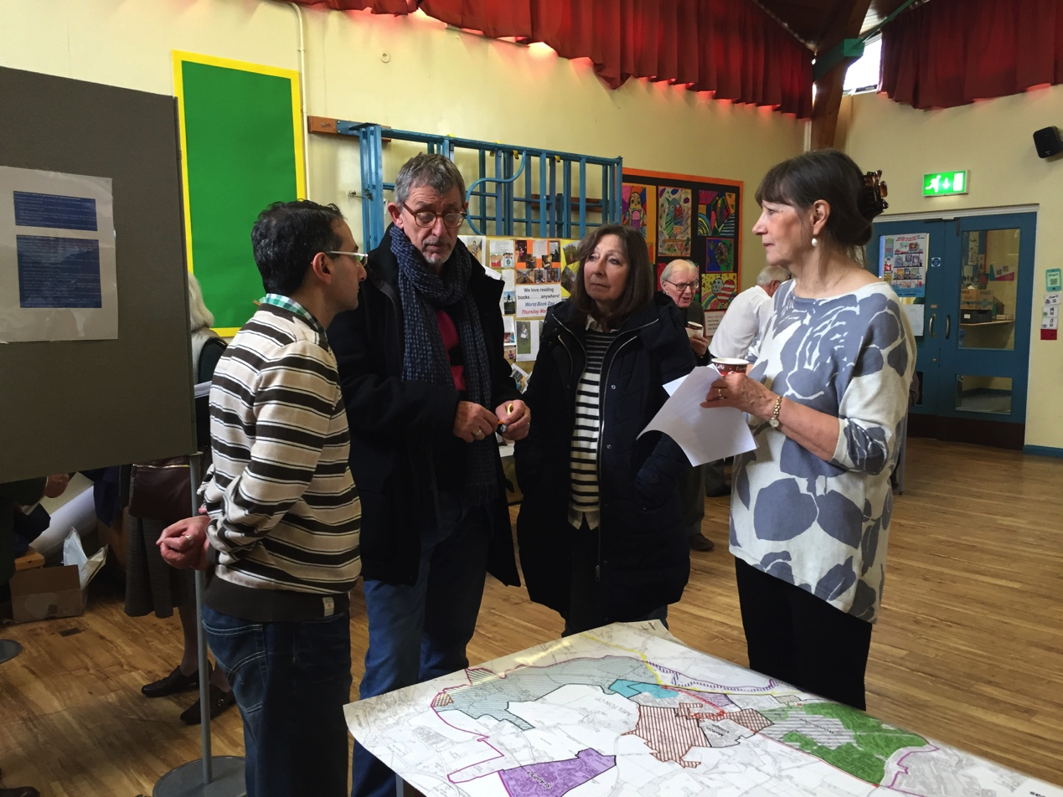

regulation 14 pre-submission consultation
- The Neighbourhood Plan Steering Group finalised the Draft MNP in ……
TBC

amendments following …… submission
TBC

Appendix A Community Engagement Strategy
MELTON VILLAGE NEIGHBOURHOOD PLAN

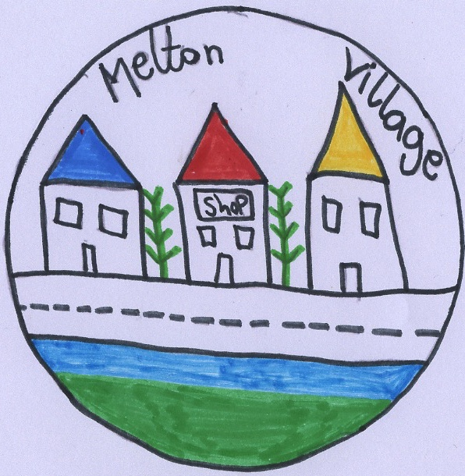

COMMUNITY ENGAGEMENT STRATEGY

Introduction
This Strategy has been prepared to help guide the process of community and stakeholder engagement needed to produce a fully focused community-led Neighbourhood Plan for Melton. It sets out a range of activities and actions that can be taken to draw information from the community in and around Melton.
Effective engagement with local residents, community groups, businesses, and service providers and adjoining Parish areas, including Woodbridge Town is a crucial aspect in creating a well-informed plan and a sense of community ownership.
We need to secure confidence from the community and those organisations and businesses that serve our needs. Confidence in the process and support for the outcomes will be more certain by starting this process in a demonstrably transparent way and continuing in that way through all stages of plan preparation.
We will do this by:
- Showing a willingness to openly encourage opinions and suggestions from all individuals and organisations within the community, whether or not these present potentially conflicting, challenging or critical views of the Plan or the process itself
- Making every effort to understand all views expressed from all individuals and groups and respond clearly on all matters raised in a timely manner
- Demonstrating, in a form that is readily accessible and easily understood by the whole community, how the Plan reflects the views and opinions expressed during each stage of engagement and, where those views cannot legitimately be taken into account, explaining why that is the case

Why do we need an Engagement Strategy?
The Engagement Strategy is a way of explaining the steps we intend to take, from the start to the end of the process, it has been prepared to demonstrate from the start that this is a process that needs community involvement and that the community knows this.
It describes the processes and methods that may be employed in community engagement activity and presents a set of commitments to the community about how we will seek to inform, communicate with and involve them throughout the project.
The Objective of the Melton Neighbourhood Plan Working Group is to:
“Ensure rigorous and effective communication, engagement and consultation with all members of the Melton Community. This includes Residents, Landowners, Businesses, Service Providers and Neighbours. We need to work towards creating a Neighbourhood Plan based entirely on the weight of evidence gathered through this process and resulting in a document that contains effective and strategic Policies agreed by the community as a whole.”
When to consult?
The Project Plan defines some of the key times to consult i.e.
- The consultation about agreeing the Parish Boundary as the boundary for the Neighbourhood Plan
- The beginning of the evidence gathering process to glean views about Melton and it’s pressures, problems and needs
- Through a Questionnaire to every household and business
- At the stage before Policies are written so that we know we are focusing on the right things
- After the first DRAFT plan is made so that everyone can check we are still on the right course

Best practice suggests that we need to consider the following when organizing events:
- think about the time of year – what else is happening - try to avoid major holiday times such as Christmas or school holidays
- are there any other local events planned which might clash with an event or could they be used to complement the event?
- be clear about when decisions will be taken and plan back from that
- be prepared to offer a range of dates and time of day / evening for events to ensure
- that all groups can take part
- build in sufficient time for analyzing what has been learnt and for feedback and
- evaluation

Who to consult?
It is important to recognize the mix of people in the community to ensure that everyone has the chance to engage in the process. Grouping residents and businesses into stakeholder groups will help identify what methods are needed to ensure their views are obtained.
Typical stakeholders groups include:
- Schoolchildren (aged 5-16)
- Young people (aged 16 – 30)
- Older groups
- Commuters (people living in the community but working outside)
- Housing estate representatives
- Community groups and societies
- Single parent families
- People with physical needs
- People with learning needs
- Faith groups
- People employed in the community
- Local businesses
- Black and minority ethnic groups
- Travellers and gypsies
- Families
- Migrant workers
- Voluntary bodies acting in the area
- Farmers
- Visitors/tourists
- Landowners
- Developers

Other bodies may also need to be consulted, those whose interests may be affected by the Neighbourhood Plan. These include:
- The Environment Agency
- English Heritage
- Natural England
- The Police
- Adjoining parishes
- Highways Agency

How to consult?
There are a range of methods that are particularly suited to Neighbourhood planning and that we intend to use but this list is not to be regarded as exhaustive:
- Questionnaires
- Public meetings / Exhibitions / Open Days
- Focus groups
- In depth interviews / face to face
- Telephone conversations / surveys
- Stakeholder meetings
- Website
- Local e-news and Magazine articles
- Workshop or group events
- Photo surveys
- Social Media – Facebook/Twitter ??
- Using other local events to showcase.

Several methods will more than likely have to be used to get the whole community involved. The following questions need to be asked before embarking on a chosen method:
- What are we trying to find out?
- From whom is the information required?
- How would they prefer to respond?
- What information do they need before they can respond?
- Is something more than a simple exchange of information required?
- How will this information be recorded?
- What resources are needed and what resources do we have?
- How much time is needed and how much time do we have?

Where to consult?
Consideration needs to be given to using different venues to help reach the whole community. Often an effective way is to 2piggy back” on other events, meetings or gatherings where people will already be in attendance.
Possible venues include:
- Community Centre’s such as Lindos / Burness
- Primary School
- Pub
- Church
- Shops
- On the street
- Community/festival events such as School Christmas Fair / Fete
- Clubs/society meeting rooms

Appendix B November 2012 Page in Melton Messenger

NEIGHBOURHOOD PLAN
Why do we need this?
So YOU can be involved in planning matters, which directly affect you
Ensuring development is in the right places
Melton Parish Council has agreed that it is in our interests as a village to do a Neighbourhood Plan.
This is basically an update to the existing Village Plan BUT it will have statutory power when planning decisions are being made.
If you have felt helpless in the past when it comes to decisions made about developments in Melton that you feel strongly about then THIS IS YOUR CHANCE to get involved in creating something that will give us all A WAY OF MAKING SURE THAT MELTON IS THE VILLAGE WE WANT IT TO BE, now and in the future.
Vision
A strong and empowered village where all residents feel they are involved positively in the planning process which directly affects them.
Key Objectives
- Build and develop positively for our future
- Protect and Preserve our unique rural and historical assets and heritage
- Maintain our identity as a village and our strengths as a community
A working group of 14 people has been formed from residents and members of the Parish Council and we are giving our Formal Submission to do a Neighbourhood Plan to SCDC on 9th November.
If you would like to know more about this OR get involved OR become part of the working group then please contact either:
clerk@melton-suffolk-pc.gov.uk
or
buffy@eaescape.co.uk
Watch this space and get ready to get involved….

Appendix C April 2013 - Flyer sent to all households with Melton Messenger
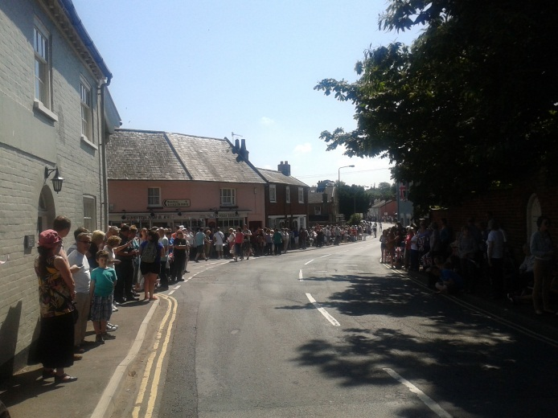
When will the Plan be finished?
Melton Parish Council and the District Council need to agree on the Plan as soon as possible and we would like to be putting it to YOUR VOTE by the end of next year if possible.
Between now and that date, there will be a lengthy consultation process. Once the plan is complete there will be a referendum – everyone in Melton will be able to vote on the Neighbourhood Plan.
If you are concerned about:
- Where houses will be built
- What new buildings will look like
- Where business can grow
- The siting of new roads
- The future for open & rural space
- The park & play spaces

Then this Plan needs your input!

The finished Plan will allow Melton residents to have stated what they want in their village.

What is the Plan for?

The main purpose for the Plan will be to look at how the village of Melton will develop in the next 5-10 years.

The Plan will have policies which we have created together which protect and control new development and show how the local economy will grow.
One of the most important parts of the plan will be consultation with residents, local organisations and business to find out what is important to them and how this can shape the village for the people who live and work here.
Your involvement is crucial!

We can’t develop our village plan without the support and involvement of ALL the residents.

Please think about the planning issues which have affected you recently and consider how you would like to see a change for the better.

This is your village and for the first time you have the power to protect it.

Having an actual say in your village’s development is no longer a dream, it will be a reality and you can be part of it.

Can you help?
The Neighbourhood Plan is a once in a generation opportunity to help shape our village.
To make sure that the Plan is as good as it can be and to make sure that everyone who wants to have a say in it can do so – the Parish Council will need help.
You do not need to be a “planning expert” or an “activist” – just someone who can help in any way. It could be helping put up signs, telling your neighbours, or helping with documents.

If you have the time we would very much like to hear from you!

What happens next?
Neighbourhood Plans are a big change in how local planning works. To make sure that the Plan is as good as it can be and that it meets the standard required by the Government, there needs to be lots of consultation in the Village.

The first public meeting will be held on the morning of:
Saturday 29th June
Lindos Centre in Saddlemakers Lane

Please also look out for:
- Posters in the village
- E-newsletters
- Information on the Melton Neighbourhood Plan website

The Parish Council will be producing a questionnaire which will be sent to every household in the village.
The questionnaire will allow everyone, including children under 16, to have their views taken in to account.

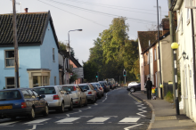
Melton needs your help!
Are you fed up with planning decisions?
Do you see inappropriate development spoiling this village?
Would you like to shape how Melton will look in the future?
Like all villages, Melton will need to develop a Neighbourhood Plan.
A Neighbourhood Plan is the ONLY way we can have some control over these issues.
This is the first time we have had an opportunity to legally affect planning decisions in our neighbourhood.
This is your opportunity to have a real say in planning decisions and that is why we NEED a Neighbourhood Plan.

Want to know more about the Melton Neighbourhood Plan?
Keep updated with progress at: www.meltonneighbourhoodplan.co.uk

For general info:
www.ourneighbourhoodplanning.org.uk

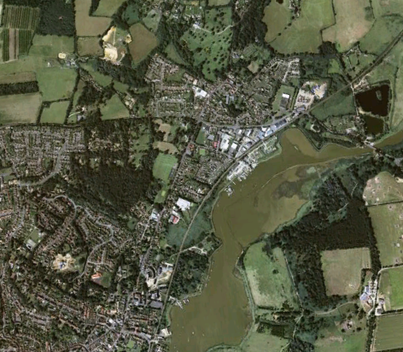
This leaflet was prepared and distributed in April 2013 by:
Melton Parish Council
The Lindos Centre
Saddlemakers Lane
Melton
Woodbridge
IP12 1PP
Tel/Fax: 01394 382224
www.melton-suffolk-pc.gov.uk

Appendix D Welcome Handout / Questions Asked and Feedback Report for 29th June 2013 Open Day

Welcome Handout
WELCOME and THANK YOU for coming today…..
Please have a look at the display boards.
There is information about how we will create a Neighbourhood Plan and what it will cover.
There are boards with areas for you to write your specific comments and concerns.
There are people to speak to who can guide you around and also take down any general comments you want to make.
Refreshments are available – please enjoy a cup of tea/coffee and a biscuit.
Keep up to date with any news about the Melton Neighbourhood Plan by looking at the website:

www.meltonvillageneighbourhoodplan.co.uk

Questions Asked:

- What is your Opinion on New houses & New housing developments?

- What is your Opinion on Commercial Spaces and a need for Business Growth?

- What is your Opinion on a Need for Play Spaces and Amenities for Young People?

- What is your Opinion on current Facilities and Amenities for Older people?

- What is your Opinion on the Preservation of Historical Buildings and Preserving the ‘look’ of Melton’s historic centre?

- What is your Opinion on Traffic Issues and How New Development Affects Traffic?

- What is your Opinion on the Preservation of Wildlife and Rural Areas and our River Frontage?

- Do you have any other General Comments?

Feedback from Open Morning 29th June
New Houses and New Housing Developments (15 comments)
- Ensure Full use of existing houses before building more.
- Happy to see small new developments enhancing Melton. Don’t want a spread into fields and along roads. Put off our merging with nearby towns. Fill in gaps in existing towns and villages first.
- New affordable houses for local people. As in the case of Grundisburgh. Not outsiders.
- More affordable ¾ bed houses with gardens big enough for families or shared ownership.
- Affordable homes for local people esp. younger people. No large developments. Infill only.
- Surely very little population increase?
- The former Girdlestones site is totally unsuitable for commercial use in the C21. Some well-designed housing including affordable housing would be more appropriate.
- Small developments however serious will need to give serious thought to the already overloaded roads.
- Careful consideration of safety and traffic.
- Development of any area is reliant on adequate transport infrastructure. In the case of Melton Road network and local transport is woefully inadequate and therefore any development should be limited.
- Preserve all wooded areas.
- Hall Farm lane green stays green.
- Triangular area end station?? Wilford Bridge Rd to be kept as green space and tidied up.
- Hall Farm Road green kept as a play area for social events.

Traffic Issues and How New Development Affects Traffic (29 comments)
- Melton traffic lights are ill timed and cause congestion.
- Traffic lights and railway crossing create a backlog of traffic am and pm.
- Traffic also backs up in Station Rd and Yarmouth Rd towards traffic lights.
- Traffic on The Street ad Wilford Bridge Rd stop and slow from 7am-9.10 + 3pm-6pm.
- Traffic lights should give more time for pedestrian crossing.
- There should be a relief road to link Rendlesham with the A12 to relieve the traffic throughput in Melton by the school and up Melton Hill.
- Relief road from Bentwaters needed to A12 to reduce traffic through Melton.
- Melton should be bypassed. Current roads are already overloaded and cannot cope any more with demands.
- Traffic in Woods Lane is becoming a serious pollution issue and dangerous for children crossing to Farlingaye.
- Worried about pollution.
- Make crossing Woods Lane to Bury Hill safer.
- There is no safe and direct route to Farlingaye. Need safe crossing for Woods Lane and Melton Road.
- Make crossing Woods Lane into Lees Hill safer.
- Make Woods Lane a slower road. Heavy lorries are too quick!
- 'Slow 'flashing sign on Woods Lane Hill as come down hill too fast from A12.
- More speed cameras on Woods Lane A12.
- Traffic calming/speed control of traffic urgently needed in Station Road.
- Flashing 30MPH or even 20-25 MPH restrictions on Melton Road.
- Saddlemakers Lane should have speed restrictions...lots of children, dog walkers, horses etc.
- Station Road is increasingly used as a rat run for those frustrated by the build up of traffic at Wilford Bridge Spur.
- Improved road layout at Railway crossing including improvements to rail station forecast and access.
- A bicycle lane on Melton Road would help safe and healthy travel to Woodbridge.
- Cycling is becoming increasingly dangerous because of non-adherence to speed limits. And increased volume of cars especially between 8am-9.30am and 4pm-6pm. A cycle lane would help but there is little scope for this. More buildings will increase this issue.
- Improve car parking in Melton village.
- Chronic in the village centre and becoming worse as time passes. Huge vehicles using Station Road and v unsafe.
- Stop parking on lawn outside old people home and car park.
- Traffic should control development not vice-versa. Therefore MINIMAL development in Melton. Don't destroy the essence of the village.
- More development for business will mean more traffic and the workforce neither will nor be using bus services but travel to work via car unless car sharing.

Facilities for young people (18 comments)
- Youth Club attached to Lindos Centre
- In park add equipment for older children
- The BMX track was a great idea. Skateboard park in Woodbridge took years but has been well used and has not caused the problems people imagined.
- BMX track for all to use.
- Need a proper youth club and more outdoor space for full size basketball court
- Melton Playing Fields towards the Woodbridge side turn into a marsh during winter months and wet weather. They need draining.
- Sort out drainage problem in the rec.
- Wooden play area in the woods for climbing.
- Play area on green at Hall Farm Road.
- Get rid of Pitstop. The supervisors are rude and loud and don’t supervise. Bring in a more controlled out of school club. My children will not be going there.
- The Playing Fields and woods provide open spaces for all to enjoy. I visit most days and there are always people enjoying these areas.
- A new building for young people’s clubs.
- Could the building on the playing field be developed?
- We must keep Melton Playing Field for young people, no development ever!
- Play area needed for Hall Farm Rd Green.
- Keep and protect play spaces.
- Preserve Playing fields and Melton Woods.
- The Playing Fields and woods must be protected from development now and forever.

Affordable Housing (2 comments)
- Affordable in lifetime terms?
- Needs to be defined in terms of cost not size.

Commercial Spaces and Need for Business Growth (5 comments)
- Many available units unused.
- Small local businesses needed but not any big business like Tesco's 5 miles up the road.
- Supportive of local business development but not national multiples. Development must be to appropriate scale.
- No more!
- Girdlestone's site should not be reserved solely for commercial use. Some could be used for housing with rest for high-tech type units rather than heavy commercial.

Facilities and Amenities for older People (9 comments)
- Sheltered bungalows with gardens and allow pets.
- Sheltered flats and dementia care.
- With ageing population undoubtedly there should be more provision for sheltered flats, care homes and car for dementia.
- Houses on Guardian site.
- Site opposite John Grose garage should be retirement properties.
- Have seen wonderful 'sports' facilities on recreation grounds for older people in the north of England. Very gentle exercise via special equipment for older people.
- More”quiet areas” for older people.
- More social activities to get elderly people out and about to meet and see people.
- Every Wednesday any parishioners could come over to lunch in the church hall for £3.

Preservation of historical buildings and Melton Centre (10 comments)
- Please leave it as it is!
- Really want to see the look of Melton’s two churches kept as they are.
- Keep upkeep of station and old-world style.
- If you look at old photos of Melton is it so changed. We need to keep what character is left.
- Preserve Burness rooms and station.
- Very important, improve and maintain, make a centre.
- Imperative as it provides a sense of identity, belonging and pride.
- It is the reason we come here and is essential.
- Preserve church.
- Conservation areas should be conserved! There has been (sadly) too much development in the conservation area of Melton in recent years.

Preservation of Wildlife, Rural areas and river frontage (21 comments)
- River frontage protected particularly against people like the Environment Agency destroying habitats.
- The green area adjacent to Hall Farm Close must be preserved.
- Maintain as many trees as possible on the former Girdlestones site.
- Must preserve open spaces and green fields around the footpaths and bridleways.
- Protecting the vulnerable means protection of green areas. This is an imperative, a duty and a necessity.
- Preserve the Melton environment and atmosphere. Do not destroy it with over development.
- What has happened to the river frontage? It used to have lovely bushes, small trees have been uprooted and “??” to be left with messy scrubland ripe for nettles.
- What will happen when all the cuts to local gvt etc. kick in? Will everywhere look a mess with no funds to maintain it?
- Preserve river frontage as wild natural area. There has been too much cutting down and tidying up along the river path.
- Preservation of wildlife is immensely important and we must have open green spaces. There is far too much infilling going on at the present time.
- Must be preserved as an amenity for peace and happiness.
- The commercial site across from the station will pollute the nature and wildlife across the road / pond etc.
- Riverside walk and areas on riverfront should be preserved how they are.
- Keep the duck pond and encourage the ducks to return.
- Keep nature reserve by the railway.
- Definitely resist any change to Leeks Hill woodland area.
- Essential to preserve green spaces and be aware of environmental / preservation issues.
- Melton Station front/foreground to be preserved.
- Look after the green space.
- Avocet House would make a great riverside pub!
- Essential to preserve riverside, wildlife and biodiversity.

General Comments (8 comments)
- Need to find a way to communicate complex details boundaries and terminology more simply.
- Allotments: For well-being and sustainability Melton should be more proactive in providing allotments or improving management of existing allotments as required by law!
- More allotments please.
- It would help to have a map to take away and think about possible development sites.
- Maps need to be labelled more clearly i.e. the PnR in yellow if labelled would get more objections.
- Has anyone taken over responsibility for the plant tubs at Melton Station?
- Thanks to all for the hard work. I know you are all volunteers.
- Develop better communication strategy / public awareness of this initiative.

Appendix E Fete Handout July 2013

Melton Village Neighbourhood Plan
Keep up to date with any news about the Melton Neighbourhood Plan by looking at the website:
www.meltonvillageneighbourhoodplan.co.uk
A Neighbourhood Plan is NOT an update to the Village Plan. It is a new document and it specifically deals with housing and development.
If you feel strongly about new development in your village, if you want to have your say and if you want to be involved in a process which will allow us to:
1. Identify acceptable sites for development as well as the kinds of development we want (such as small family homes, affordable housing, small/medium scale commercial units, play areas etc)
2. Protect the conservation area, riverside and rural aspects of our village through the control of unnaceptable applications or unnaceptable design criteria
3. Encourage development where WE want it and not just where the developers want it
4. Meet the needs of older residents
5. Decide what is best for our village and safeguard our children's heritage……
then PLEASE GET INVOLVED!!!
We will be holding a number of meetings and sending out a questionnaire to all households later this year. There will be many opportunities for you to have your say.
Appendix F Melton Messenger Page – November 2013

Melton Neighbourhood Plan
YOUR CHANCE TO CHANGE THINGS
As hopefully most of you know now, we are committed to doing a Neighbourhood Plan for this village but we need the help of all residents to achieve this.
A Neighbourhood Plan is NOT a Village Plan. It is specifically about housing and future development.
A Neighbourhood Plan is a document that WE CAN ALL CREATE that will have policies WE WANT to achieve new housing developments WHERE WE WANT THEM and in the PLACES WE AGREE and designed in a way we are all HAPPY WITH.
Part of the Neighbourhood Plan is also looking at the issues we need to tackle that affect and are effected by housing developments i.e. traffic, road systems, general infrastructure.
We can also look at getting housing for SPECIFIC NEEDS such as housing for the elderly, supported housing for those with special needs and locations for affordable houses so those living in Melton can continue to live in Melton in the future.
There is more information about all this at:
www.meltonneighbourhoodplan.co.uk
PLEASE GET INVOLVED!!!
- You can do this by attending any open sessions we have for residents to gather views and opinions.
- You can contact the Working Group (23 residents and councillors) to express any specific views you have.
- You can join the working group!
- You can keep a look out for all information we will be sending round over the next year…

And most importantly:
- PLEASE fill in the QUESTIONNAIRE that we will be sending round to every household in January 2014. There will be a £100 Prize Draw and everyone who fills in their questionnaire and returns it will be entered into the draw.

Watch this page in every edition of the Melton Messenger for further updates

Appendix G Public Consultation Poster / All Questions Asked / Feedback Report for July 2014 Open Sessions

Public Consultation Poster:

MELTON NEIGHBOURHOOD PLAN
PUBLIC CONSULTATION
Sunday 13th July 3pm-6pm
Tuesday 15th July 6.30pm-8.30pm
Lindos Centre
Please come along to look at the NEXT STAGE of our Plan.
We need your views on:
Results of the Questionnaire
Objectives we will focus on
POLICIES we will begin to write
We look forward to seeing you!!!
www.meltonneighbourhoodplan.co.uk
Welcome.

This Open Event is so we can get YOUR feedback on the next stage of our Neighbourhood Plan.
You will see here the results of both the Household and Business Questionnaires as well as all the information we have gathered so far. These have been sorted into specific ISSUE AREAS.
The Issues raised point to OBJECTIVES and in turn these point towards FOCUS POINTS, which may or may not lead to the eventual policies we might write. Some things may well already be covered by Policies in other forms i.e. through the Core Strategy that Suffolk Coastal have written or through National Planning Policies.
We will assess each Focus Point against the protection we already have through either of these existing frameworks but BEFORE we do that we need you to just confirm that we are FOCUSING on all the right things.

1. Please look at each section and let us know whether you agree with the way in which we have analysed the information.
2. Do you agree with the direction we are moving towards and do you agree with the general area we are focussing on?
3. Please tick the boxes provided according to your thoughts OR use the post it notes to write your comments.
If you have ANY questions please ask someone wearing a badge and they will be able to help.
Many thanks for taking the time to come today and please help yourself to some refreshments before you go.

www.meltonneighbourhoodplan.co.uk

What is Neighbourhood Planning?
Neighbourhood planning gives communities direct power to develop a shared vision for their neighbourhood and shape the development and growth of their local area.
They are potentially able to choose where they want new homes, shops and offices to be built, have their say on what those new buildings should look like and what infrastructure should be provided, and grant planning permission for the new buildings they want to see go ahead.
Neighbourhood planning provides a powerful set of tools for local people to ensure that they get the right types of development for their community where the ambition of the neighbourhood is aligned with the strategic needs and priorities of the wider local area.

What Neighbourhood Planning is Not….
Neighbourhood Planning is not a way to stop all development in your community.
The Neighbourhood Plan also has to be in total alignment with the National Planning Policies and District Planning Policies that are already in place. It can not create a policy in direct contravention of any of the above but as a document sits underneath these. It is more a way of FOCUSING on a small area – rather than separating it.
On the table are copies of the Core Strategy and Saved Policies of Suffolk Coastal District Council. You will see that many of the areas highlighted by you in the questionnaires are also areas already covered to a large extent by policies we already have in place in these documents.
The aim of the Melton Neighbourhood Plan is to focus in on certain key issues, which may need additional thought, protection and work. It is also to make sure that ALL your concerns are dealt with either through a new Policy or an Objective that has to be fulfilled.

SITES you might APPROVE for DEVELOPMENT

The sites around the station (coloured green) received the highest number of votes for development.

729, 833, 488, 634b

However Sites 501 and 706 (marked in yellow) to the North of Melton Park did get a significant number of people saying both that they would not want these developed at all but also they would want ‘careful’ and ‘minor’ development here.

(N.B. A large number of people also wanted to protect the woodlands on site 501)

SITES where you DO NOT WANT DEVELOPMENT

Sites which were voted very definitely for NO DEVELOPMENT were:

722, 634, 635, 751, 851, 750 and 750a (marked in red on the map)

You were less sure, but still negative about development on the following sites:

634a, 839, 640, 705 (marked in orange)

Business Objectives and Policies

- Traffic / Infrastructure improvements needed

- More Parking needed

- Encourage more small businesses

- Mobile Phone signals

- Create more opportunities for young people in Melton to get work experience

- Community Farm – ‘Pitstop’

The above points are the 6 main issues to come out of the Business Questionnaire.
Points 1, 2, 3 and 6 are also issues highlighted by the Household Questionnaire.
Points 4 and 5 will be additional issues, possibly to be addressed by the Neighbourhood Plan.

Community Assets

Springside Nursery and Shop

McColls

Burness Parish Rooms

Both Pubs, especially the Coach and Horses

Playing Field

Woods

Lindos Centre

St Andrews Church and Melton Old Church

Station

Fish and Chip Shop
(These were all mentioned and favoured by respondents to the Questionnaire)

A community asset is a local building or piece of land that the community considers to be of particular value. Each community is free to decide for itself what it values.
This includes assets such as social centres, cricket pitches, swimming pools, playgrounds, village shops, pubs and lots more.
There are a variety of tools available that the community can use to protect those assets most valued. These include:

The Community Right to Bid

Assets that presently, or recently used to, promote social wellbeing can be nominated to the local authority as ‘Assets of Community Value’. If the asset is listed by the Local Authority it cannot be sold, unless the community is also given the opportunity to bid for it.
Some assets are excluded from this process including operational land owned by statutory undertakers such as transport providers (i.e. The Station).

Designated Community Assets in the Neighbourhood Plan
Community assets can also be defined and designated in the Neighbourhood Plan. This will protect them from a change of use.
Buildings you want PROTECTED

All Old Period Houses on The Street

Whitwell House

Houses on Yarmouth Road in CA brick

Decoy House

Foxborough House

Melton Lodge

Long Springs

Melton Grange

Archway House

Melton Meade

Primary School

St Audrey’s Hospital, Water Tower and Chapel

Phyllis Memorial Home

The Beeches

Old School House

Turnpike House

Cedar House

Through the questionnaire you mentioned these buildings as the main ones you would like to see protected. (Please note that the Map at the entrance of the room shows all currently LISTED buildings in Melton).
Are there any other very important ones you feel might have been missed?
Please use a Post It Note to tell us….
Other Projects
Community Orchard / Garden / Farm

Allotments

Re-Build the Pavilion with a Café and Public Loos

More Picnic Tables

More Dog-mess Bins

Exercise Equipment on Playing Field (for the elderly too)

BMX Track / Zip Wire / Skate Park

Additional Play equipment on Hall Farm Road Green

Additional Play Equipment on Site 634B Saddlemakers Lane

Heritage Trail

More Signage and Wildlife Info Boards on Footpaths / Woodland Walks
Part of the various work we have done, including the Questionnaire, to consult with the community in Melton a number of OTHER PROJECTS have been highlighted.

These are things we can work on doing as part of the Neighbourhood Plan - BUT they won’t be specifically covered by a Policy they will be a general objective to do something.

As most of the projects require funding we will need to look at ways of obtaining this.

One way will be if Suffolk Coastal District Council formally adopt the Community Infrastructure Levy.

If they do we will get 25% of any Levy applied to new developments in Melton.

DO YOU AGREE THAT THESE PROJECTS LISTED ARE WORTH PURSUING?
(please tick inside one box)

YES | NO
If your answer is NO or you think we have missed a vital project for Melton please use a POST IT NOTE to tell us why or what it is……

Focus Point 1

Scale of New Developments / Phasing

This would seek to ensure future developments in Melton are small scale and therefore sustainable.

It would also require that IF a larger scale development were to be deemed necessary or appropriate that it would be phased carefully over time to allow infrastructure to be geared up to accommodate it.

Focus Point 2

Favour Brownfield Sites

This would require all developers to assess brownfield land for development before any approach is made for greenfield sites.

This would also link to the SPECIFIC SITES highlighted by the Neighbourhood Plan consultation exercise, that shows that the majority of residents are keen to develop the brownfield land in Melton as a priority.

Focus Point 3

Design Criteria

This would set out specific Design Criteria for ALL new housing in Melton encompassing the need to mix eco-friendly modern designs with a balance of period design to complement existing period buildings.

This will be linked to a Housing Design Map of Melton that will show the main design features in each part of the village.

Focus Point 4

Affordable / Special Needs Housing

This will require that any new development must achieve a % of Affordable Houses as well as some houses for those with special needs.

This will also link to the SPECIFIC SITES highlighted by the Neighbourhood Plan consultation exercise, showing which sites would be favoured for small groups of Affordable Houses and houses for those with special needs.
Focus Point 5

Facilities / Service Provision and Access to Them

This would require that Developers would ensure that for any development of 5 or more houses:

- new footpaths OR improvements to existing footpaths/bridleways were made to give pedestrian access to key services within the village

- new cycle lanes are created to give residents safe and enjoyable access by bike to key services in the main village area

- current services i.e. schools, doctors surgeries etc. can cope with the rise in population and if not that funding is made available to increase / support such existing services to cope with it

Focus Point 6

Traffic Management

This would aim to ensure that all applications for development should identify and demonstrate the additional level of traffic they are likely to generate.

The impact of any such additional traffic should be assessed with regards to how it affects pedestrians, cyclists, road safety, parking, congestion on key roads (such as Woods Lane) and safe access to and from all local schools.

Proposals which are likely to increase the impact of traffic on road users will need to demonstrate fully how this will be managed and what new infrastructure will be put in place to deal with it BEFORE the houses are built.

Focus Point 7

Off Road Parking

This would require that ANY new development i.e. houses, retail or business, would be provided with off street parking facilities, sufficient for the needs of the new residents/employees.

Focus Point 8

Support Small Retail and Business Growth

This would seek to encourage further growth of small retail outlets and small local businesses within Melton.

Such developments can be creatively mixed within any new housing so that we do not create any more mini business parks or ‘industrial zones’ i.e. along the river.

Focus Point 9

Trees and Landscape protection for New Developments

This would ask that any Applications to fell significant trees must be supported by appropriate evidence and that SHOULD such evidence support felling of trees developers should be asked to plant a new tree for every one they fell.

All applications for development on sites or land in the rural area of the parish should demonstrate within their Design and Access Statements how to minimise negative visual or landscape impact as part of the scheme design – preserving any beautiful views which are important to current residents.

Focus Point 10

Wildlife Corridors and Green Buffer Zones

This would require that all proposals for development in ‘buffer zones’ or ‘green/wildlife corridors’ must not harm or impact these protected areas.

A map would be provided to show where these specific areas are – based on research and analysis done through the Neighbourhood Plan.

Focus Point 11

‘Green Lung’ protected area

This will protect specific green/rural areas of Melton as mapped.

The objective being to enhance, maintain and create NEW green/wildlife corridors in the Parish and work with landowners and other key stakeholders to achieve this.

It will specifically focus on the ‘Green Lung’ between Woods Lane and Saddlemakers Lane/New Road.

Ensuring the Built Environment meets residents’ needs:
WHY?
- No more major developments in the parish, aim for small scale and sustainable

- Any acceptable larger development should be phased over a number of years

- Development MUST favour brownfield sites first

- Agreed Design Criteria should be applied

- New buildings must reflect the historical character of the village esp. any within its centre

- Better mix of housing (tenure and price)

- Increase the number of truly affordable homes for different local needs including Special Needs Housing.

- Development is inevitable and welcome BUT it is important that the scale and design is appropriate for the community.
- New development should not be prominent in scale, visually dominant, too dense or significantly change the character of the village or outlying hamlets.
- A new development should pay attention to key distinctive views in and out of the parish and design accordingly in terms of height, massing, appearance. Special attention should be paid to views to and from listed buildings, key open space, landscape features and the Conservation Area.
- Developers should give consideration to any existing brownfield sites before putting forward any plans within open countryside.
- New development should be incremental to allow for infrastructure changes (especially roads / traffic management) and evolution of new facilities, which can gradually change to cope with the increase.
- All new market and affordable houses across the parish should maintain and add to the vitality of the community. Developers should therefore demonstrate how their proposals would help maintain a balanced and thriving community in the future.
- All new housing should help broaden the range of stock available in the parish. It should also complement the existing stock and broaden the choices available to people. The type, tenure and cost of new housing should meet the needs of those in the local area. A target should be set whereby at least 35% of all housing should be affordable to local people.
- The Neighbourhood Plan will identify sites that residents feel would be appropriate for new housing and also identify the scale of new developments that would be felt to be acceptable.
- A design statement for new houses will also be created based upon feedback received during the Neighbourhood Plan process
Better facilities for local people:
- Maintain current and where possible extend community and social facilities

- Encourage local clubs, societies and other recreational facilities

- Provide better facilities for younger people

- Support the needs of our elderly residents

WHY?
- Current key facilities such as the Primary School, nurseries, churches, vet, shops and community buildings (Burness Parish Rooms / Lindos Centre) should be supported and retained.
- Any development will have an impact on these facilities and developers should demonstrate what the impact is likely to be and how such facilities can be enhanced to meet the needs of such proposed growth.
- All developers should ensure that there is safe and easy access for residents from the new site to current local facilities and services.
- Offer members of the community of all ages opportunities to get involved with parish activities.
- Continue to look at the needs of young people and try to implement some of the suggestions that were given through the Young People’s Questionnaire that Melton parish Council sent out in 2013 and the Neighbourhood Plan Questionnaire in 2014.
- Look at ways of improving local facilities and service for older people in the parish and try to implement some of the suggestions given through the Neighbourhood Plan Questionnaire in 2014.
- Look at options for re-building / modernising the Pavilion on the playing fields.

Transport and Infrastructure:
- Traffic management issues esp. congestion on Woods Lane and the length of the A1152

- Availability, reliability and cost of local bus services

- More footpaths needed to link different parts of Melton and create circular routes

- Safety / parking issues especially with getting children to and from local schools

- Cycle Lanes

WHY?
- All applications for development should identify and demonstrate the additional level of traffic they are likely to generate. The impact of any such additional traffic should be assessed with regards to how it affects pedestrians, cyclists, road safety, parking, congestion on key roads (such as Woods Lane) and safe access to and from all local schools. Proposals which are likely to increase the impact of traffic on road users will need to demonstrate fully how this will be managed and what new infrastructure will be put in place to deal with it.
- All applications need to provide off-road parking.
- All applications for development in the village or outlying settlements should demonstrate how they would improve safe and enjoyable movement by pedestrians and cyclists to the main village area and its facilities. This may include creating new cycle lanes.
- All developments should explore how they can enhance and/or provide new footpaths and bridleways to connect outlying hamlets to the main village.
- Investigate ways to improve the bus service through Melton village.

Supporting the local economy:
WHY?
- Improve local job opportunities esp. for young people

- Encourage small business and small retails units but NOT large scale industrial or retail sites

- Work with local businesses through Melton Parish Council to encourage them to offer employment and apprenticeships to local people
- Support applications for new small business units and local small retails units provided the proposal has no unacceptable impact on other key areas and services.

Protecting landscape and nature conservation interests:
- Extend the current Conservation Area

- Create a Village Green

- Protects local wildlife sites and habitats including woodlands, riverbanks and open farmland

- Protect the green corridor currently in place between Woods Lane and Saddlemakers Lane / New Road

- Support the development of wildlife / green corridors especially taking note of endangered local species and their needs

- Protect beautiful views. Protect current trees and plant more.

WHY?
- All proposals for development in ‘buffer zones’ or ‘green/wildlife corridors’ must not harm or impact these protected areas.
- All applications for development on sites or land in the rural area of the parish should demonstrate within their Design and Access Statements how to minimise negative visual or landscape impact as part of the scheme design.
- Ensure all development proposals adhere to national government landscape and nature conservation policy.
- Enhance, maintain and create NEW green/wildlife corridors in the Parish and work with landowners and other key stakeholders to achieve this – looking specifically at the ‘Green Lung’ between Woods Lane and Saddlemakers Lane/New Road.
- Protect and wherever possible restore, create and manage all actual and potential wildlife sites in the Parish.
- Applications to fell significant trees must be supported by appropriate evidence.
- All developers should be asked to plant a new tree for every one they fell, due to new building.
- Extend the Conservation Area to include the Playing Fields and Melton Woods and possibly other suggested areas.
- Create a proper Village Green in the centre of the village, working alongside parking needs. More seating. Planted areas.

DO YOU AGREE WITH THIS KEY ISSUE AND THESE FOCUS POINTS?

YES  (Please put a tick in this box if you agree) | NO  (Please put a tick in this box if you don’t agree)

IF YOU DON’T AGREE WITH THIS KEY ISSUE OR THESE FOCUS POINTS PLEASE TELL US WHY… OR SUGGEST SOMETHING ELSE.

(PLEASE WRITE ON THE POST IT NOTES PROVIDED AND STICK TO THIS SHEET)

Feedback Report

July 2014 OPEN EVENTS

Public Consultation

To gather feedback on the ‘NEXT STAGE’ of the Melton Neighbourhood Plan

In total 71 people came to these two events.

These are the results of this consultation….

Ensuring the Built Environment meets residents’ needs:

WHY?
- No more major developments in the parish, aim for small scale and sustainable

- Any acceptable larger development should be phased over a number of years

- Development MUST favour brownfield sites first

- Agreed Design Criteria should be applied

- New buildings must reflect the historical character of the village esp. any within its centre

- Better mix of housing (tenure and price)

- Increase the number of truly affordable homes for different local needs including Special Needs Housing.

- Development is inevitable and welcome BUT it is important that the scale and design is appropriate for the community.
- New development should not be prominent in scale, visually dominant, too dense or significantly change the character of the village or outlying hamlets.
- A new development should pay attention to key distinctive views in and out of the parish and design accordingly in terms of height, massing, appearance. Special attention should be paid to views to and from listed buildings, key open space, landscape features and the Conservation Area.
- Developers should give consideration to any existing brownfield sites before putting forward any plans within open countryside.
- New development should be incremental to allow for infrastructure changes (especially roads / traffic management) and evolution of new facilities, which can gradually change to cope with the increase.
- All new market and affordable houses across the parish should maintain and add to the vitality of the community. Developers should therefore demonstrate how their proposals would help maintain a balanced and thriving community in the future.
- All new housing should help broaden the range of stock available in the parish. It should also complement the existing stock and broaden the choices available to people. The type, tenure and cost of new housing should meet the needs of those in the local area. A target should be set whereby at least 35% of all housing should be affordable to local people.
- The Neighbourhood Plan will identify sites that residents feel would be appropriate for new housing and also identify the scale of new developments that would be felt to be acceptable.
- A design statement for new houses will also be created based upon feedback received during the Neighbourhood Plan process

Focus Point 1

Scale of New Developments / Phasing

This would seek to ensure future developments in Melton are small scale and therefore sustainable.

It would also require that IF a larger scale development were to be deemed necessary or appropriate that it would be phased carefully over time to allow infrastructure to be geared up to accommodate it.

Focus Point 2

Favour Brownfield Sites

This would require all developers to assess brownfield land for development before any approach is made for greenfield sites.

This would also link to the SPECIFIC SITES highlighted by the Neighbourhood Plan consultation exercise, that shows that the majority of residents are keen to develop the brownfield land in Melton as a priority.

Focus Point 3

Design Criteria

This would set out specific Design Criteria for ALL new housing in Melton encompassing the need to mix eco-friendly modern designs with a balance of period design to complement existing period buildings.

This will be linked to a Housing Design Map of Melton that will show the main design features in each part of the village.

Focus Point 4
Affordable / Special Needs Housing

This will require that any new development must achieve a % of Affordable Houses as well as some houses for those with special needs.
This will also link to the SPECIFIC SITES highlighted by the Neighbourhood Plan consultation exercise, showing which sites would be favoured for small groups of Affordable Houses and houses for those with special needs.
FEEDBACK
41 people agreed with this Key Issue and Focus Points
Comments:
- Small Sustainable Development. Local Community Needs Addressed
- What is the definition of ‘small scale?’
- Please get ‘Affordable Housing’ not ‘Executive Homes’
- No to Point 2 – needs investment in parking, upgrade of roads, sewage etc.

1 person didn’t agree with this Key Issue and these Focus Points
Comments:
- Do not use Brownfield Sites first as business should be integrated with housing to cut out migration of people to go to work thus reducing traffic and creating sustainable employment.
- A1152 is far too narrow for existing traffic and further housing and development in Melton must be considered.
- Yarmouth Rd Development is on a greenfield site. The developer claims SCDC doesn’t have a viable plan to build sufficient houses.
- What is the definition of ‘small’ and ‘large’ and all other terminology
- What size development is small and would any ‘small development’ include affordable housing
- At what point does an increase of housing/residents impact on other infrastructure e.g. woods/school/leisure facilities

Better facilities for local people:
- Maintain current and where possible extend community and social facilities

- Encourage local clubs, societies and other recreational facilities

- Provide better facilities for younger people

- Support the needs of our elderly residents
WHY?
- Current key facilities such as the Primary School, nurseries, churches, vet, shops and community buildings (Burness Parish Rooms / Lindos Centre) should be supported and retained.
- Any development will have an impact on these facilities and developers should demonstrate what the impact is likely to be and how such facilities can be enhanced to meet the needs of such proposed growth.
- All developers should ensure that there is safe and easy access for residents from the new site to current local facilities and services.
- Offer members of the community of all ages opportunities to get involved with parish activities.
- Continue to look at the needs of young people and try to implement some of the suggestions that were given through the Young People’s Questionnaire that Melton parish Council sent out in 2013 and the Neighbourhood Plan Questionnaire in 2014.
- Look at ways of improving local facilities and service for older people in the parish and try to implement some of the suggestions given through the Neighbourhood Plan Questionnaire in 2014.
- Look at options for re-building / modernising the Pavilion on the playing fields.

Focus Point 5
Facilities / Service Provision and Access to Them
This would require that Developers would ensure that for any development of 5 or more houses:

- new footpaths OR improvements to existing footpaths/bridleways were made to give pedestrian access to key services within the village

- new cycle lanes are created to give residents safe and enjoyable access by bike to key services in the main village area

- current services i.e. schools, doctors surgeries etc. can cope with the rise in population and if not that funding is made available to increase / support such existing services to cope with it

FEEDBACK
35 people agreed with this Key Issue and Focus Point
Comments:
- Primary school important part of community
- Definitely a youth club/sports facility
- A car free village square area
- The playing field is a great asset lets look after it

Transport and Infrastructure:
- Traffic management issues esp. congestion on Woods Lane and the length of the A1152

- Availability, reliability and cost of local bus services

- More footpaths needed to link different parts of Melton and create circular routes

- Safety / parking issues especially with getting children to and from local schools

- Cycle Lanes

WHY?
- All applications for development should identify and demonstrate the additional level of traffic they are likely to generate. The impact of any such additional traffic should be assessed with regards to how it affects pedestrians, cyclists, road safety, parking, congestion on key roads (such as Woods Lane) and safe access to and from all local schools. Proposals which are likely to increase the impact of traffic on road users will need to demonstrate fully how this will be managed and what new infrastructure will be put in place to deal with it.
- All applications need to provide off-road parking.
- All applications for development in the village or outlying settlements should demonstrate how they would improve safe and enjoyable movement by pedestrians and cyclists to the main village area and its facilities. This may include creating new cycle lanes.
- All developments should explore how they can enhance and/or provide new footpaths and bridleways to connect outlying hamlets to the main village.
- Investigate ways to improve the bus service through Melton village.

Focus Point 6
Traffic Management
This would aim to ensure that all applications for development should identify and demonstrate the additional level of traffic they are likely to generate.
The impact of any such additional traffic should be assessed with regards to how it affects pedestrians, cyclists, road safety, parking, congestion on key roads (such as Woods Lane) and safe access to and from all local schools.
Proposals which are likely to increase the impact of traffic on road users will need to demonstrate fully how this will be managed and what new infrastructure will be put in place to deal with it BEFORE the houses are built.

Focus Point 7
Off Road Parking
This would require that ANY new development i.e. houses, retail or business, would be provided with off street parking facilities, sufficient for the needs of the new residents/employees.
FEEDBACK
36 people agreed with this Key Issue and Focus Points
Comments:
- Woods Lane Traffic Big Issue
- Woods Lane and Yarmouth Rd big issue
- Include parking in St Andrews Place
- More bus shelters required
- More parking in Melton needed
- Parking is already an issue
- Can Focus Points be strengthened?
- Timetables at ALL bus stops
- Junction at Pytches Rd/Melton Hill an issue esp. with buses
- Volume of traffic on main roads, woods lane and towards Rendlesham already an issue
- Definitely agree with point 6
- No more building unless roads improved first
- Woods lane very dangerous needs action now
- Parking by far the biggest problem
- It’s easy to write what we want, who is going to help obtain it? Sign on the dotted line…ha.
- Agree Woods Lane awful traffic
- Church View Close only has one entrance/exit, which is extremely difficult to gain access to the main road at peak traffic times
- Cycle paths for families and pupils going to Farlingaye. Very dangerous journey from Melton. 20’s Plenty zones.

2 people didn’t agree with this Key Issue and these Focus Points
Comments:
- Any development great than 5 houses must explain how pedestrians and car owners will get around without creating additional adverse consequences for the village
- Woods Lane more than dangerous, need action now!!!
- Stop Parking on the green space in Melton village adjacent to post box, opposite car park please.
- We need a subway at the traffic lights at Melton to help keep the traffic moving over the peninsular. The lights stay red too long, it’s hopeless for businesses and unsafe to cross

Supporting the local economy:
- Improve local job opportunities esp. for young people

- Encourage small business and small retails units but NOT large scale industrial or retail sites
WHY?
- Work with local businesses through Melton Parish Council to encourage them to offer employment and apprenticeships to local people
- Support applications for new small business units and local small retails units provided the proposal has no unacceptable impact on other key areas and services.

Focus Point 8
Support Small Retail and Business Growth
This would seek to encourage further growth of small retail outlets and small local businesses within Melton.
Such developments can be creatively mixed within any new housing so that we do not create any more mini business parks or ‘industrial zones’ i.e. along the river.
34 people agreed with this Key Issue and Focus Points
Comments:
- Diverse small businesses
- Be sure of tenants before building units
- More small food shops (Not Tesco) and a café
- We already have enough industrial units of Wilford Bridge
- V. small businesses required plus a doctors and dentist
- High-speed broadband required
- Create and identify learning hubs for the unemployed and specifically for 18-25 year olds
- Basic need is to make sure people are trained for jobs – is this Melton’s job?
- What about an internet café or high-speed broadband hub for community use?
- Training needed!

1 person didn’t agree with this Key Issue and this Focus Point
Comments:
- Encourage local employment but don’t dismiss medium sized business enterprises
- You wont get small business if you destroy the brownfield sites for houses
- What is meant by small? What is wrong with medium? Small no’s of employees (e.g. so not a small call centre employing 50 people)
- Small footprint area? (e.g. so not a warehouse operation)
- Small effect on transport/infrastructure
- A healthy sports facility for all ages / outdoor pool?? Girdlestones would be a wonderful location. (the owner wouldn’t agree)

Protecting landscape and nature conservation interests:
- Extend the current Conservation Area

- Create a Village Green

- Protects local wildlife sites and habitats including woodlands, riverbanks and open farmland

- Protect the green corridor currently in place between Woods Lane and Saddlemakers Lane / New Road

- Support the development of wildlife / green corridors especially taking note of endangered local species and their needs

- Protect beautiful views. Protect current trees and plant more.

WHY?
- All proposals for development in ‘buffer zones’ or ‘green/wildlife corridors’ must not harm or impact these protected areas.
- All applications for development on sites or land in the rural area of the parish should demonstrate within their Design and Access Statements how to minimise negative visual or landscape impact as part of the scheme design.
- Ensure all development proposals adhere to national government landscape and nature conservation policy.
- Enhance, maintain and create NEW green/wildlife corridors in the Parish and work with landowners and other key stakeholders to achieve this – looking specifically at the ‘Green Lung’ between Woods Lane and Saddlemakers Lane/New Road.
- Protect and wherever possible restore, create and manage all actual and potential wildlife sites in the Parish.
- Applications to fell significant trees must be supported by appropriate evidence.
- All developers should be asked to plant a new tree for every one they fell, due to new building.
- Extend the Conservation Area to include the Playing Fields and Melton Woods and possibly other suggested areas.
- Create a proper Village Green in the centre of the village, working alongside parking needs. More seating. Planted areas.

Focus Point 9
Trees and Landscape protection for New Developments
This would ask that any Applications to fell significant trees must be supported by appropriate evidence and that SHOULD such evidence support felling of trees developers should be asked to plant a new tree for every one they fell.
All applications for development on sites or land in the rural area of the parish should demonstrate within their Design and Access Statements how to minimise negative visual or landscape impact as part of the scheme design – preserving any beautiful views which are important to current residents.

Focus Point 10
Wildlife Corridors and Green Buffer Zones
This would require that all proposals for development in ‘buffer zones’ or ‘green/wildlife corridors’ must not harm or impact these protected areas.
A map would be provided to show where these specific areas are – based on research and analysis done through the Neighbourhood Plan.

Focus Point 11
‘Green Lung’ protected area
This will protect specific green/rural areas of Melton as mapped.
The objective being to enhance, maintain and create NEW green/wildlife corridors in the Parish and work with landowners and other key stakeholders to achieve this.
It will specifically focus on the ‘Green Lung’ between Woods Lane and Saddlemakers Lane/New Road.
39 people agreed with this Key Issue and Focus Points

Comments:
- 1 tree for 1 felled is insufficient. 1 major oak should require ¼ acre of saplings
- Protect wildlife areas, more flower gardens, benches and grass
- Protect Melton riverside and don’t forget the tree preservation orders on the Girdlestones site
- The idea of a village green is a positive one but not included in the focus points
- Protect duck pond, playing fields, fishing lake, river wall etc.
- What about community beehives?
- Yarmouth Road, Church Lane and Saddlemakers Lane should be designated ‘green lung’ areas
- 2 - 10 replacement trees for every one felled depending on maturity or species
- Wildlife corridors should link to corridors in other parishes / a larger scale of coordination is required

SITE PROPOSALS MAP - COMMENTS
- No development preferred on 706/501 but if we HAVE to have it would prefer 501 please.
- Do not build on sites 706/501 please!
- Developments in green will require new roads through St Andrews please and across railway
- No new roads around St Andrews please. All exiting roads too narrow, Wilford Bridge Rd exit too narrow and busy

BUILDINGS YOU WANT PROTECTED - COMMENTS
- Old school building
- Burness Rooms and architecture on Station Road should be protected
- Archway House is part of Melton Grange Mews. There is already planning permission for a 6 bedroom house in the garden – passed 2012. Residents of the rest of the Mews applied for Grade 2 listing which was refused.

COMMUNITY ASSSETS – COMMENTS
- Hall Farm Road – children need a space to play
- The pre-school in Hall Farm Road is an asset
- The river path from Wilford Bridge to Woodbridge needs maintenance

OTHER PROJECTS – COMMENTS
22 people agreed with the OTHER PROJECTS we listed.

- Melton Old Church and Graveyard should never be touched
- Hall Farm Road Green would get lots of use
- Protect Burness Rooms and buildings opposite St Andrews Church
- Exercise equipment would need information/instructions
- Allotments please
- Pavilion to be café with loos (a la Kingston Field) – Parish office?
- More circular walk footpaths needed

GENERAL COMMENTS / FEEDBACK

- Better mobile signals badly needed
- Extend conservation area North and South
- ONLY allow buildings in green and yellow areas with very strict control on traffic
- If the sizewell lorry park happens by the station a new road is needed from Rendlesham out to the A12
- Businesses cost of start-up premises – is it possible to get this cheaply? What are business rate levels?
- Melton Messenger is a great community resource and source of local info
- The parish council have worked really hard to bring the village together and create a Melton identity
- The village would benefit from allotments, is there any land available
- This is all motherhood and apple pie, who could possibly disagree?!
- Great exhibition! Logical, easy to follow. Thanks you!
- Exhibition, a bit of a muddle – needed to spend longer here to interpret it!
- Use social media to attract younger people and people who don’t walk around the village to see signs to these meetings etc.
- Very interesting, I feel definitely needs some youth club/fitness centres for all. Beccles outdoor lido is very successful, this might work here.
- Must protect green areas! Beehives? Maybe school children could volunteer to work/look after green areas during holidays plus earn an ‘eco/community’ badge
- There were comments on the desirability of creating more circular footpaths but there appears to be no Focus Point addressing this issue!
- Unfortunately the response sheet questions are leading questions and only direct towards one answer – the answer that you got – yes. Maybe at this stage that is all you want! I would like to see footpaths identified and prioritised and where necessary attempts should be made to create / modify paths to allow use for purpose (e.g. going to school, work, shops),Leisure (e.g. exercise, walking the dog) or tourism (e.g. sign posted/interpreted routes) ….Tourism maybe for outsiders for outsiders or locals! Thank you for all your hard work.
- I would agree with above – many facilities are available in Woodbridge – Melton. Development should be small the A1152 cannot cope as it is.

Appendix H Household Questionnaire

MELTON NEIGHBOURHOOD PLAN
“Shaping the future of Melton”
Household QUESTIONNAIRE

Please complete this questionnaire and send it back by the 1st March 2014 in the SAE enclosed and we will enter you into a
£100 prize draw!!!!

If you run a business from home and would like to have a copy of our Business Questionnaire please contact us and we will send you a copy.
We are offering Free Advertising to any business that completes one and sends it back.

What this is and why you are being asked to help……

Hopefully you are aware that a Neighbourhood Plan (NP) is being undertaken by residents and the Parish Council, in Melton. This is NOT a repeat of the village plan done a few years ago. This is primarily about managing new development and housing within our Parish Boundary (see map 1).

Melton is under lot of pressure to accept new housing developments and whilst we want and need some new housing in the future we also want to be able to have more control over how much we get, where it goes and what it is.

This Questionnaire and a Business Questionnaire will be used to gain wider community views.

Do you care about increased traffic volume on our roads caused by new developments?

Do you care about protecting our rural areas and preserving the natural environment?

Do you think we need more affordable houses?

Your collective answers will form the main evidence base for the completed Neighbourhood Plan so it is really important that you fill this in and send it back. The Plan is for YOU and must reflect the wants and needs of the village residents. As far as money allows we will try to achieve the desires expressed by the community for improvements to Melton. The Plan itself will contain Planning Policies that encompass your major concerns. You’ll then be asked to vote to accept the Plan in a referendum.

Once voted in and accepted the Plan can be used to encourage positive development in the future and fight any negative planning applications.

Name:

Address:

E-mail:

Phone number:

Number of people in your house (please tick):
1

2

3

4

Other: (How many?)

Number of Adults:

Number of Children (under 18):

Confidentiality
We will retain the personal information that you provide (i.e. name, address) for no longer than two years after the end of the Neighbourhood Plan process, and will only use it for the purposes of communication via the Parish Council, and to enable the analysis and verification of the data provided by you in the survey. It will not be shown in any public document or disclosed to any third party. All general views, opinions and answers will be used publicly but anonymously for the purposes of the Neighbourhood Plan.
MELTON – YOUR VILLAGE

1. Why did you choose to live in Melton? (tick any that apply)

Rural location

Quality of urban environment

Near to Woodbridge

Near to work

Near to family

Availability of housing

Near to good schools

Other (please tell us what)

…………………………………………………………………………………………………………

2. After some consultation with residents in recent months the Neighbourhood Plan Working Group has suggested the following as our main objectives. Please tick those you agree with:

Build and develop positively for our future

Protect and Preserve our unique rural and historical assets and heritage

Maintain our identity as a village and our strengths as a community

3. Are there any other objectives you would like to add?

………………………………………………………………………………………………………………………

……………………………………………………………………………………………………………………….

4. What do you think the threats to Melton are?

………………………………………………………………………………………………………………….

………………………………………………………………………………………………………………….

5. What do you think the opportunities for us are?

………………………………………………………………………………………………………………….

………………………………………………………………………………………………………………….

TRAFFIC and TRANSPORT

1. Which, if any, roads in Melton do you think have regular traffic problems and why?
………………………………………………………………………………………………………………………..

2. Would you like to see more control over traffic speed through Melton? If so where specifically?
………………………………………………………………………………………………………………………

3. Do you think we need any kind of ‘by-pass’ option and if so where would this go?
……………………………………………………………………………………………………………………….

4. What should be done to ensure future development is prevented from making traffic conditions worse?
……………………………………………………………………………………………………………………….

……………………………………………………………………………………………………………………….

5. Is parking an issue on your street? Yes No Don’t Know

6. Is it an issue anywhere else in Melton? Yes No Don’t Know

If yes, where and what other improvements could you make to car parking in Melton?

............................................................................................................................

……………………………………………………………………………………………………………………….

7. Do you use the bus service? Yes No

8. If so, is it sufficient for your needs? Yes No

If not, suggest how you would improve it?
………………………………………………………………………………………………………………………..

9. Do you use the rail link from Melton station? Yes No

10. Does the Melton rail service meet your needs? Yes No

If not, what is wrong and how would you improve it?
……………………………………………………………………………………………………………………

11. Do you cycle in Melton? Yes No

12. If so, do you feel safe cycling in Melton? Yes No

If you don’t feel safe, why not?

............................................................................................

13. Do you think there should be any cycle lanes? If so, where?

………………………………………………………………………………………………………………………..

………………………………………………………………………………………………………………………..

14. As a pedestrian in Melton do you feel the pavements in Melton are sufficient and safe? Yes No

If not, state where and if possible suggest an improvement?
………………………………………………………………………………………………………………………..

……………………………………………………………………………………………………………………….

15. If you have children in your household, how do they get to school?

Walk Cycle Car Bus Train

16. Do you feel there are safe routes to their school? Yes No

If not, please state where and if possible, suggest an improvement:

………………………………………………………………………………………………………………………..

………………………………………………………………………………………………………………………..

17. Please state any other important transport or traffic concerns in Melton that you have:
………………………………………………………………………………………………………………………

………………………………………………………………………………………………………………………

SERVICES

1. Are you satisfied with broadband speeds? Yes No

2. Are you satisfied with your mobile reception? Yes No

If no - what network are you on?……………………………………………………………..........

3. Did anyone in your household fill in the Young Persons Questionnaire that we sent round in 2013? Yes No

4. If No – do you feel there are enough facilities for young people in Melton?

Yes No

If not, how could they be provided and what would they be?
………………………………………………………………………………………………………………………..

………………………………………………………………………………………………………………………..

5. Are there enough services for old people? If not, how could they be provided and what would they be?
………………………………………………………………………………………………………………………..

………………………………………………………………………………………………………………………..

6. Are there other specific services that you would like to see provided in the village?

……………………………………………………………………………………………………………………….

……………………………………………………………………………………………………………………….

7. We have the opportunity, as part of the NP, to identify and protect valued assets in this village e.g. pubs, shops, village halls etc. Which do you think these might be in Melton?

……………………………………………………………………………………………………………………….

………………………………………………………………………………………………………………………

THE ‘BUILT’ ENVIRONMENT

1. Part of Melton lies in a Conservation Area, which helps protect the character of that part of the village. Do you believe this is important?

Yes No

2. Does the boundary covers the correct area? Yes No
(see map 1)

If no, please draw on the map where else it should cover.

3. Are there any specific buildings of great character in Melton that you feel should be protected in the long term? Please mark on either map or list below:

……………………………………………………………………………………………………………………..

………………………………………………………………………………………………………………………

……………………………………………………………………………………………………………………..

4. The Parish Council is considering improvements to the green area in the centre of Melton, near the village sign and phone box. Would you like to see this improved?

a) Use it to provide more car parking? Yes No Don’t Know

b) Stop people parking there? Yes No Don’t Know

c) Something else? Please tell us what? Yes No

………………………………………………………………………………………………………………

DESIGN CRITERIA

The Neighbourhood Plan could include broad DESIGN guidance covering future developments. It might enable us to make sure new houses built in certain areas looked similar to what was already there OR it could allow for new modern designs where appropriate OR ask developers to make sure a mix of designs is used in larger scale building projects.

1. Is this important? Yes No

If yes, do you have any suggestions as to what such guidance might be?
………………………………………………………………………………………………………………………..

………………………………………………………………………………………………………………………..

2. Would these be specific to certain areas or sites?

………………………………………………………………………………………………………………………..

………………………………………………………………………………………………………………………..

THE ‘NATURAL’ ENVIRONMENT

1. Would you like to see detailed policies for the village to protect or enhance its landscape, flora, fauna, etc? Yes No

If so, what should it include? (tick any that apply)

Tree planting

River bank improvements

Habitat management

Woodland management

Protection of beautiful views

Other (please tell us what)

………………………………………………………………………………………………………………………

………………………………………………………………………………………………………………………

2. Please suggest any views, single trees and/or groups of trees that you would like to see particularly preserved You can mark these on either map provided if you wish.

………………………………………………………………………………………………………………………..

………………………………………………………………………………………………………………………..
3. Are there views of countryside that in your opinion contribute to the character of the village? If so, please list them, or enclose photographs.
………………………………………………………………………………………………………………………..

………………………………………………………………………………………………………………………..

4. Is the River Deben important in terms of your quality of life in Melton?

Yes No Don’t Know

If yes, is there some way we could make more of this major asset?

………………………………………………………………………………………………………………………..
5. Is the Playing Field and Melton Woods important in terms of your quality of life in Melton?

Yes No Don’t Know

If yes, is there some way we could make more of this major asset?

………………………………………………………………………………………………………………………..

HOUSING and DEVELOPMENT

N.B. Melton will have to play its part in meeting the demand for new housing and employment over the next 15 years. The Neighbourhood Plan is not about saying No to new houses. It is to try and ensure we get the right number and types of new houses in the right places and in the right timescale.

1. What kind of further development should be encouraged in Melton?

Extensions

Infill / garden development

Small residential (i.e. up to 3 bedrooms)

Large residential (i.e. more than 3 bedrooms)

Affordable housing (for rent or shared ownership)

Housing for those with special needs &/or the elderly

Small business premises (offices or small industry)

Large business premises (large blocks or large industrial sites)

Small retail

Large retail

Community facilities

Other …………………………………………………………………………………………………….

2. Are there any particular types of development that should be restricted?

…………………………………………………………………………………………………………………

3. Please suggest sites that could be developed (list below or mark with an “Y” on map 2):
………………………………………………………………………………………………………………………..

………………………………………………………………………………………………………………………..

………………………………………………………………………………………………………………………..

Please suggest sites that should NOT be developed (list below or mark with a “N” on map 2):
………………………………………………………………………………………………………………………..

………………………………………………………………………………………………………………………..

………………………………………………………………………………………………………………………..

4. Which positive planning applications or local developments in the last 5 years reflect your ideas about how Melton should develop in the future and why?
………………………………………………………………………………………………………………………..

………………………………………………………………………………………………………………………..

………………………………………………………………………………………………………………………..

5. Which planning applications / developments in the last 5 years do you feel DON’T reflect the way Melton should develop in the future and why?

………………………………………………………………………………………………………………………..

………………………………………………………………………………………………………………………..

………………………………………………………………………………………………………………………..

RECREATION and ACCESS

1. Are there sufficient footpaths and bridleways in the village?

Yes No Don’t Know

If not, do you have any suggestions as to possible new routes? Please mark on map 1 (which show the existing footpaths etc) or write down the route below.
………………………………………………………………………………………………………………………..

………………………………………………………………………………………………………………………..

2. Do you feel our footpaths and bridleways are maintained properly?

Yes No Don’t Know

If not what are your concerns and where?

……………………………………………………………………………………………………………….

3. Are you satisfied that our main playing fields, play area and tennis courts meet the needs of the village?

Yes No Don’t Know

If no would you add any further elements to this public recreation area (or others?) and what other changes would you make?
………………………………………………………………………………………………………………………..

………………………………………………………………………………………………………………………..

4. Are there any other areas or pieces of land that you feel should be protected and specifically used for public recreation, education or conservation?

Yes No Don’t Know

If yes please mark on map 2 or write down where:

………………………………………………………………………………………………………………………..

………………………………………………………………………………………………………………………..
5. Would you like to see the Pavilion (in the Playing Fields) re-built?

Yes No Don’t Know

If yes what should it be used for?
………………………………………………………………………………………………………………………..

………………………………………………………………………………………………………………………..

OTHER MATTERS

1. Overall how do you see the village developing in 10 and 20 years time?
………………………………………………………………………………………………………………………..

………………………………………………………………………………………………………………………..

………………………………………………………………………………………………………………………..

2. Are there other issues you would like to see addressed in the Neighbourhood Plan?
………………………………………………………………………………………………………………………..

………………………………………………………………………………………………………………………..

3. How would you like to be kept informed of progress:

E-mail

Letter

Melton Messenger

Village Notice Boards

NP website

Facebook

No contact please

THANK YOU for taking the time to fill this in.
Please send it back by 1st March 2014 in the stamped addressed envelope provided so that we can enter you into the Prize Draw.

For any questions you have, further information about the Neighbourhood Plan or to be part of Working Group, please contact the Melton Parish Council Office or go to:
www.meltonneighbourhoodplan.co.uk

If you would like to be signed up to Melton E-News and receive e-mails about local events, including updates on the Neighbourhood Plan please go to:

http://melton-suffolk-pc.gov.uk/MeltonNews.html

Our thanks to:

Blake at Melton Primary School who came up with the Neighbourhood Plan Logo.
The Residents and Parish Councillors who are part of the Working Group for this Neighbourhood Plan.
Bettaprint in Woodbridge for printing this questionnaire.
Planning Aid and its kind volunteers for their help and advice throughout this process.

Appendix I Business Questionnaire (this was also available to be filled in Online and all Businesses in Melton were told where they could do this)

Melton Neighbourhood Plan
‘Shaping the future of Melton’
Business Questionnaire
If you need help completing the questionnaire or have any questions
relating to the Neighbourhood Plan please go to the contact page at:
www.meltonneighbourhoodplan.co.uk

All businesses that return their questionnaire will be given FREE ADVERTISING in the Neighbourhood Plan document.
PLEASE COMPLETE AND RETURN BY 1st March 2014
(You can return via the SAE enclosed or go online to:….)

THE QUESTIONNAIRE IS IMPORTANT BECAUSE:
It may identify new ideas for improving the community of Melton.
It will give the Parish Council a list of key objectives.
It will provide the Parish Council with a mandate to implement the proposals that you favour and resist those, which you don’t.
It will be used to submit views to Suffolk Coastal District Council on land use in and around Melton.
It will promote partnership between businesses and the community.

The information collected from the questionnaires will be used to prepare the Melton Neighbourhood Plan, which, if passed by referendum, will become planning policy and will form part of the Suffolk Coastal Local Development Plan.

THE PLANNING SYSTEM
The LDF is an important part of local authority planning. It is a group of planning documents that will shape the future of our district for the foreseeable future. The Neighbourhood Plan, once voted in by referendum, will be one of these documents. The District Council is currently looking at their 15-year land supply that will include commercial as well as housing sites in Melton. Now is the opportunity to create the planning policy, through the Melton Neighbourhood Plan, to say where and how many commercial premises and houses should be built, and most importantly, the infrastructure that needs to be in place.
NOW is the time for YOU to help shape the future of Melton.
Remember, it’s your village; it’s your Neighbourhood Plan. The greater the response to the questionnaire, the greater the credibility of the Plan.

Confidentiality
We will retain the personal information that you provide (i.e. name, address) for no longer than two years after the end of the Neighbourhood Plan process, and will only use it for the purposes of communication via the Parish Council, and to enable the analysis and verification of the data provided by you in the survey. It will not be shown in any public document or disclosed to any third party. All general views, opinions and answers will be used publicly but anonymously for the purposes of the Neighbourhood Plan.
Name of business: ..........................................................................

Address of business:.......................................................................

......................................................................................................

Name of person completing this questionnaire:

................................................................................

Position in the business:.................................................................

Q1) Are you self-employed? YES NO

Q2) Is your business located in?
Domestic premises
Agricultural holding
Deben Mill
Decoy Farm
Dock Lane
Melton Park
Smithfield
The Street / Melton Road
The Sidings / Deben Way
Wilford Bridge Road / Spur / Spur End
Other (please specify)

Q3) Into which category does your business fall?
Maritime
Agriculture/Horticulture
Construction
Finance/Professional Services
Engineering
Manufacturing
Catering/Food Processing
Retail
Tourism e.g. hotels, catering, B&B
Transport
Childcare/School/Nursery
Healthcare/Care Home
Health/Beauty/Wellbeing
IT
Animal Care
Other (please specify)

Q4) How many people do you employ?
Please write the relevant letter (A-E) in the box...
A = 0; B =1-5; C = 6-10; D = 11-20; E = 21-40; F = 40+
Sub-contract
Seasonal Part-Time
Seasonal Full-Time
Permanent Part-Time
Permanent Full-Time
Temporary
Apprentices

Q5) How many of those employees live in Melton or Woodbridge?
Please write the relevant letter (A-E) in the box...
A = 0; B =1-5; C = 6-10; D = 11-20; E = 21-40; F = 40+
Sub-contract
Seasonal Part-Time
Seasonal Full-Time
Permanent Part-Time
Permanent Full-Time
Temporary
Apprentices

Q6) Do any of your local employees have problems in finding appropriate local accommodation in Melton?
Yes, generally
Occasionally
No
Don’t know

Q7) If you needed to expand the size of your business premises, would you be able to do that in Melton?
Yes
No
Don’t know

If ‘Yes’ please answer Q8. If not, please go straight to Q9.
Q8) What type of premises would your business require? (Please tick all that apply)
Small office
Small workshop
Medium office
Medium workshop
Large office
Large workshop
Other (please specify)

Q9) Do you expect to create job opportunities in the future?
Yes
No
Don’t know

Q10) Do you expect to reduce your workforce in the future?
(This information will be used only to provide an overall picture and will be kept strictly confidential)
Yes
No
Don’t know

Q11) Do you have a shortage of skilled employees?
Yes
No

If ‘No’, please go to Q13.
Q12) If ‘Yes’, what skill requirements is your business short of?

Q13) If you have had problems filling job vacancies over the last 12 months, was it because of: (Please tick all that apply)
Lack of applicants with required qualifications/skills
Lack of applicants with required work experience
Lack of suitable candidates/basic ability
Lack of affordable housing
Unsocial hours/shift work
Lack of public transport
Other (please specify)

Q14) Does your business have a need for any of the following training in Melton?
(Please tick all that apply)
Basic Literacy
Basic Numeracy
ICT Skills
Foreign Languages
Other (please specify)

Q15) How do you advertise your job vacancies? (Please tick all that apply)
Local shops/notice boards
Job Centre
Local Radio
Word of Mouth
Local press
County Press
National Press
Other (please specify)

Q16) How do you rate the following services?
Please rate the following by writing the relevant number in the box.
If ‘Poor’, please comment on any problems with these services.
1 = Very Good; 2 = Good; 3 = Average; 4 = Poor; 5 = Not Applicable
Mains Water Supply
Mains Gas Supply
Mains Electricity Supply
Sewerage
Refuse Collection
Street Lighting
Street Cleaning
Gritting and snow clearing
Landline Telephone
Mobile Phone Reception
Internet
Postal service
Public Transport

Q17) What are your views on the standard of the following services provided to Melton?
Please rate the following by writing the relevant number in the box.
1 = Very Good; 2 = Good; 3 = Average; 4 = Poor; 5 = Have Not Used Them
Fire Brigade
Police
Police (Emergency)
Community Police Officer
Ambulance (Emergency)
Hospital (Transport)
Public Transport

Q18) How do the following affect the smooth-running of your business?
Please write the relevant number in the box.
1 = Not At All; 2 = To a Limited Degree; 3 = To A Large Degree
Traffic Flow through the Village
Parking/Deliveries
Signage
Footfall

(Please comment in more detail where appropriate)

Q19) What other facilities/services would improve the day-to-day running of your business? For example, marketing and advertising opportunities, improved road infrastructure, networking opportunities...

Q20) If new business developments are proposed within Melton, how would this impact your own business?

Q21) What could your business do to engage with the community?
(Please tick all that apply)
Links to schools/nurseries
Sponsor community events and projects
Donate raffle prizes
Offer work experience
Offer apprenticeships
Give talks/tours of the business
Offer practical help
Other (Please specify)

If you would like to tell us how your business could help the community, please comment below:

Thank you for completing this questionnaire. PLEASE make sure you return it in the SAE provided (OR FILL IT IN ONLINE AT http://www.surveygizmo.com/s3/1514858/Melton-Neighbourhood-Plan
by 1st March 2014. Your views and comments will provide valuable information on shaping the future of Melton.
If you have any further suggestions/comments or issues that you would like to raise, please let us know via our website:
www.meltonneighbourhoodplan.co.uk

Appendix J Feedback / Statistical Report for Household Questionnaire

Melton Village Neighbourhood Plan Household Questionnaire REPORT/STATISTICS

448 Melton Household Questionnaires completed

2011 Census No. of Households in Melton is 1,783

This means we had an approx. overall 25% response

The statistics you can see in this report reflect the % of votes that certain questions got from the people who responded to them. However please note that NOT ALL respondents voted on ALL questions.

OTHER main reasons given for living in Melton:

- Affordable / Available housing
- Good transport links
- Sailing / near the river
- Quiet / Not overdeveloped
- Born here / family history

Other Objectives suggested:

14% wanted More Affordable Housing

14% wanted to Prevent Overdevelopment

13% wanted Better Services/Facilities

10% wanted to Maintain the Rural Character of Melton

9% wanted to Protect the Environment

9% wanted to Reduce traffic Speed & have more Sustainable Transport

Perceived Threats to Melton

49% felt there was Too Much Development and Inadequate Infrastructure

36% felt there was too much Traffic

12% worried about being Absorbed into Woodbridge and Loss of Identity

Perceived Opportunities ?

23% thought there was an opportunity for an Increased Sense of Community

13% thought there was an opportunity for Business Growth

11% thought we had an opportunity to do some Positive Planning of Developments

10% felt there was an opportunity for More Affordable Housing

10% felt there was an opportunity for More Services to be provided

Which Roads have Traffic Problems?

Strikingly 72% of all respondents thought that the A1152 had Serious Problems.

This included Woods Lane in general, the turning onto Woods Lane from Bredfield Road, The Crossroads and Traffic Lights, The Railway Crossing and Wilford Bridge Road in general.

13% felt that The Street and Yarmouth Road had problems with speed, narrowness, parked cars and queues at the traffic lights.

12% felt that Melton Hill/Road was a problem due mainly to speeding and people parking on both sides of the road.

Where should Traffic Speed be controlled?

22% thought that speeding was Not a problem

21% thought that speed was a big problem on Woods Lane

13% thought that speed should be more controlled on Yarmouth Road

12% thought that speeding was an issue on The Street

How can we prevent future development from making traffic worse?

18% wanted no overdevelopment / restricted commercial development

12% wanted a restriction on housing

11% said that traffic management systems MUST be implemented with any new development / integrating it / having it in place before new houses were built.

10% suggested an alternative route to avoid Woods Lane

If Parking IS an issue, where in particular? In Priority order:

- The Street
- Station Road / by Fish and Chip Shop / St Andrews Place
- Melton Hill (due to parking on both sides)
- Around Woodbridge Primary School
- Around Melton Primary School / Dock Lane

Any suggestions for improvements?

- Underground parking facility?
- Use the Girdlestones site!
- Can we use Thurlow Nun for parking out of hours?
- Need Cycle lanes!!
- Provide off-street parking for new developments!
- If car parking in Woodbridge itself was free (or cheaper) then people wouldn't park in The Street and on Melton Hill which is causing congestion.
- Provide passing places in Valley Farm Rd.
- Multi-storey car park - reasonable priced 1 hr parking to encourage shopping locally and investors investing in new shops generating revenue.
- Traffic lights at main junction turning into the street are very short in changing time making long queues at certain times.

Suggested improvements to the bus service, in priority order:

- More frequency
- Buses should run later and at weekends
- Need a service to and from St Audreys
- Make the fares cheaper
- Bring back the Anglia Bus service
- Better advertising of routes and timetables needed
- Service needed to and from Park and Ride at Martlesham
- Buses need to be pushchair friendly
- More shelters and stops needed

Issues with Rail service and ways to improve it, in priority order:

- More frequency, trains should run earlier and later too
- The direct train to London should be re-introduced
- The car park needs to be larger
- Trains are not reliable and are often late
- Tickets are too expensive
- There should be a ticket machine and info boards
- There is no real shelter or facilities for families
- Lighting should be better
- Buses should sync with trains
- Should be a better sync with London connection
- Trains should be quicker
- There should be a link to West Anglia

Why don’t you feel safe cycling in Melton?

Should we have cycle lanes? If so where?

- Melton Hill / Road
- Woods Lane
- NO to any cycle lanes
- Not possible as roads are too narrow
- Wilford Bridge Road
- The Street
- Wherever possible
- Melton to Ipswich
- Use the footpaths!
- Along the river
- Bredfield Rd
- To Rendlesham
- Yarmouth Rd
- Pytches Rd
- Not possible when cars park on the road

Other suggestions with regards to Cycling:

- Everywhere - adopt the European method. Good wide cycle lanes not on the road then there would be less cars and fitter people.
- Bike track down path from Melton Day Nursery to Wilford bridge. (Waterhead lane).
- Over the railway line where even lorries are sometimes over the other side of the road to get round.
- Melton crossroads to Woodbridge. Sign post the route from Melton to Woodbridge bypass / Farlingaye high school via Turnpike Lane, Melton Grange Road and Warwick Ave.
- General feeling that cycling should be encouraged
- Roads are too narrow and too busy but IF they could be widened and not become busier it would be welcomed

Where should we make Improvements to the School Route?

40% wanted Improvements to the Pavement and General Safety of Woods Lane

21% wanted a Cycle Lane to Farlingaye

13% wanted a Zebra Crossing on Bredfield Road

8% wanted Improvements to the Pavement on Pytches Road

Other Important Traffic Concerns

12% stated again about the dangers of the Bredfield Rd Junction with Woods Lane

10% said Woods Lane in general needed to be sorted out as a matter of urgency

11% again said there was generally Too Much Traffic for Melton to cope with

10% said Speeding was the biggest concern

6% said Parking in the Village Centre was a problem

Provision for Young People

Only 5% of respondents had filled in a Young Persons Questionnaire.

60% of all respondents did NOT think there were enough facilities for young people.

45% felt there should be a Youth Club/meeting place with Internet provision.

24% felt there should be more Sports activities for young people.

20% felt that there should be a Skate park/BMX track on the playing field site.

Other suggestions were for:
- A zip wire
- Basketball court
- Dance, gym and martial arts classes for 5-10 year olds.

Provision for Older People

24% of respondents felt that there should be a Day Centre for older people in Melton providing refreshments / social time / activities. Many suggested using the Burness Rooms.

20% of respondents felt that the Bus Service needed massive improvements including making them higher frequency, more accessible, more reliable and wheelchair friendly.

10% wanted a Coffee shop/Tea room in the village.

8% wanted a Post Office.

Other suggestions:

- A volunteer centre/service based in Melton could tackle unmet needs of older people to help them remain in their homes
- Social support offered for the elderly when coming out of hospital
- Linking younger families with old people or neighbour checking
- We need to develop a community scheme to support needs like hospital appointments, doctors appointments, collecting prescriptions, finding the lonely and visiting them
- Shopping for disabled and internet access for non-computer owners

Other Specific Services that should be provided in the village

18% want a Post Office

9% want a better Shop / more Unique shops / Shops to rival Woodbridge

7% want more Sport/Dance/Fitness classes

6% want a free ATM/Cash Machine

5% want a Medical centre / Doctor surgery

5% want Allotments

4% want better Recycling

4% want a Youth Club

4% want to Develop the Pavilion and make a Café in the park

Valued Assets in the village

17% value the Local Shops we have

17% value the Burness Parish Rooms

15% value the two Pubs, especially the Coach and Horses

8% value the Playing Field

Others mentioned were the Woods, the Lindos Centre and the Churches

Those who wanted to extend the conservation area extended suggested the following:

- From Woods Lane, along Yarmouth Road, then along past the church.
- Extending out to Long Springs and to Foxborough Hall.
- Encompassing Melton Old Church
- To include Leeks Hill Woods and the Playing Field
- The fields around the Retreat towards the South East and West of Saddlemakers Lane where many people walk, ride, cycle, run and enjoy the countryside.

Specific buildings of character to be protected

25% want to protect St Andrews Church

23% want to protect Melton Old Church

9% want to protect the Burness Parish Rooms

6% want to protect the Station

5% want to protect the old Houses on The Street

5% want to protect The Coach and Horses pub

4% want to protect the Chapel at St Audreys

Others mentioned were:

- All old houses of character
- Lindos Centre
- Whitwell House
- Houses on Yarmouth Road in CA brick
- The Council Offices
- Decoy House
- Foxborough House
- Melton Lodge
- Long Springs
- Melton Grange
- Archway House
- Fish and Chip Shop
- Melton Meade
- Primary School
- St Audreys Hospital
- Phyllis Memorial Home
- The Beeches, McColls
- Old School House
- Wilford Bridge Pub
- Turnpike House
- Water Tower at St Audreys
- Cedar House

65.3% agreed that ‘something else’ should be done with the green space opposite McColls.

34.7% did not think anything else should be done.

67% felt that Design Guidance should be attributed to ALL AREAS of Melton and for any new development.

The following chart shows the types of guidance people feel should be written into the Neighbourhood Plan.

Under OTHER:

- Protection of Open Farmland
- Protection of Endangered species
- Protection of River Bank and riverbank improvement policies i.e. more seating
- Protection of green-field sites. Build on brownfield only.
- Protection of Physical Limits Boundary
- Protection of Beautiful Views
- Preservation / Improvement to the AONB gateway

How can we improve the Playing Fields / Woods?

21% wanted to rebuild the Pavilion and make it into another Village Hall / Café with public loos.

19% felt that they were fine as they are

14% wanted the drainage issue to be sorted out

7% wanted more big community events like the fete

6% wanted the footpaths in better condition

6% wanted both these included in the Conservation Area

Other interesting suggestions were:

- Circus, fun fair, cricket pitch, winter ice skating, musical picnics
- Picnic tables relocated next to the children’s play area
- Use half at the Woodbridge end for a modest housing development
- Farmers Markets
- Possibly get rid of smelly pond in woods and continue to safely fence the garden which backs on to the woods.
- Community Garden
- Fence around car park so dogs can't run out into the road and cause an accident and children are safe from the car park.
- The woodland is being thoughtfully maintained. We would support further planting of hazel and oaks to retain the traditional mix of trees. It is important to keep plenty of undergrowth for small mammals and birds so not too much clearance.
- Remove charges for tennis courts as this has become a 'white elephant' and could now be redeveloped into something used by the young.
- Landscape the area near the car park with more trees and shrubs & picnic tables.
- Build an Arts Centre

OTHER suggestions for development:

- Apprenticeship training centre
- Cinema
- Allotments
- Small supermarket on Girldestones site
- Arts Centre

Development that should be RESTRICTED/PROHIBITED

25% did not want any large Retail or Commercial builds ESPECIALLY Tesco’s

17% didn’t want Large Dense Estates with insufficient parking and poor quality housing

14% did not want large Industrial builds

7% did not want any more Executive Houses with 4 or more bedrooms

7% didn’t want anything Large Scale at all that Increased Traffic and had No Infrastructural support

6% didn’t want anything High Rise

3% did not want garden Infills

3% did not want Affordable/Social housing

2% didn’t want Flats

2% didn’t want the Park and Ride/Lorry Park anywhere nearby

Other types of development mentioned that were unpopular were:

- Casinos and Betting shops
- Residential next to employment sites
- Shared ownership
- Strip club
- Bungalows
- Nothing north of woods lane
- Flood plain developments
- Fast food outlets
- Avocet house types
- Old Peoples Homes
- Pylons/Wind Turbines/Phone masts
- Rented / Holiday properties
- Factories
- Anything near the river or woods
- Business units (many still empty)
- Anything on Greenbelt
- Bad designs
- Ribbon development on major roads

The above results show that all the major sites around the Train Station and Girdlestones site are most favoured for development.

Other suggested areas for development were:

- Old Chapel site at St Audreys
- Thurlow Nunn
- Melton Allotment Gardens or part of could be developed as infill (suggested by son of landowner)
- Around the duck pond area - a tea/coffee shop to encourage local/national tourism

Other comments about where we should not develop:

- All sites adjacent to Woods Lane
- All existing and proposed conservation areas
- Anywhere causing significant traffic impact
- Anywhere along the river
- Anywhere off Saddlemakers Lane - too narrow and dangerous
- Nothing next to At Audreys
- Conservation areas
- Sports facility areas that provide buffer zones
- Current agricultural land e.g. field adjacent to St. Audrey’s lane where deer, fox, badgers, flocks of geese and many other creatures use as a passage / route
- From the fishing lake (Wilford bridge) footpath to Decoy farm both sides once through wood and over railway line (views across to Bromeswell) lovely area

Suggestions for New Footpath Routes

14% wanted more access through Leeks Hill and the Woods

12% wanted Better/Improved River Routes

10% wanted more circular routes joining those off Saddlemakers Lane and Foxborough

8% wanted better Signage for footpaths and Info. Boards about local Wildlife

8% wanted better pathways to avoid Woods Lane

6% wanted more Circular routes upstream of Wilford Bridge

6% wanted a Footpath connection between the River and Melton Old Church

6% wanted Circular routes Joining what is already there

Your Concerns about Footpath Maintenance

Other areas, specific pieces of land that should be Protected or used for Public Recreation/Education/Conservation

Other Issues to be addressed by the Neighbourhood Plan?

Priority 1:
Infrastructure i.e. Traffic Issues, cycle lanes, parking, street lighting, street sweeping etc.

Priority 2:
Designated Green Spaces and Protect the Environment

Priority 3:
No Park and Rides

Priority 4:
Don’t Overdevelop

Appendix K Feedback Report for Business Questionnaire

Melton Neighbourhood Plan
Business Questionnaire Analysis

111 Businesses were found and contacted in Melton. We wrote to each one and asked if they would fill in the Business Questionnaire online which they could access through the website.

17 businesses responded.

This gives us a 15% response rate overall.

The businesses were:

Arkray Factory Ltd

DEBEN INNS LTD

EDUFOCUS LIMITED

Hopkins Homes Ltd

Infotex UK Ltd

Keystone IMC Ltd

Margary & Miller

Melton Primary School

Pitstop Out of School Club

Polestar (Woodbridge) Ltd.

REACT Computer Partnership

Rectory Garden Montessori School

Safetyboss

Springside shop

St.Audry's Golf Club

Ufford Park Woodbridge, Hotel Golf & Spa

Woodbridge Self Storage

Other premises:
Old Church Road, Hall Farm Road and Yarmouth Road

How many of your Employees live in Melton or Woodbridge?

What type of premises would your business require?

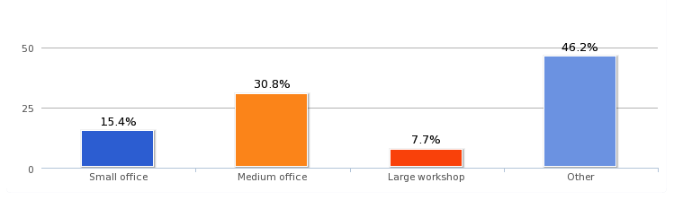

Other:
- Extension
- Medium sized building plus land for outdoor activities
- An increase in the Schools capacity would trigger an expansion of the premises
- Extend on existing sites
- Warehouse

What skills do you require?

- Montessori qualified teachers
- Solicitors specialising in Trust work and related topics

If you had problems filling job vacancies in the last 12 months why was it?
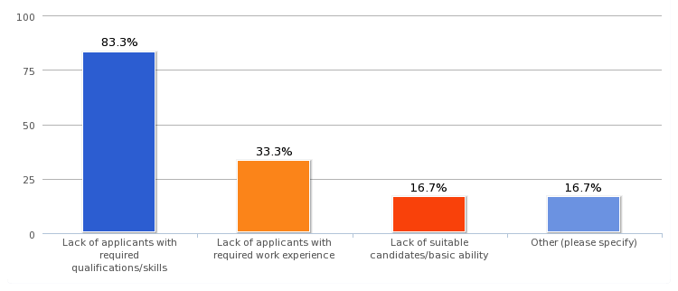

How do you Advertise your Job Vacancies?
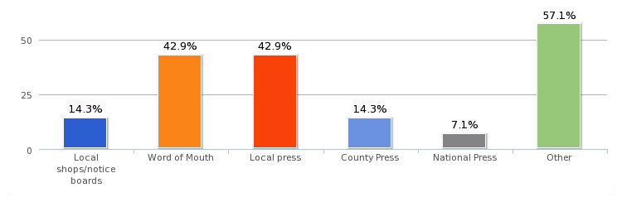

Other:
- Agencies
- Recruitment Agencies
- Specialist Agencies
- Specialist publications
- Suffolk County Council jobs site
- We are regularly approached by individuals who are seeking work
- Web Site

How do you rate the following local Services in Melton?

The only services to get a fairly high rating of ‘Average’ or ‘Poor’ were Mobile Phone signals and Public Transport.

How do you rate the following public services in Melton?

How do the following effect the smooth running of your Business?

Other Comments:

- Our business is self contained hence the only issue is directing visitors.
- The building works in Old Maltings approach can be disruptive at times
- The biggest problem we incur is the traffic lights in Melton Street from Ufford to Woodbridge. Often long delays.
- Access to site in Dock Lane can sometimes be restricted by cars in Dock Lane-some from residential, some from businesses and some from School
- Traffic congestion at the traffic lights can result in delays in picking up children from school. To explain - we collect children from 7 local schools and staff often collect from more than one school e.g. Eyke at 3.10pm then Woodbridge at 3.30pm.
- One of main advantages of being located on modern business park is availability of client parking on site and level access for wheelchair users and clients with limited mobility
- The smooth running of traffic locally is important for ease of access and customer perception of ease of access. We have parking on site so no problem there and signage and footfall are fine.
- All seems quite in order, the visual impact of A board advertising is sometimes off putting and dangerous when restricting views from cars.
- Parking is always an issue around the school in the mornings and afternoons. The Coach and Horses Pub kindly allow parents to park in their car park however we still do have issues with cars that illegally parked
- Parking in the road leading to Deben Mill has been extremely dangerous until recent yellow lines put down - understand that these will be removed once the building work is complete. These should be retained to enable persons coming to the offices to get here safely.
- If working outside home/attending meetings and leaving home at peak times I often waste time sitting in traffic queues. At peak times, when the fish and chip shop is open or there is an event in the church, it is impossible to park near my home. This means that I may need to make several journeys to my car with boxes of papers etc. that I need to take with me.

What Other Facilities would improve the Day-to-Day running of your Business?

- Better roads in and out of Woodbridge and Melton
- Having a 30 mile an hour limit along Old Church Road as transport moves fast along this road.
- Improved road infrastructure, marketing and network opportunities.
- Mobile phone signals are the biggest problem.
- None
- Wi Fi & better mobile phone signals
- Marketing and Advertising signage
- The only thing that would help improve my business would be a bigger car park on Melton Playing Field to stop the constant bad parking in Melton road Stopping delivery to the shop and upsetting residents by parking on both sides of the road. The Recreation Committee should do more to stop all this bad parking with the car boot in the summer and the 2 football matches at the same time on Saturday in the winter. Parking facilities need to be improved on the field if the car boot and winter football are to continue It is getting dangerous!
- Nothing I can think off, but perhaps road verges maintained more efficiently would improve the visual appearance all round.
- Road infrastructure would help as long as children had a safe environment to walk to school. Increase in housing would of course allow for potentially more children to come to the school!

If new business developments were proposed in Melton how would this effect your own Business?

56% Positive

11% Negative

33% No Effect

Comments:
- We would welcome new business developments to enable expansion of the services we provide, which in turn would create additional employment opportunities. Current restrictions do little to help the viability of the business.
- It would depend on how they influenced traffic and whether any of the businesses were the same as ours.

What can your Business do to Engage with the Community?

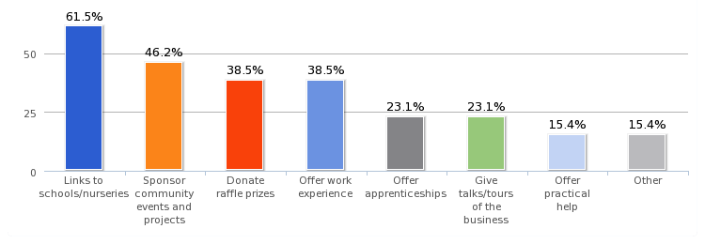
Other ways your Business can Engage with the Community?

- Access to all our facilities is readily available. We are very active in all local activities.
- We hope, in the future, to offer informal meetings to provide info. about older client issues. We have confidentiality issues, which make it difficult for us to offer work experience, particularly to young people. I’ve answered the questions on basis of Melton but we’re part of a larger group of offices where we do sponsor local events etc. Many of the questions aren't relevant to a small office like ours, which is part of a larger group. None of us reside in Melton but we all live within five miles.
- We supply and online service (EVOLVE) that enables schools (LA maintained, as well as independent) to safely and securely create, register and approve educational visits. We would happily demonstrate our services to schools n the local area that do not already use our system and could offer training to those that do.
- As a health and safety consultancy we could give practical advice and assistance for community projects etc. – we’d be prepared to assist in other projects involving the disadvantaged or elderly should the need arise.
- We’re currently looking for land to expand the business and create a community farm. Ideally we would like to do this in Melton as it’s been Pitstop's home since it started in 2003. The farm would encompass animals and horticulture, bring additional employment and training opportunities, as well as a local feature for the people of Melton to learn about the great outdoors. Our Business Plan on our new venture will be available in March and we would welcome the opportunity to discuss this further with the Parish Council.

Appendix L March 2016 Melton Messenger Call to Action for Open Days

YOUR HELP AND FEEDBACK IS NEEDED on the DRAFT - MELTON NEIGHBOURHOOD PLAN

Melton Parish Council has been preparing its Neighbourhood Plan for over 3 years. In the beginning much of the work was done by community volunteers and the Parish Council is now working on finalizing the plan with the help of a paid consultant.

The details needed for the plan are considerable and we have also faced a large number of obstacles to progress i.e. the possible Woods Lane Development. We are a small Parish Council and it has been hard to get the money and the man power to do the huge amount of work that it has involved.

However we now have a DRAFT Plan for the Community to look at and comment on. This includes suggested development (affordable houses, small business units, a community orchard, farm and new allotments as well as a new lake and recreational area) which we need you to comment on!

Once you have given us your feedback on this DRAFT we will re-write what is necessary and make any changes you have asked for and then we will be able to submit it to SCDC for final comments. We will need your opinions one last time on the final draft (hopefully in the Summer) and then we want to get this through the Inspector and on to Referendum by the end of the year.

PLEASE HELP!

We wish to invite you to any of the 3 Open Events which we have set up. This is where you can come along and read the key elements of the Draft Plan and give you comments – positive and negative.

The dates are:
Thursday 10th March. 7.00 p.m - 9.00 p.m
Friday. 11th March. 7.00 p.m - 9.00 p.m
Saturday. 12th March. 10.00 a.m - 1.00 p.m

The venue is: The main school hall in Melton Primary School.

Other notices will be posted in shops, pubs, notice boards, church halls and
schools.

We hope that many of you will take part and help us to produce the best and most suitable plan that we can for the residents of Melton Parish Council. The plan and its implementation are of very real concern to residents living within Melton Parish.

We look forward to meeting with you on whichever date you can attend.

Cllr Alan Porter - Chairman Melton Parish Council

Appendix M Welcome Handout at March Open Sessions

Welcome.

These Open Events are so we can get YOUR feedback on the DRAFT Melton Neighbourhood Plan.
As you move around the room in a clockwise direction you will see all the policies and objectives which are part of this Draft Plan set out in sections.
ISSUES, which have been raised by YOU through previous consultation have focused us towards OBJECTIVES and in turn these have enabled us to create POLICIES.
Please give your thoughts and feedback on each section.
Some things you have raised may not be part of a policy we have written into this plan and this is because it may already be covered by Policies in other forms i.e. through the Core Strategy that Suffolk Coastal have written or through National Planning Policies.
1. Please look at each section and let us know whether you agree with the Policy that we have come up with. Is there any way to make it better? Have we missed something?
2. Please tick the boxes provided according to your thoughts OR use the post it notes to write your comments.
3. You will see that there is a section on DEVELOPMENT. WE have taken on board all the previous feedback and comments received and found the place we believe is best for a SMALL amount of development. This includes:
- AFFORDABLE market housing, suitable for first time buyers, elderly couples or those wishing to downsize but remain in Melton.
- small business and retail units, suitable for local people to build their business or as an alternative to working from home
- a recreational lake which we hope will be suitable for boating, picnics etc
- a large area of green space for picnics, dog walking etc
- the re-location of Pistop, Out of School Club including a community farm and lakefront café (they will also be looking to run new allotments and a community orchard on a small piece of land off Saddlemakers Lane).
- changing the A1152 so that the bend over the level-crossing is straightened out and makes it easier to pass larger vehicles
Please note that access to and from the new housing will only be through the St Andrews Estate. Access to the business units will be through the ‘Girldstones’ development.
If you have ANY questions please ask someone wearing a badge and hopefully they will be able to help.
Many thanks for taking the time to come today and please help yourself to some refreshments before you go.
www.meltonneighbourhoodplan.co.uk

Appendix N Feedback Report from March Open Sessions

Feedback from March 2016 Open Sessions

Development (general)
I am very concerned that the proposed developments at Woods Lane and Yarmouth Rd are not mentioned anywhere as if they go ahead they will have a massive impact on Melton.
If children continue to live with parents why do we need the extra housing?
The elephant in the room is the lack of infrastructure to support proposals of this magnitude. The road system in inadequate and already at breaking point and so in fact is the sewerage system. See Planning Inspectorate Report to SCDC June 2013 on SCDC website.

Development Proposal Carter/Warburg Site
In favour of housing development but with reservations on the traffic problems.
Development of new lake, housing, farm etc. looks very promising. Please forge ahead.
Ensure housing really IS affordable.
Under no circumstances should the Carter/Warburg site access directly into St Andrews and Station Rd. It should have access off the main road by way of a roundabout opposite the station. The current layout will just encourage traffic build up throughout the village.
Ludicrous plan to take the access road through St Andrews Place. Take the main road through the commercial area.
St Andrews Place is already a nightmare for traffic.
A lot of hard work has been done here. Appreciate your effort.
New development looks very good and I fully support this.
The size of this development will cause added problems for the existing congestion.
I don’t think the road system will cope with the vast amount of increased traffic generated by this scheme.
Good masterplan. Good balance of development and use of floodplain. Like the green infrastructure.
Consider adding a circular running route to the green space.

Good design ideas well done!
What has happened to the traffic calming measures proposed for Station Rd?
If increased traffic is coming out of St Andrews then Station Rd needs to be one way.
This is such a major development with devastating consequences that every house in Melton should be sent a copy of the plan.
More recreational needed for children and young adults so a good improvement to the area.
Experience has shown that ‘artists impressions’ never turn into reality. The neat rows of business units end up empty and vandalised rubbish bins and skips overflow.
(??)There is no affordable housing included in these proposals. Many local people can’t afford open market housing even if it is small. In general there is not enough information included to form an opinion about housing.
If you put a car park on the small plot of land opposite the council offices this will cause an accident black spot due to volume of traffic. Please put the Little Drummer Boy in there and create a proper garden of remembrance for Afghanistan and a community picnic area.
Disagree with proposal for parking on this amenity green space with protected trees.
Bring back the ducks.
Play equipment good and good to have another park.
It would have been helpful if the developer had been here.
If there is a flood risk don’t build there.
All the neighbours at the top of St Andrews Place object to this needless development.
It will be nice to take the family for a walks in Melton and stop for a coffee.
Community farm and allotments a good idea!
2-3 bedroom shared ownership please!
Good use of brownfield site – we could get something a lot worse!
If the new site is accessed via Station Rd the junction should be configured such that traffic leaving the site cannot turn right and has to join the main road (one way system).
Where are the plans for improving the existing infrastructure of the village to cope with the increased pressure from the new development? Our roads and sewers are already overburdened – how will it cope with all the extra demand? Melton crossroads already suffers from significant air pollution. Do we really want Melton to be used as an industrial park for Woodbridge? I thought Melton residents wanted the rural character of the village to be retained? How does huge industrial development achieve this? It doesn’t.

Object to more cars accessing St Andrews Place. Suggest hub is made via play area to commercial road serving business units.
I feel generally favourable to these plans provided the new housing does not have to be accessed via St Andrews Place as this has quite enough traffic using it already and children play on the green ‘island’ at the centre.
Ensure that small affordable houses have sufficient variety and interest to allow owners and individuals to feel different and add visual interest to area.
Concerned about 1. Lack of parking for Council Offices and new residential properties and 2. Terrible knock-on effect on already bad traffic.
Traffic volume in Melton is becoming a problem.
More parking at Melton Station and cycle racks.
OK but ‘affordables’ should include open market DISCOUNTS on dwellings. So called ‘social housing’ will soon be subject to the ‘right to buy’ and will be lost in time. SCDC needs to take a firm stance on this.
As this will improve the visual disaster that the current lorry park is I am in favour of some development.
It seems a lot of thought has been put into increasing the amount of business units, but very little has been put into the new housing. The proposal is a very unbalanced solution to the problems faced by Melton. The houses are tiny – do we really want to be forcing older residents to live in shoeboxes? Also ‘open market housing’ is not necessarily affordable – even if it is small.
It is detrimental to build a housing development in a quiet area. NOT A TOWN. It is also a natural area for wildlife.
Very sensible approach to the developemtn BUT the traffic / road issues need to be addressed.
We like the plans, concern about the traffic and access onto Wilford Bridge Rd.
Can there be alternative access?
Much more good than bad. Not sure about no. of housing units. More parking for station? Allotments by lake?
All well and good but more pressure on schools, Doctors etc
Well done some good ideas.

Would love to see priority for pedestrians and cyclists in any new development.
Please do not allow the traffic to access via St Andrews as the roads can not take this excess.
They didn’t protect the trees on the western boundary of the Riduna site!!
Community Farm what a brilliant thing to have!!
What access road will be used to get to these new houses and facilities?? Already too much traffic in Station rd.
St Andrews Place is already very busy – when a church service is on it is almost impossible to negotiate the junction with cars larked all along the road.
Please do not open the 2 ends of St Andrews Place to traffic from the new houses. Make an exit road for that on the Eastern end.
Terrible congestion at level crossing – possible road straightening?
Station parking is already maxed out. Inevitable further demand means more parking must be provided. Suggestion: phase the permission for the units near the station until real need is established and the reality of parking at the commercial and business units is seen.
Who are these parking spaces for? Is this an admission that there wont be enough on the main site?
It doesn’t look like there is sufficient parking on this industrial site.
Ask all developers to install ‘swift boxes’ in all new buildings.
There is too much traffic already. To assume that residents and workers will walk or cycle is naive.
More traffic. Enough.
Too much traffic going through Station Rd already. Too narrow to cope with any more.
Not in favour of any housing BUT 1/3 houses 1/3 green field and 1/3 business is better.
Consider tarmacking the start of the lane that comes off Yarmouth Rd as one of the access routes as this would take some train away from Station Rd and Wilford Bridge Rd.
Proposed extension of St Andrews Place is too large. SAP at times difficult to drive up with cars parked on both sides of the road.
Would allotments on new development be used? Existing ones in SAP have not been used and have been allowed to become overgrown.
Great to have more community facilities.

This proposal puts a huge increase on traffic in the village. Find alternative rd access.
Same as above.
Same as above. Please access opposite the station.
Same as above.
Could Brick Lane be used for access?
Very imaginative development. Full marks BUT need to split access to main road.
3 alternatives:
- through commercial park
- down track over level crossing
- exit around boundary and move lake upwards

There are 300 allocated parking spaces in the new development. What alterations will have to be made to the roads to accommodate these extra cars?
1 letter received from a St Andrews resident: asking for no access through St Andrews but to use our imagination and skills to find a more environmentally acceptable route.

Traffic and Transport
Woods Lane is chaotic at times, difficult and hazardous at best. The 180 house development MUST be stopped. Mini roundabout at junction with Bredfield Rd should be installed as current T-junction arrangement is dangerous.
Wilford Bridge Rd is dangerous and congested and your plan seems to make it much worse. The Vision seems to be blurred.
Proposed traffic calming in Woods Lane and The Street will not improve the air quality.
Very concerned that the increased traffic at junction by Melton Primary School will cause raised pollution and raised risk of accidents as well as massive traffic problems.
I have been told that the air quality testing at Quay Stree shows the air quality to be below EU Standards. Has there or will there be similar testing at the traffic lights at Melton School? Pollution levels near the school may increase with more traffic.
There will be more standing traffic on The Street – air pollution will increase. Design green areas to reduce the impact of this increase.
Shared cycle ways and footpaths???

Shared cycle paths work well if both users are aware of their own space. Helps if paths split with a line or different coloured tarmac. Needs lots of width! Will this be a consideration?
Traffic calming should be carefully designed to allow safe routes for pedestrians whilst retaining use for residents.
Agree with cycle lanes and paths. Speed reminders on the hill – flashing ones.
This morning 11/3/16 Dock Lane had 38 commercial vehicle movements between 10.15am and 11.15am to the 3 businesses situated there. How many vans, lorries etc. will these new units produce to the new site on the proposed development?
Signals for traffic lights too quick in changing.
Traffic flow on Melton Hill becoming more difficult. Crossing for high school / cyclists concerning.
Recognise that traffic and parking is difficult to tackle. Keep trying to rise to the challenge.
Reminders of speed limit on Yarmouth Rd needed. No evident signage and haven’t seen the police for some time.
Timing of traffic lights needs investigation
Woods lane pavement should be larger – very dangerous at present
Create cycle lane from Melton to Woodbridge
Pedestrian cycling paths needed from Bury Hill area to Melton and Woodbridge
Pytches Rd is dangerous for pedestrians and almost impossible for cyclists. New paths req’d.
There shouldn’t be any more houses. If it does go ahead the entrance should be opposite the station. Station Rd needs to be one way!
Very dangerous to walk down Woods Lane
There should be a cycle lane linking Bredfield Rd with the top of the new Woods Lane development.
Road signs on Woods Lane should clearly show Bredfield Rd turning, Traffic is TOO fast
Getting out of Church View Close is a nightmare at peak times
Pavements becoming narrower due to overgrown banks on Yarmouth Rd and Woods Lane
The width of the current pavement could be increased by removing the soil that has, over the years, come across the pavement in Woods Lane

More cycle parking provision in Melton please. Less emphasis on cars and car parking.
Reduce the ‘no cycling’ signs through the countryside.
One way system down Station Rd, round Wilford bridge Rd and round to Traffic lights.
It might be useful to set up a small group to consider movements of pedestrians and cyclists within Melton at he moment (starting and finishing points / hazardous routes) and what could be done to improve this. Secondly what would enable local people to use cars less for local movements?

Parking
People park in the car park in the morning and leave it there all day.
Policy MEL6 – very good standards to implement.
More parking req’d for local residents also capacity of main road junction needs increasing.
Agree strongly with this policy. People using local shop, some break the law by parking outside as the car park is always full.
This is a complete mis-representation. The cars and vans are parked overnight NOT just when the shops are open. Why are they allowed to continue to park there?
Do not reduce green areas OR compensate with trees. Air pollution is a growing health concern. Parking is an issue here. Keep conservation area to the fore.
Agree that more parking space is needed in this area. If cars are parking all day perhaps changes should be introduced i.e. free for one hour then pay?
Parking in Melton Rd is a problem, particularly from contractors working. Consider extending yellow lines / using residents parking permits.
Please sort out the flooding problem in Melton Rd.
There is a real problem with safety when traffic parks, often on double yellow lines and on the pavement outside our excellent fish and chip shop. HGVs and buses are often obstructed. More regularised parking needed.
Recognising that some people do park dangerously to get to the shops extra parking would probably be useful, although there is already a car park x 1. Think some people are just lazy and park immediately outside. Be nice to combine it with planting and landscaping. (by McColls)
Surely cars should be discouraged and cycling encouraged

Make commercial premises offer parking spaces for evening/weekends. E.g. Thurlow Nunn, SCDC
Need to sort parking in Dock Lane of Bowls Club players
PLEASE do not park by the Melton Village Sign on that lovely bit of green!!
Parking outside McColls prevents safe exit for cars at the bottom of Saddlemakers Lane
Stop green verge btw Fison House and McColls being destroyed by selfish parking. If necessary offer to get it transferred to Melton PC.
Some roads should be for access only.
Need to sort traffic in Dock Lane. Double yellow lines on one side of the road would help.
If amenity green space is lost e.g for parking then it should be provided elsewhere e.g. community hall.
Yes agree with footpath on Woods Lane. Make sure there is cycle provision creating a safe route from Melton (The Street) to the high school.

Commercial and Retail
What about Dock Lane Industrial Area? 1 building now empty. What is going to happen to it?
I have a business in The Street. If the proposals go ahead there would be more people in the area and this could be good for business. But if a rival business opens on the development my own might fail.

Riverside and Boats

Please do not agree planning for buildings such as Avocet House – this does not blend in!
Duckpond/wildlife area needs updating – it is looking overgrown and tired.
I like the more ‘individual’ boats. They add character and interest as long as they don’t accumulate rubbish and clutter on the bank. I enjoy the boat ‘garden.’ The houseboats are more interesting than the expensive marina.
I strongly agree with the above comment.

Houseboats are a part of the river scene – please don’t ban.
I agree with above.
We need a policy that houseboats can conform to – not an outright ban.
Houseboats fairly unique and therefore provide some sense of place for this area. We like them. Why are people discriminated against just because they decide to live on the water?
Houseboats MUST be controlled otherwise a free for all. No more should be permitted and SCDC should enforce against those not permitted.
I like the houseboats, as do many others I know.
A suggestion re. residential boats that there should be a condition they have full insurance cover as this would guarantee a certain level of maintenance and protect nearby boats, property etc in case of fire. (from a boat owner)
Houseboats are not a problem and enhance the riverside.

Environment
Pedestrian footpaths should be shared with the cyclists when they pass through woods and countryside. Remain un-surfaced.
A laugh for a start. ‘Protection of rural character’
Consider the air pollution around Melton Primary School. It will only get worse with more traffic.
Deplore the loss of mature trees on the Pytches Rd site.
No protection of the mature trees on the boundary of the Riduna site. Mature trees were felled and will take years to re-grow more and hedgerows are lost.

Non Land Use - votes
Getting assets of community value registered. (16)
Creating a local list of heritage assets. (24)
Better maintenance of ‘green lungs’ and rural environments where they are used by people. (26)
Create more opportunities for young people in Melton to get work experience and create better links between schools and local businesses. (28)
More picnic tables and dog mess and litter bins. (22)
More play equipment on the green on Hall farm Rd or generally. (12)

Objectives
If these are the stated objectives why are there proposals that don’t meet objectives 1, 2 and 3?

Community Infrastructure
Yes please – sooner rather than later!! Re. 1.5 bullet point (Three main improvements were suggested to help support the users of this facility:
• The replacement of the existing pavilion with a modern village hall which
incorporates public conveniences, a café and changing rooms for formal sports
recreation users of the playing fields
• Skate park/BMX track
• Outdoor gym equipment for people of all ages)

Re above. Very excited by this – as soon as possible please!
An outdoor gym a good idea!
Are trees community facilities?
Allotments should go ahead.
Why no badminton in Village Hall?
Yes great ideas. Like the green space improvements for the community.
If community hall goes ahead trees and hedges in NE corner of REC should be safeguarded and if pitches lost replaced.
If this is done car parking area. No more houses.
Yes please preserve the green lung of Melton Woods. It’s size is important for visual impact, bio-diversity and our health.
Appreciate care and development of Melton Woods and Playing field. Excellent ongoing….

Re. BMX track/skatepark idea. What are the actual numbers (not %) of residents who actually suggested this? Is the demand really there?
BMX/Skatepark – how can long term management be guaranteed?
Re adult gym equip. Suggest consult with Bawdsey PC to see how much use it actually gets.
BMX/Skatepark: what proportion of our young community members will actually use this high capital cost amenity? Has the target proportion of our community who will consistently use this been properly quantified with demonstrated evidence? Cost / benefit for wider community? Is it the parents who think their children desire this or the children themselves?

Design / Heritage and Character
Special attention to building materials. Don’t make it too prescriptive e.g. in 1950s/60s black clapperboard was used.
It is vital to protect the unique heritage of Melton.
Planning Authority should not shirk away from insisting these development rules are adhered to in the proposal plans but also ensure that design infrastructure is maintained after construction.
Planning criteria for developments should not be over prescriptive so as to stifle innovative design. Best premise to ‘reserve or enhance’ character or appearance.

Vision
Melton Road not Hill!

Challenges
Has there been similar air quality monitoring as at Quay Street and what are the results?
Analysis
In total approx. 149 residents attended the 3 opens sessions on March 10/11/12th at the Primary School. We took a register, but not everyone signed in.
All the feedback received in writing is above, as written.

As with most things the positive comments tended to be verbal but anyone with a negative comment was more willing to put it in writing.
There are various parts of the Draft NP we need to look at again but in general the policies we have suggested were seen to be positive. We do need to have another look at the policy on houseboats, BMX/Skatepark proposals and the parking issue by McColls.

Proposed Development
Parish Councillors in attendance reported that in general the feedback on the proposed development was positive BUT with one major exception – access / traffic issues. We had a large number of St Andrews residents who were very worried about the idea of access for the new houses through the site. To this end we need to think of an alterative solution.
Most people loved the idea of the lake, farm, café, allotments, play areas and public green space. A lot if people were also keen to see that we were trying to get affordable houses built. The Pitstop Community Farm idea was particularly well received.
It was explained to anyone who was willing to discuss things that as a brownfield site this will be developed at some stage and it would surely be better to have a hand in what happens there. There have to be elements of compromise but as the Carter site is former industrial use and also a flood plain we have to have some small business units there and we can’t have any more houses.
Meetings will continue with MasterLord and SCDC and Highways but the thinking so far is as follows:
1. We will look at getting access coming through the commercial site onto the A1152 with a possible mini roundabout or other solution – not through the estate.
2. We will look at the possibility of making Station Rd one way or other solutions.

Appendix O Maps showing where residents marked for development / or not

In 2005 Melton Parish Council held a meeting at St Andrews Church to ask residents what they thought about putting houses on specific sites identified by SCDC:
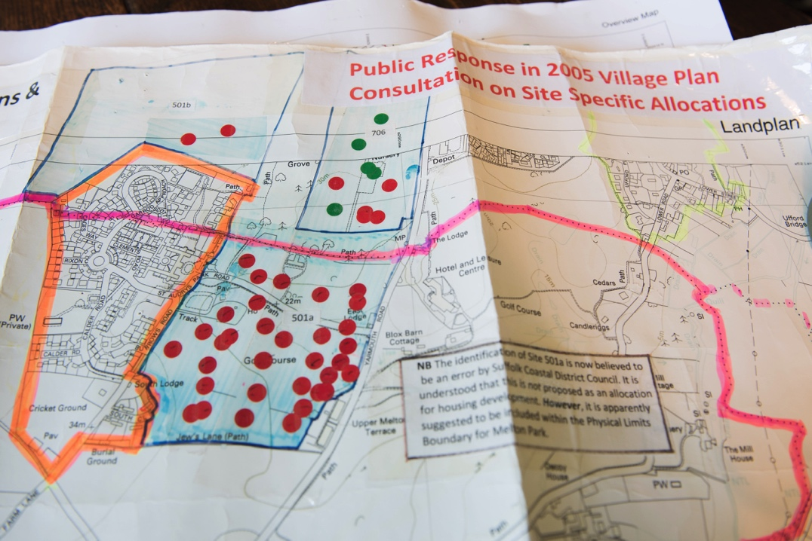

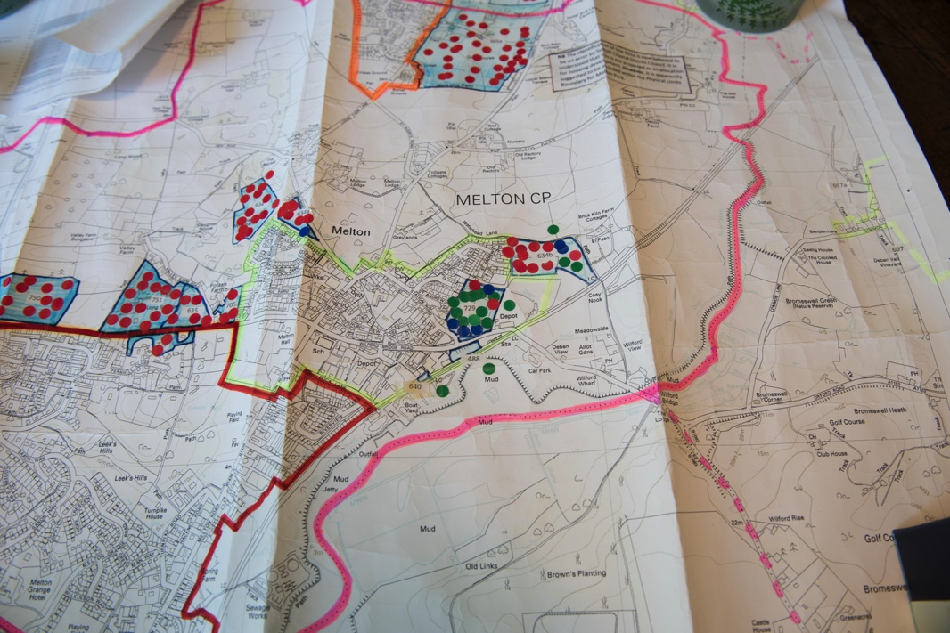

In June 2013 at the first NP Open Session residents were asked to put red dots for no housing, green for housing and blue for exception sites for affordable housing on a general map of the Parish:
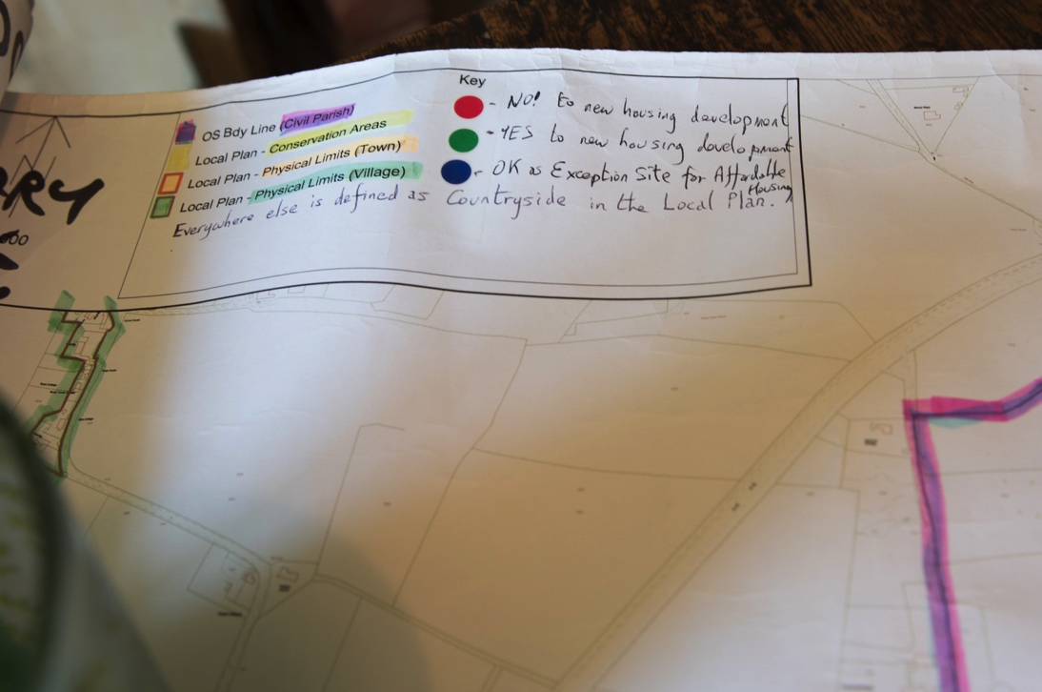

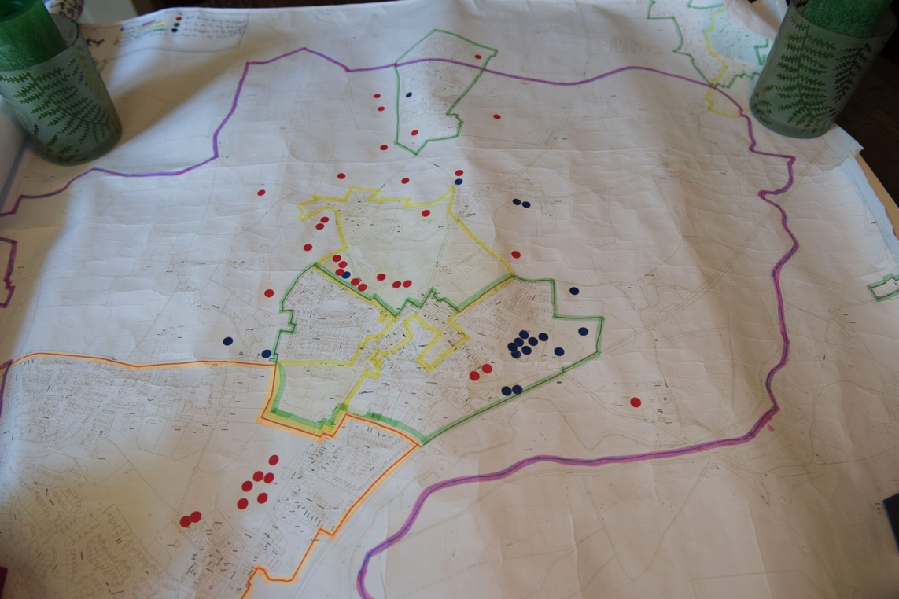

In July 2014 the same map from the Questionnaire which showed specific sites where landowners had approached SCDC for comments / permission to build was presented again and people were given the opportunity to put red dots where they didn’t want houses and blue where they did:
