Melton Neighbourhood Plan 2016-2030

Pre-Submission Consultation (Regulation 14)

June 2016

Contents

1 introduction 1
National and local policy 2
2 local context 4
History of Melton 4
Melton today 6
Socio-economic profile 9
3 vision and objectives 11
Vision for Melton 12
Objectives of the Neighbourhood Plan 12
4 physical limits boundaries 13
5 transport and movement 15
Key issues 15
Pedestrian and cyclist networks 16
Views from footpaths and cyclepaths 20
Public transport 20
Parking 21
6 community infrastructure 23
Retention of community facilities 23
Provision of community facilities 24
7 environment 29
Special Landscape Areas 29
Local Green Spaces 30
Protection of trees and rural character 33
Retention of riverside qualities 34
Residential boats 35
8 heritage and character 37
Conservation Areas 37
Areas to be protected from development 38
Character Areas 38
9 commercial and retail 41
General employment areas 41
Deben Mill 42
10 land off wilford bridge road 43
11 non-land use issues 47
proposals map 49
GLOSSARY 52

Appendix A Socio-Economic Profile
Appendix B Suffolk Coastal Local Plan saved policies to be superseded by the Neighbourhood Plan

All photographs were taken by Melton Neighbourhood Plan Working Group members

introduction
- This document represents the Neighbourhood Plan for Melton Parish (hereafter known as ‘Melton’). It represents one part of the development plan for the parish over the period 2016 to 2030, the other part being the 2013 Suffolk Coastal District Local Plan. For clarity, the development plan consists of any planning policies currently adopted by the local planning authority, Suffolk Coastal District Council, and this Neighbourhood Plan.
- Suffolk Coastal District Council, as the local planning authority, designated a Neighbourhood Area for the whole of the Melton parish area in December 2013 to enable Melton Parish Council to prepare the Neighbourhood Plan. The Plan has been prepared by the community through the Melton Neighbourhood Plan Group (MNPG).
Figure 1.1: Melton Neighbourhood Plan boundary
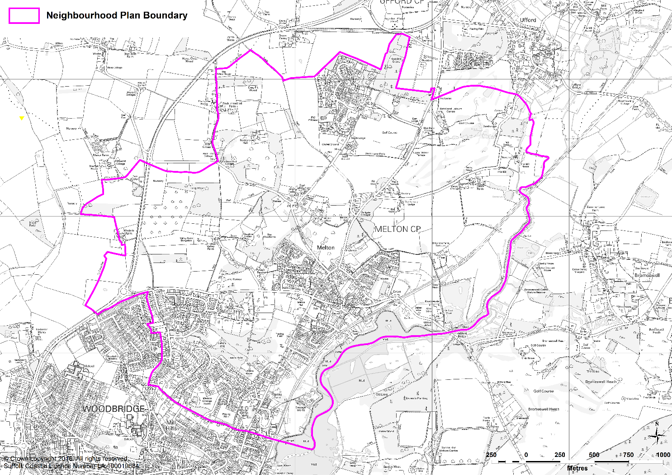

- The Neighbourhood Plan is being prepared in accordance with the Parish & Country Planning Act 1990, the Planning & Compulsory Purchase Act 2004, the Localism Act 2011 and the Neighbourhood Planning Regulations 2015 (as amended). The MNPG has prepared the plan to establish a vision for the future of the parish and to set out how that vision will be realised through planning and controlling land use and development change over the plan period 2016 to 2030.
- The map in Figure 1.1 above shows the boundary of the Neighbourhood Plan area, which is the same as the administrative boundary of Melton Parish.
- The purpose of the Neighbourhood Plan is to guide development within the ward and provide guidance to any interested parties wishing to submit planning applications for development within the designated Neighbourhood Area. The process of producing a plan has sought to involve the community as widely as possible and the different topic areas are reflective of matters that are of considerable importance to Melton, its residents, businesses and community groups. It has therefore given the community the opportunity to guide development within their neighbourhood.

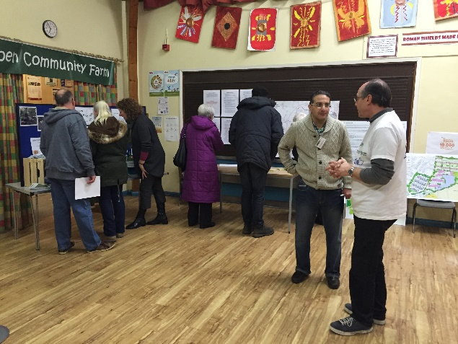 | 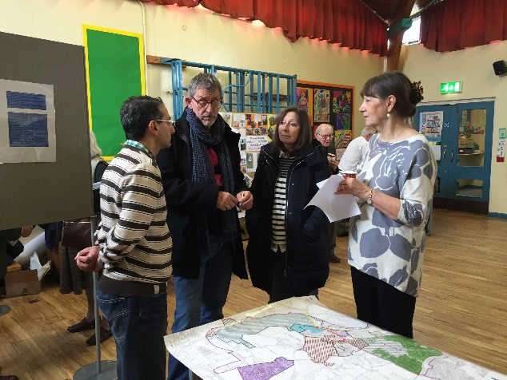

National and local policy
- The National Planning Policy Framework (NPPF) states:
“Neighbourhood planning gives communities direct power to develop a shared vision for their neighbourhood and deliver the sustainable development they need. Parishes … can use neighbourhood planning to set planning policies through neighbourhood plans to determine decisions on planning applications (para.183).
Neighbourhood planning provides a powerful set of tools for local people to ensure that they get the right types of development for their community. The ambition of the neighbourhood should be aligned with the strategic needs and priorities of the wider local area.
Neighbourhood plans must be in general conformity with the strategic policies of the Local Plan. To facilitate this, local planning authorities should set out clearly their strategic policies for the area and ensure that an up-to-date Local Plan is in place as quickly as possible. Neighbourhood plans should reflect these policies and neighbourhoods should plan positively to support them. Neighbourhood plans and orders should not promote less development than set out in the Local Plan or undermine its strategic policies (para.184).
Outside these strategic elements, neighbourhood plans will be able to shape and direct sustainable development in their area. Once a neighbourhood plan has demonstrated its general conformity with the strategic policies of the Local Plan and is brought into force, the policies it contains take precedence over existing non-strategic policies in the Local Plan for that neighbourhood, where they are in conflict. Local planning authorities should avoid duplicating planning processes for non-strategic policies where a neighbourhood plan is in preparation (para.185)”.
- The relevant Suffolk Coastal District Local Plan was adopted in 2013 and, under the guidance provided by the NPPF, is up to date. It provides the strategic context for the Neighbourhood Plan. The Local Plan also currently consists of a number of saved policies that are relevant to Melton. It is the intention that these saved policies, were applicable, will be superseded by the Melton Neighbourhood Plan once it is made. Clear reference is made in the Neighbourhood Plan to where this is the intention.

How to read this document
Each section of the plan covers a different topic. Under each heading there is the justification for the policies presented which provides the necessary understanding of the policy and what it is seeking to achieve. There is also a summary of how each policy contributes towards the objectives of the plan. The policies themselves are presented in the blue boxes. It is these policies against which planning applications will be assessed. It is advisable that, in order to understand the full context for any individual policy, it is read in conjunction with the supporting text.

local context

History of Melton
- Melton is an old-established settlement. Its history can be traced back to the Doomsday Book of the 11th Century, if not to the time of the Roman occupation a thousand years earlier. Its closeness to the Sutton Hoo burial site of Redwald, first king of Anglia, bears witness to this. It has doubtless been inhabited for hundreds, perhaps thousands, of years before records were written down.
- The Suffolk Traveller of 1829 shows that the Manor of Melton formerly belonged to the Dean and Chapter of Ely, but at that time was held by a Mrs Christine Burroughes. It records gifts made in the middle of the 16th century for the building and maintenance of the bridge at that time. In 1829 the rebuilding of the former House of Industry to form the Suffolk Lunatic Asylum was begun - "very pleasantly situated on a hill, commanding a delightful view of the country." At the time of that publication the population of the village was 607.
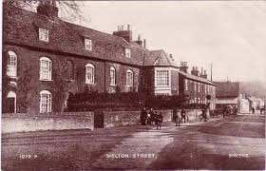

- Commercial navigation of the river had been extended from Woodbridge to Melton in 1840, with the construction of a new quay. The railway came to Melton in 1859 with the opening of the East Suffolk Railway. The station closed in 1955 but, in response to public requests, it was reopened in 1984. Just as the railway brought an end to commercial use of the river, improved roads brought a great increase in traffic and the end of local freight trains. The construction of bypasses, firstly for Woodbridge and later for Wickham Market, relieved Melton of the weight of traffic on the modern A12.
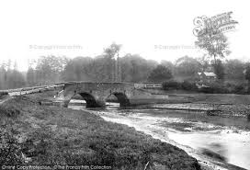

- One of the defining aspects of Melton, until relatively recent times, had been the absence of a central focus to the village. In historical terms, it failed to ‘nucleate’ in the Middle Ages and remained as a collection of widely separated farmsteads until the coming of the turnpike road and the railway, when The Street, Station Road, Dock Lane and Melton Road were developed.
- Perhaps perversely, the construction of the relief road (the western end of Wilford Bridge Road) in the 1980s helped identify a village centre, around the new crossroads and the village street.
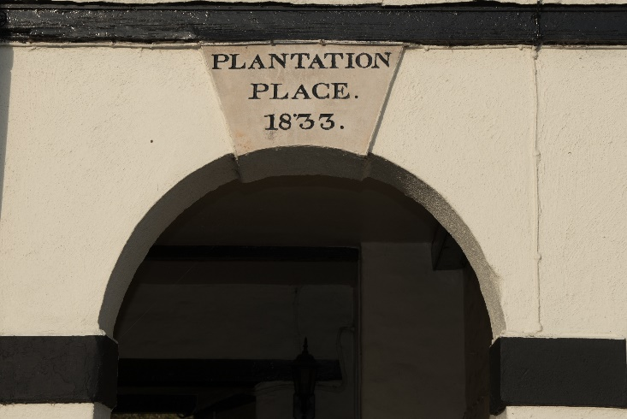

- Melton Park was from the 1760s the site of the House of Industry (workhouse) for the parish of Loes and Wilford Bridge, with up to 200 inmates. In 1827 the building was purchased by the County Magistrates and became the Suffolk County Asylum for Pauper Lunatics. The renown of the Asylum, renamed St Audry’s Hospital in 1917 grew such that ‘Melton’ was closely identified with it. Additional buildings sprang up on the site and in nearby Upper Melton Terrace and South Close, to provide good quality housing to the staff. Many local families worked for generations at St Audry’s and some of these have been recognized in the street names of the subsequent housing development on the site, such as Cage’s Way and Rixon Crescent.
- With the growing emphasis on care in the community, the need for institutional care diminished and in 1993, after 226 years of service, the facilities were closed. For a few years the site lay shuttered unused and faced an uncertain future.
- The Hospital site, including the ancient woodlands known as Hospital Grove, was purchased and developed with a number of residential properties between 1998 and 2009. Original listed Georgian buildings were converted and additional homes built in empathetic styles, within the grounds. This award-winning development is now home to some 200 households, the headquarters of Hopkins Homes Ltd, St Audry’s Golf Club and a handful of small businesses. Volunteers from the community operate the Melton Park Management Company Ltd, which owns and maintains the common areas for the benefit of all residents.
- During the latter part of the 20th century, Melton as a village settlement continued to evolve and develop with additional housing added in various parts of the parish.
- Woods Lane saw small scale, low rise housing development during the pre- and post-war period with housing, much of it provided as municipal housing on behalf of local authority or local housing corporations.
- During the interwar and post war period, additional housing was provided at St Andrews Place off Station Road. Melton saw the addition of further larger scale residential developments during the 1970s and early 1980s with additional housing to cater for the local population and cater for specific demand such as the accommodation in the local area for American service personnel and British service personnel and their families at the nearby airbases which includes Bentwaters. Hall Farm Road and Close and Bury Hill/Orchard Close are such examples.
- The village further increased its housing stock as part of the Melton relief road (Wilford Bridge Road) when Church View Close and Debenside where built.

Melton today
- Melton is classed as a Key Service Centre although a large part of it feels very much more like a village and sits within a large area of countryside. It comprises farmland, many varied bridleways and footpaths, Woodland, Special Landscape Areas, Riverside in an Area of Outstanding Natural Beauty and a large Conservation Area. Suffolk Wildlife Trust run Foxborough Farm in Melton and just across the river there is Sutton Hoo and Sutton Heath which is a huge expanse of natural heathland rich in wildlife. Melton also has a healthy employment base, with several employment areas accommodating over 150 businesses. Currently being built is a new headquarters for Suffolk Coastal District Council at Riduna Park, also known as the former Girdlestones site. This in turn frees up the existing headquarters site off Melton Hill, which straddles the boundary of Melton and Woodbridge.
- In addition there are a significant number of local retail businesses which serve the resident population. These residents are primarily housed on four large housing estates. There is also a large space owned and managed by the Parish Council which serves as dedicated green recreational space for the community.
- In recent times, changes have affected Melton but at a comparatively slow pace. There are now several large housing estates which surround the old village and there is no longer a discernible separation between Melton and the neighbouring town of Woodbridge. Indeed, the popularity of Woodbridge coupled with its shortage of space for new housing means that many people then look to Melton to fulfil this need. The Suffolk Coastal Local Plan describes Melton as the ‘gateway to the AONB’ and certainly those living in Melton value the beauty of the surrounding countryside and riverside as much as they value the fact that it is close to Woodbridge and the A12. Its popularity as a place to live and work however has meant that house prices are often now too high for local people to stay. With a growing number of young families as well as elderly people wishing to downsize, the need for affordable housing – in all senses of the term - has become more and more relevant.
- There are now well over 2,000 dwellings in Melton, with the associated increase in traffic volume that accompanies this. However, due to its location, Melton has always had pressure from increasing through traffic. It is next door to Woodbridge and it is the only way onto the A12 for many neighbouring parishes and almost all traffic from the Deben Peninsular (including Bawdsey, Sutton, Rendlesham, Bentwaters) is to go through Melton via the A1152. This road goes past the Primary School and has two roundabouts at either end as well as a bridge, crossroads with traffic lights and a level crossing, all of which serve to create congestion. Traffic from the Wickham Market direction also has to come through Melton, past Ufford and through the traffic lights to access Woodbridge and the A12 as there is no right hand turn towards Ipswich any further up.
- The volume of heavy goods vehicles from the villages on the Deben Peninsula that travel through Melton and along the A1152 has also increased dramatically in the last few years. In September 2015, consent was granted for up to 180 further dwellings on land off Woods Lane which, as at June 2016, was the subject of a legal challenge. If the permission is upheld then the development will add considerably to the volume of traffic along this route. One of the conditions attached to the permission requires the widening of the existing footway on the northern side of Woods Lane, and the provision of a toucan crossing of Woods Lane.
- The village has lost the Melton Grange Hotel and the Horse & Groom pub, cutting the number of licensed establishments from four to two; only the Coach and Horses and the Wilford Bridge pubs remain but both are doing well. The village has also lost its Post Office and an important community facility in the Lindos Centre which provided a place for sport, classes, events, meetings and other recreational activities.
- Melton Primary School is now flourishing although it has a high percentage of children needing special care or assistance.
- Despite the nature of modern times, there is still a village atmosphere in Melton and this is best demonstrated by the support at the annual fête.

Figure 2.1: Summary of key issues affecting Melton
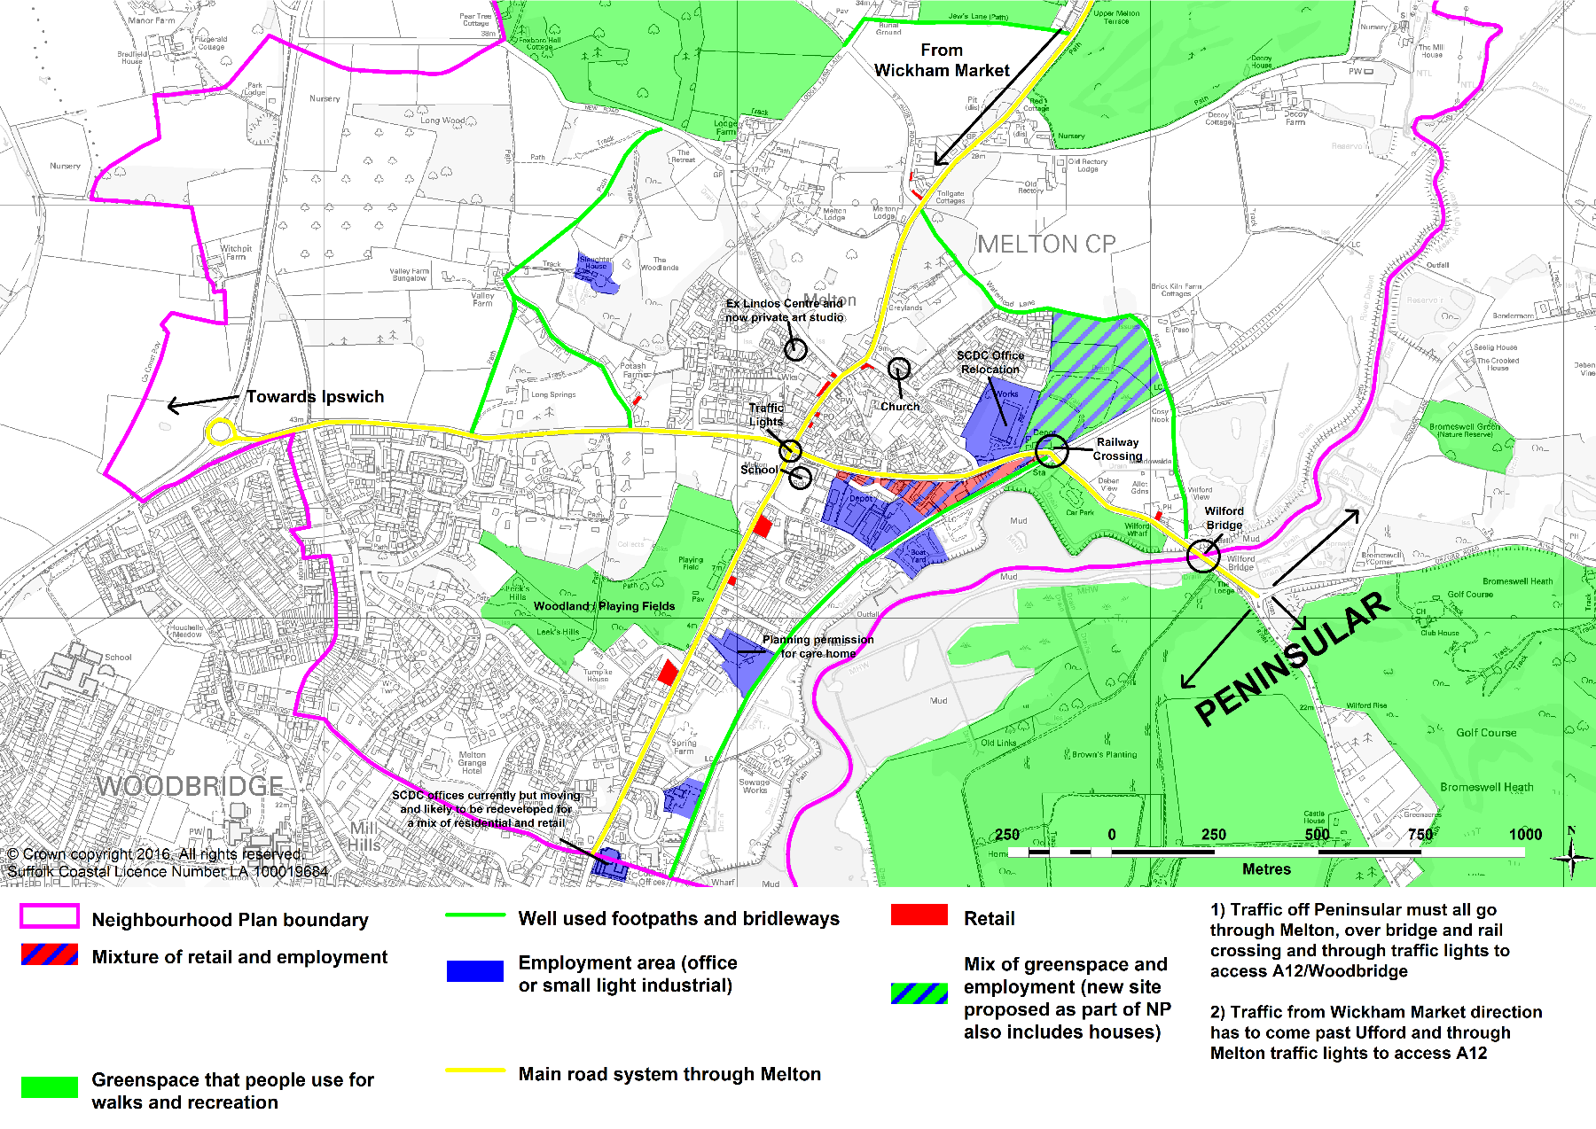

Socio-economic profile
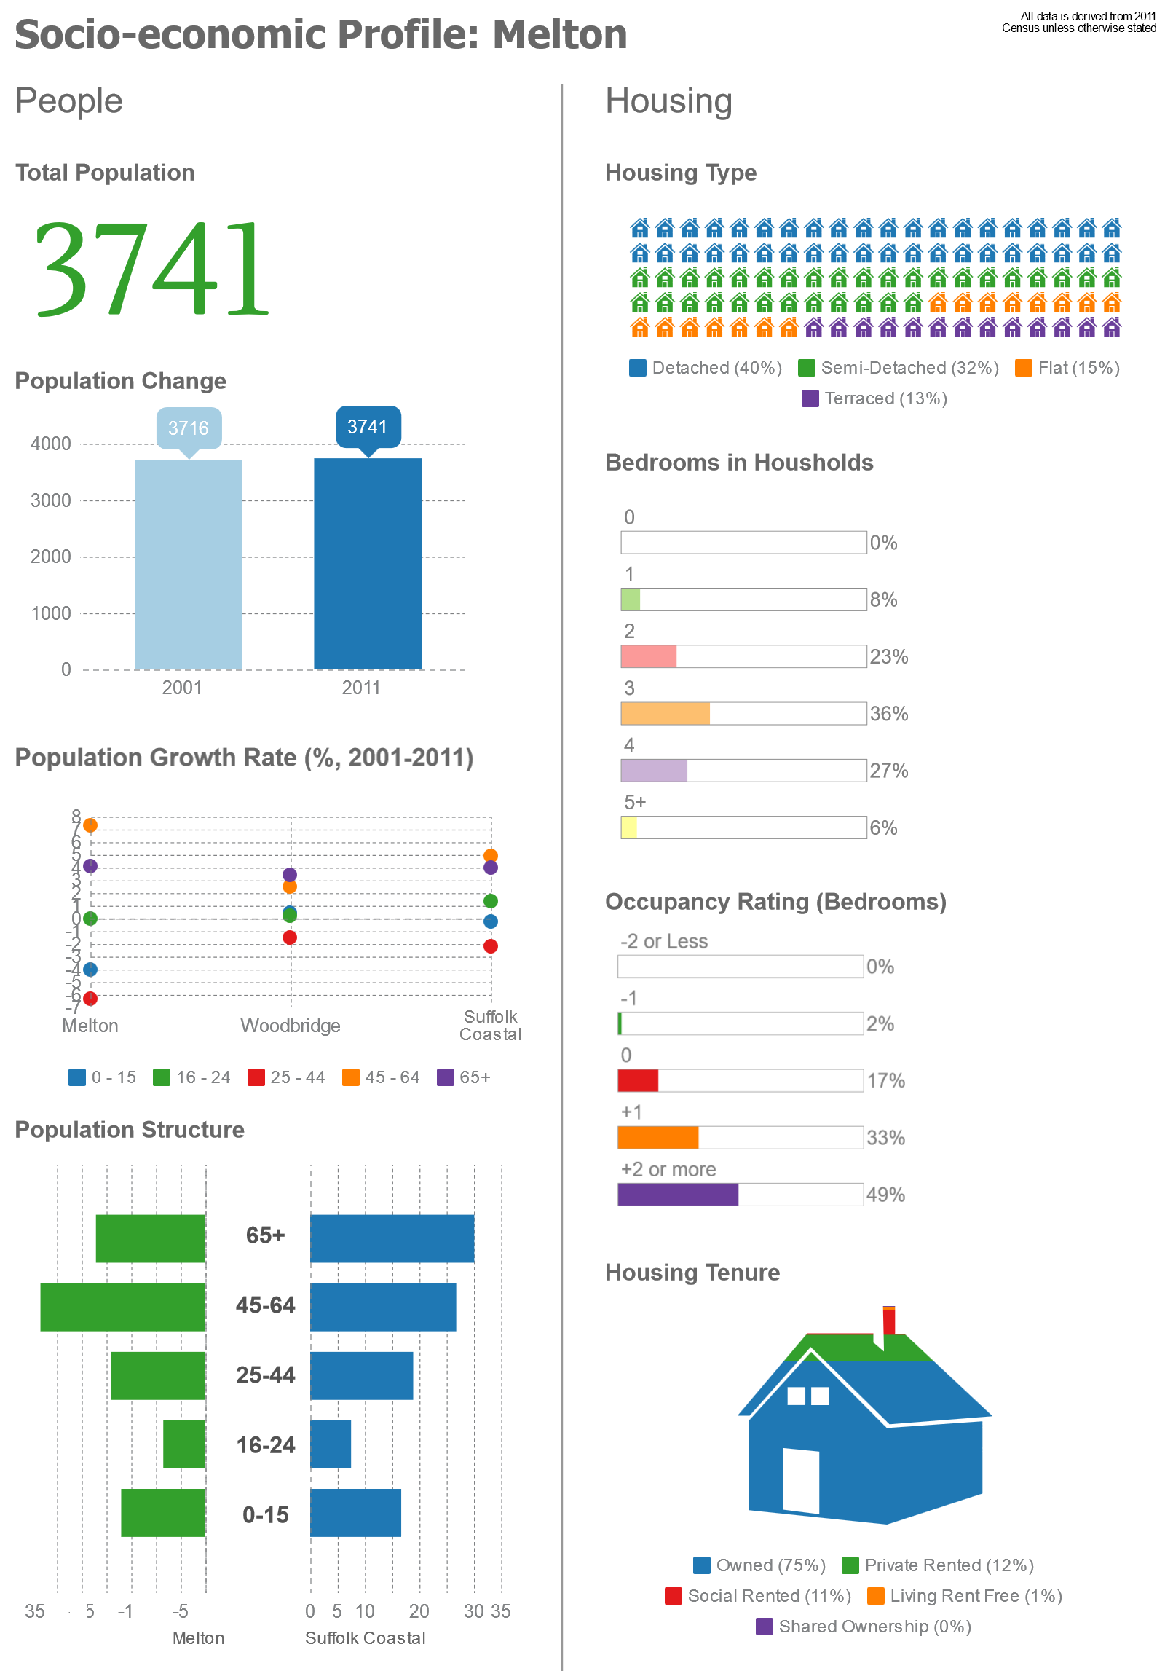
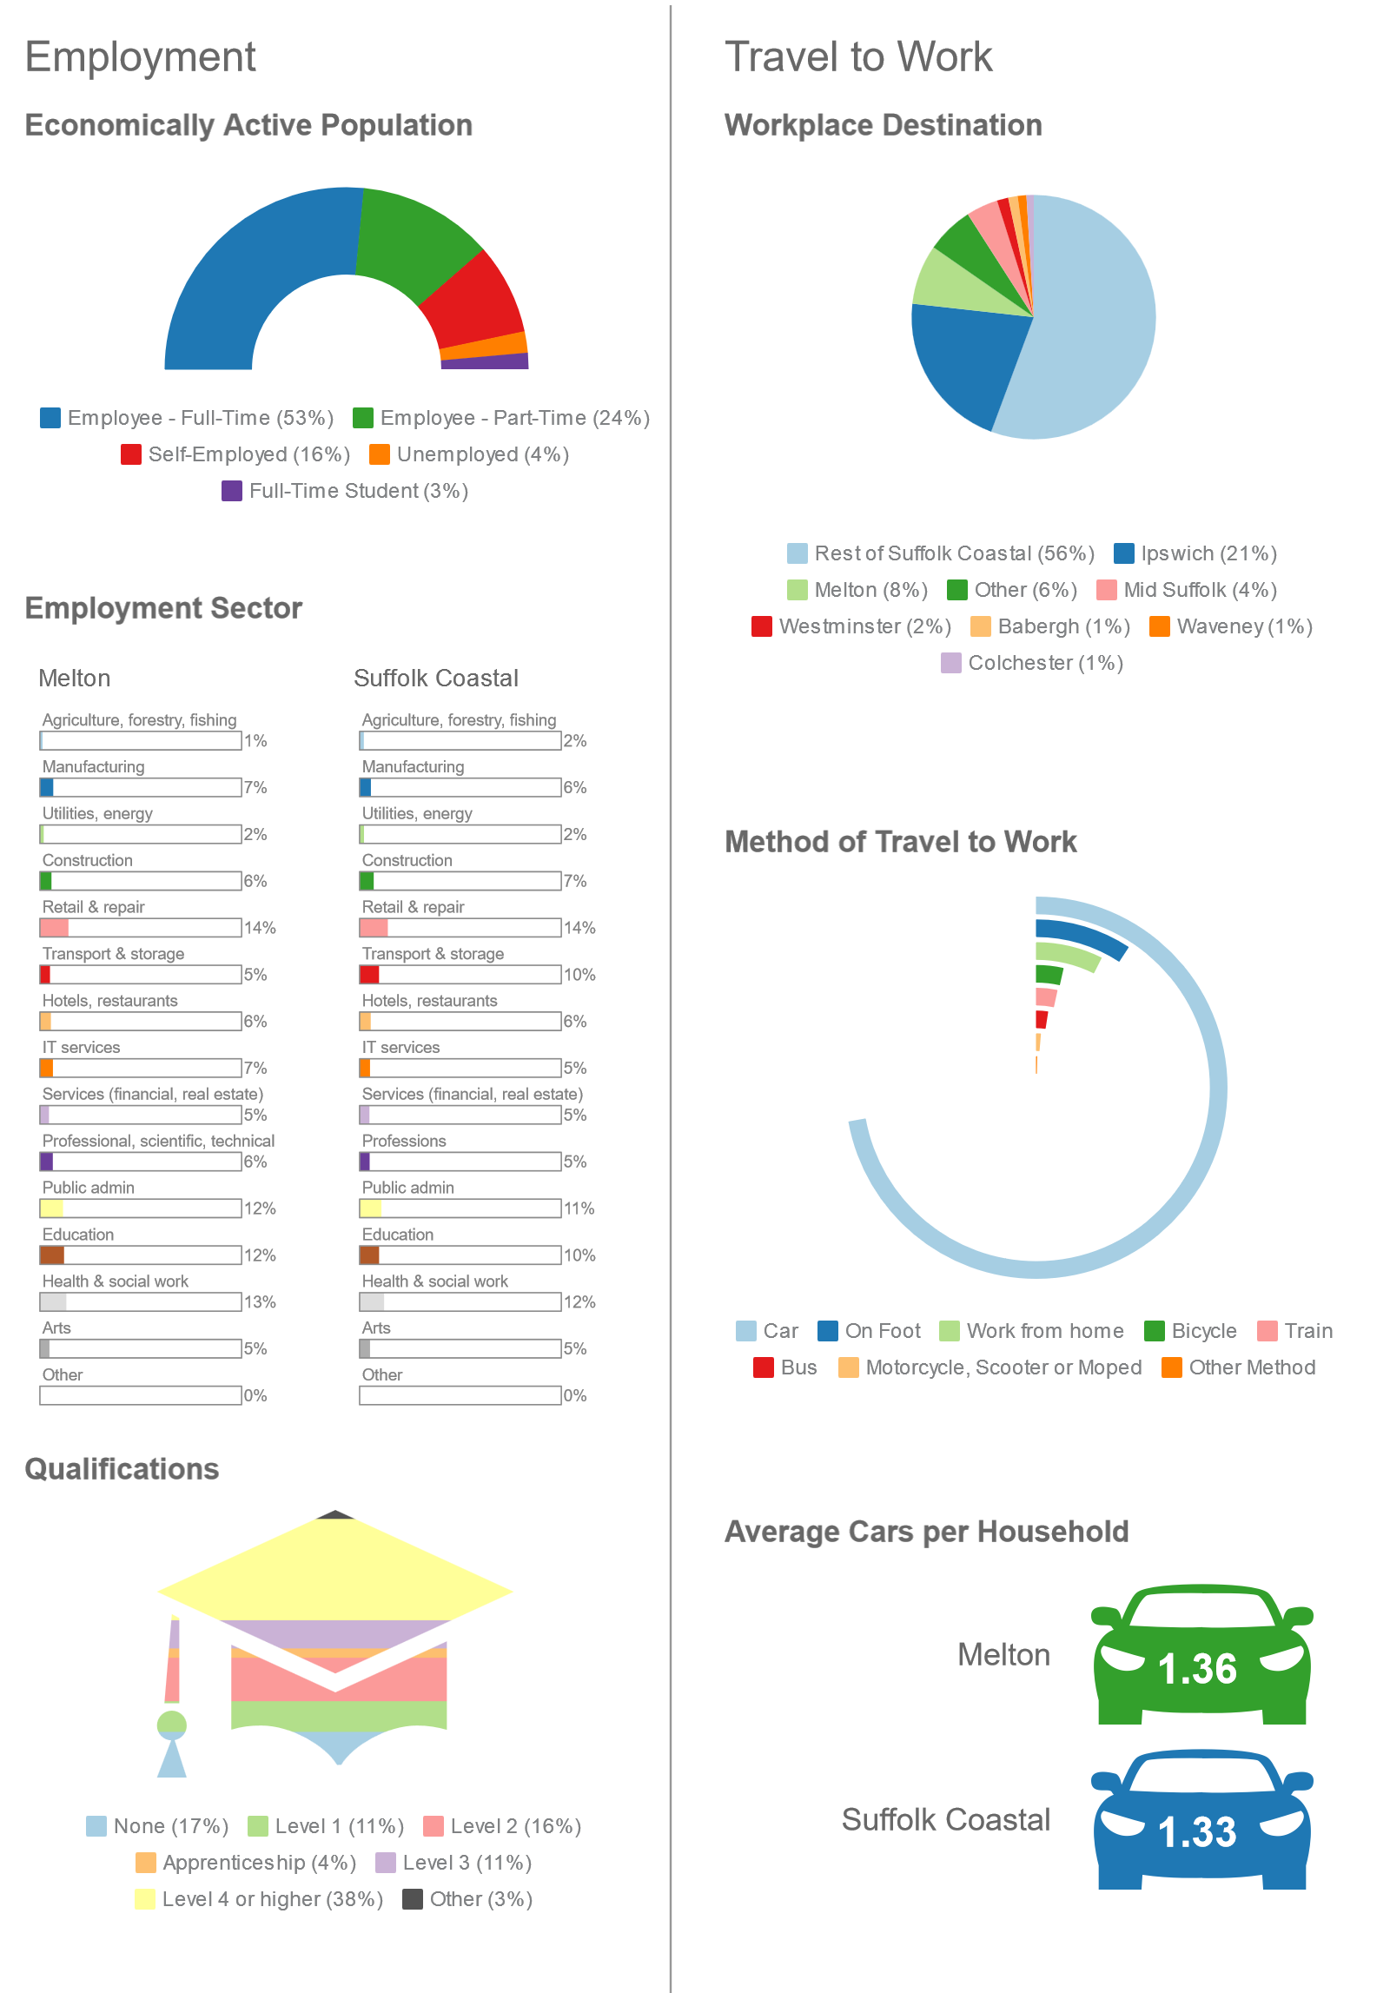
- A more detailed analysis is shown in Appendix A.

vision and objectives

Challenges for Melton
  - The Neighbourhood Plan seeks to address, as far as is possible, the challenges that face the community of Melton Parish. In summary these challenges are:
- Traffic – the volume of traffic using Woods Lane/Wilford Bridge Road which travels through the village.
- Infrastructure – recognising that the infrastructure in Melton has not kept pace with its growth over time and that there is a need to ensure new growth is appropriately supported by new infrastructure.
- Environment – protecting the sensitive environment around Melton, in particular the Deben Estuary.
- Movement by non-car modes – the associated need to enhance movement by non-car modes, particularly walking and cycling.
- Vitality of Melton village – seeking to retain and improve the vitality of the village, particularly in terms of its shops and services.
- Air quality – recognising that this is an issue in Melton as a result of the traffic using the main routes.
- Community activities – the need to provide for more community activities that will encourage particularly young people and families to stay in the parish.
- Commercial activity – recognising the value of the existing businesses in the parish and trying to provide for their needs in order to ensure their ongoing presence, along with the employment and value they bring to the local economy.

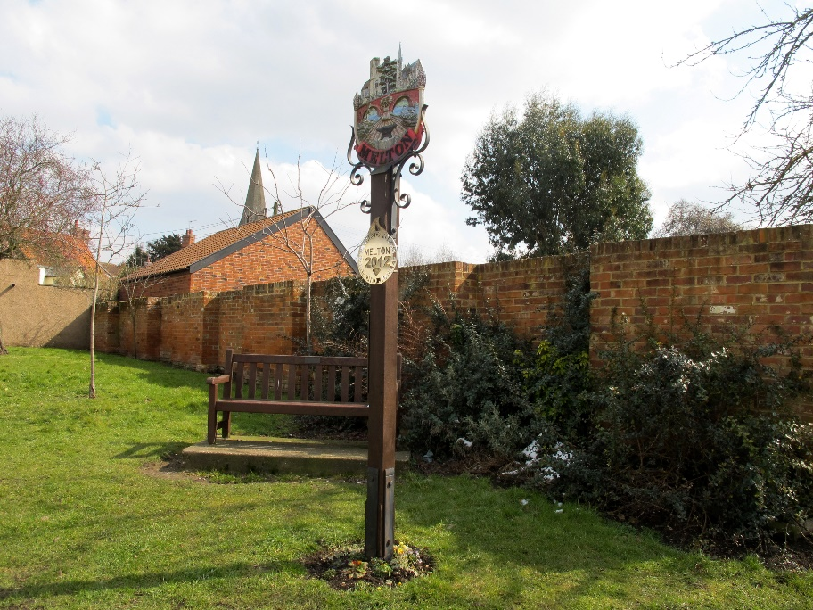

Vision for Melton
- The vision for Melton Parish is as follows:
‘In 2029 the parish of Melton remains a unique place, with its village and important historical and community assets sitting within a sensitive but well protected natural environment. There continues to be a clear separation of the village from Greater Woodbridge. The character of each of the distinct parts of Melton’s built-up area has been retained.
Infrastructure and traffic issues, particularly along the A1152 and Woods Lane, have been managed in conjunction with new development so that no further pressure is put on already very busy key roads and densely built areas. Improvements have been made to pedestrian and cyclepaths so that there are genuine alternatives to the private car for getting around Melton.
Small and sensitive development of local commercial and retail businesses have been encouraged, which sit appropriately in the context of Melton’s village environment. Employment areas at Wilford Bridge, Deben Mill and off Melton Road are thriving.
The community facilities serving Melton have been protected and improved, particularly at the Playing Fields on Melton Road where the new Village Hall has provided a focus for community activities. In addition, new allotments, a community orchard and a community farm have provided a range of quality green spaces that have supported the growing population and galvanised Melton’s community spirit. Now a large number of groups and events are able to draw the community together and provide activities for both young and old.’

Objectives of the Neighbourhood Plan
- The objectives of the Neighbourhood Plan as identified through engagement with the community are as follows:
- Objective One: Ensure that development does not worsen the detrimental impacts of traffic congestion (including air quality and safety) along the main routes in Melton, whilst encouraging safe movement on foot and by bicycle.
- Objective Two: Ensure that development provides for the infrastructure needs of Melton and does not breach the capacity of the parish’s infrastructure to properly support the population.
- Objective Three: Protect and enhance the unique environment and heritage, particularly the rural, riverside and historical assets of Melton and its streetscape.
- Objective Four: Preserve the respective roles and identities of the different built-up areas within the parish, specifically Melton village (including its shops and services) and the northern part of the ‘Greater Woodbridge’.
- Objective Five: Protect and enhance the strengths of Melton as a community, in particular through the retention and provision of community infrastructure.
- Objective Six: Protect Melton’s business base and seek to ensure that it can grow and thrive.

physical limits boundaries
- It is important that development within the plan area is directed to appropriate locations and that sprawl is avoided. The purpose of boundaries defining the ‘physical limits’ of development is to help to provide that direction.

Policy justification
- The Melton Neighbourhood Plan area has two built up areas with physical limits boundaries:
- The southern part of the Neighbourhood Plan area falls within the boundaries of Woodbridge Town.
- Immediately to the north of this is the area covered by Melton Village.
- Woodbridge Town is identified in Strategic Policy SP19 of the Suffolk Coastal Local Plan as a market town in the wider district’s settlement hierarchy which is a “focal point for employment, shopping and community facilities” and “a transport hub”. Strategic Policy SP26 articulates a strategy for Woodbridge Town which, amongst other things:
- “retains the quality of the built environment and the character of the riverside and estuary;
- experiences appropriate growth on a range of sites across the town;
- represents an attractive ‘gateway’ into the Area of Outstanding Natural Beauty where the scale of new development and standard of design reflects that function, particularly at Melton.”
- Strategic Policy SP26 goes on to note that “further significant expansion of Woodbridge (and Melton) will be sympathetically considered having regard to the local character and key physical thresholds.”
- Melton Village is identified in Strategic Policy SP19 of the Local Plan as a Key Service Centre which should “provide an extensive range of specified facilities”. Strategic Policy SP27 states that, amongst other things, such centres should:
- “permit housing development within defined physical limits or where there is proven local support in the form of small allocations of a scale appropriate to the size, location and characteristics of the particular community.”
- The Suffolk Coastal Local Plan refers to the fact that ‘physical limits boundaries’ will be defined for each settlement. This includes these various settlement areas in Melton parish and it is the role of the Neighbourhood Plan to define this.
- Over the plan period it is expected that additional growth will come from infill development on small windfall sites within the physical limits boundaries, as directed by the strategic policies in the Local Plan.
- Outside of the physical limits boundaries in the open countryside, development is more restricted. This is led by Suffolk Coastal Local Plan Policy DM3 (Housing in the Countryside) which states that only the following types of development will be permitted:
“(a) Workers’ dwellings for agricultural, forestry and other rural-based enterprises which satisfy the criteria set out in Annex A of national policy PPS7;
(b) Replacement dwellings on a one to one basis where they are no more visually intrusive in the countryside than the building to be replaced;
(c) The sub-division of an existing larger dwelling where this would meet a local need;
(d) Affordable housing on ‘exception’ sites in accordance with policy DM1;
(e) Conversions of existing buildings subject to certain controls (Policy DM13); and
(f) Minor infilling within clusters of dwellings well related to existing sustainable settlements (Policy DM4).”
- The physical limits boundary includes sites that have planning permission which is capable of being implemented, e.g. the land next to Potash Cottage on Woods Lane.

POLICY MEL1: PHYSICAL LIMITS BOUNDARIES
Development in the Melton neighbourhood plan area shall be focused within the physical limits boundaries as identified in the plan.
Development proposals will be supported within the physical limits boundary subject to compliance with other policies in the development plan, particularly:
- Strategic Policy SP19 of the Suffolk Coastal Local Plan in respect of the Woodbridge Town physical limits and the Melton Village physical limits; and
- Strategic Policy SP26 of the Suffolk Coastal Local Plan in respect of the strategy for Woodbridge, incorporating the built-up areas within the Melton neighbourhood plan area; and
- Strategic Policy SP26 of the Suffolk Coastal Local Plan in respect of the strategy for Key and Local Service Centres;
- Strategic Policy SP28 of the Suffolk Coastal Local Plan in respect of the Melton Park physical limits.
Development proposals outside the physical limits boundary will not be permitted unless:
- They relate to the site allocated in Policy MEL21; or
- they are in accordance with Suffolk Coastal Local Plan Strategic Policy SP29 and Policy DM3; or
- they relate to necessary utilities infrastructure and where no reasonable alternative location is available.

transport and movement
- Movement around Melton parish and connectivity with the surrounding areas, particularly Woodbridge Town and the Deben Peninsula to the east, are key issues of concern to the community of Melton.
- In particular, traffic congestion on Woods Lane is a significant issue. Woods Lane is a key link between the A12 and the communities on the Deben Peninsula. Its route through Melton village causes considerable congestion, particularly at peak periods. This not only makes movement for local residents difficult but it has a detrimental impact on the identity of Melton as a village. The 2015-consented residential scheme for up to 180 dwellings at the top of Woods Lane is going to put considerable additional traffic onto this route if it is developed.
- The Neighbourhood Plan cannot actively reduce the levels of traffic using Woods Lane. What it does seek to do is manage the growth in Melton effectively so that it minimises additional traffic and also seeks to promote improved movement by non-car modes through Melton village and into Woodbridge Town. It is noteworthy that over one-quarter of respondents to the Neighbourhood Plan survey cited proximity to Woodbridge as a reason why they live in Melton. Assisting movement on foot and by bicycle between Melton and Woodbridge is therefore a key priority for the Neighbourhood Plan, as is increasing movement by public transport.

Key issues
- From the Neighbourhood Plan survey and engagement events, the key issues are summarised as follows:

Road congestion and associated impacts
- Peninsular traffic all comes through Melton on the A1152 over Wilford Bridge, across railway, through traffic lights and up to Woods Lane roundabout. There is currently no other sensible route for this traffic including any from Rendlesham and Bentwaters (which includes HGV's). A specific pinchpoint is the junction with Bredfield Road.
- Traffic coming from the Wickham Market direction wanting to access A12 has to currently drive through Ufford and Melton (traffic lights) which at peak times can create a big tailback.
- Air pollution from traffic – pollution readings are high on The Street in Melton by the traffic lights and, just outside the Neighbourhood Plan area, at the traffic lights on Lime Kiln Quay in Woodbridge.
- These issues will be exacerbated by further planned development. In particular, the potential Woods Lane development of 180 houses has only one access point onto Woods Lane, directly opposite the already very congested Bredfield Road junction.
- Potential impact of Sizewell C traffic during build phase over several years, if this goes ahead.
- Saddlemakers Lane used as a rat-run when traffic builds up elsewhere and as a narrow lane with high sided sharp bends it is not suitable for HGV's, driving at speed or large volumes of traffic. There have been many minor collisions recently especially on the bends.

Pedestrian safety
- Pedestrians feel unsafe due to lack of adequate footpath provision - pavements are narrow. This is particularly the case when walking along Woods Lane, The Street, Station Road, Melton Road and Yarmouth Road, as well as outside St Andrews Church.
- Significant difficulties have been reported in trying to cross Woods Lane in the vicinity of Bredfield Road.

Cycling
- The need for cycle lanes particularly to Farlingaye School which is a destination with a very high proportion of existing cyclists. Similarly, improved cycle links to Melton railway station are required.

Buses
- Bus services need to be more frequent and run later in the day to and from St Audrys, as well as linking up with the Park-and-Ride at Martlesham. Along with this is a need for better advertising of routes and timetables at bus stops and for more shelters and bus stops.

Parking
- More parking in required generally, with a particular pinchpoint being outside the McColls convenience store.
- Parking on both sides of Melton Road up to Melton Hill. This can make it difficult for passing traffic, especially when a larger vehicle (bus or HGV) is on one side.
- Along with these issues, the relocation of Suffolk Coastal District Council’s headquarters from Melton Hill to the former Girdlestones site is likely to have a more direct impact on Melton village in terms of traffic and potentially parking.

Pedestrian and cyclist networks
- There is concern amongst the community of Melton for the safety of pedestrians and cyclists. With the high levels of traffic movement on many of the main through-routes, access on foot and by bicycle can be unsafe at particular points. This also causes a certain degree of rat-running along minor roads which results in vehicles moving at excessive speeds.
- At present there are a significant number of cyclists in Melton. The Neighbourhood Plan survey revealed that over four in 10 respondents are cyclists. By contrast, approximately half of them do not feel safe when they cycle.
- On a similar theme, over one-third of survey respondents said they did not feel safe walking in Melton.
Vehicles creating an unsafe environment for pedestrians, Woods Lane
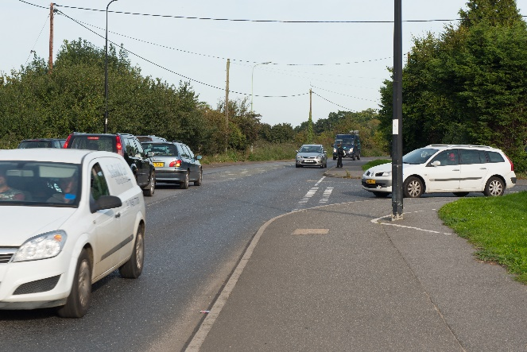

Woods Lane/Wilford Bridge Road
- Woods Lane/Wilford Bridge Road is the main route through the parish, linking the residential areas immediately to the east of the A12 with Melton Village. Given their proximity, this is a key route where improvement of pedestrian and cycle access between the residential areas and the village centre and railway station will serve to reduce local vehicular movements.

- For pedestrians, there is a need for a pedestrian/cycle crossing of Woods Lane to the east of the junction with Bredfield Road. This will link up the footway from the residential area to the footway leading in to Melton Village. In addition, this will serve to stop westbound traffic along Woods Lane, so enabling traffic from Bredfield Road to be able to turn right onto Woods Lane. This is a regular pinchpoint at peak times and this route is a key one for many students wishing to walk or cycle to Farlingaye School.
- The existing footpath on the north side of Woods Lane is directly adjacent to the roadway which has high volumes of traffic often travelling at significant speeds. This discourages many people from walking into Melton Village, a point raised in the Neighbourhood Plan survey by a significant number of people. The same principle applies to cyclists that are forced to share the roadspace with motorists. If the existing footway, as well as land behind the hedge to the north of Woods Lane, was utilised for a footway/cycleway which could be separated from the roadway, this would make walking and cycling to and from Melton Village much safer and more appealing.

Access to Melton Railway Station
- In addition, the cycleway along the north side of Woods Lane should be continued along Wilford Bridge Road to Melton Station. This is a key interchange for local residents and improving dedicated cyclepaths directly to the station will reduce the number of car trips made by passengers using the station. Widening of the existing footway will enable this.
- A footway/cycleway could be provided off the carriageway of Wilford Bridge Road on the south side. Again, widening of the existing footway will enable this.
- A pedestrian/cycle crossing in the vicinity of the station would assist those wishing to cross to Station Road and also would serve to slow the traffic. Such a facility is due to be provided as part of the package of measures supporting the development of the new Suffolk Coastal District Council headquarters at the former Girdlestones site.

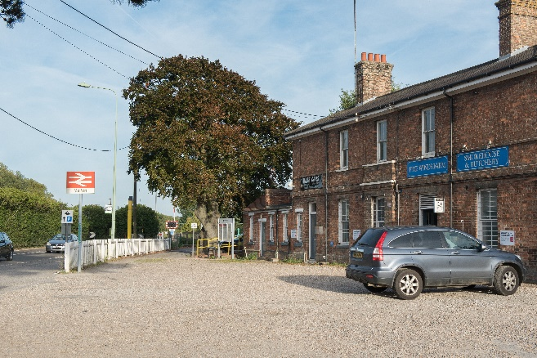

The Street
- The Street (B1438) is a key road serving Melton Village. On it is located a number of local services, including the local convenience store (McColls). As such, this is an area where there a number of pedestrians yet at the same time it is a B-road that has a high volume of traffic using it. In order to make it safer for pedestrians, traffic calming could be introduced. By narrowing the roadway it would also be possible to facilitate the improvement of cycle movement along this route.

Melton Road
- For pedestrians looking to travel into Woodbridge Town footway access is an issue because it requires the crossing of Melton Road. A zebra crossing near the junction of Melton Road and the top end of Turnpike Lane would assist pedestrians and cyclists whilst giving better visibility. Parking bays could be marked out along Melton Road to accommodate some of the displaced vehicles.

POLICY MEL2: DEDICATED PROVISION FOR CYCLISTS AND PEDESTRIANS
Proposals to provide dedicated and improved access for cyclists and pedestrians will be encouraged.
In particular, the following will be strongly supported:
- provision of a dedicated footpath/cyclepath along the north side of Woods Lane eastwards from the junction with Bredfield Road to the junction with Hall Farm Road; and
- provision of a dedicated pedestrian/cycle crossing point of Woods Lane, just to the east of the junction with Bredfield Road; and
- provision of dedicated footpaths/cyclepaths along the south and north sides of Wilford Bridge Road from the junction with Melton Road to Melton Railway Station; and
- a dedicated crossing point where the footway/cyclepath along Woods Lane/Wilford Bridge Road switches from the north side to the south side; and
- traffic calming measures to be provided in The Street (B1438) with associated provision of dedicated cycle access; and
- traffic calming measures to be provided in Station Road with associated provision of safe pedestrian access to and from St Andrews Church; and
- provision of a dedicated pedestrian/cycle crossing point of Melton Road near the junction with the northern end of Turnpike Lane.

Figure 5.1: Proposals to improve cycling and walking
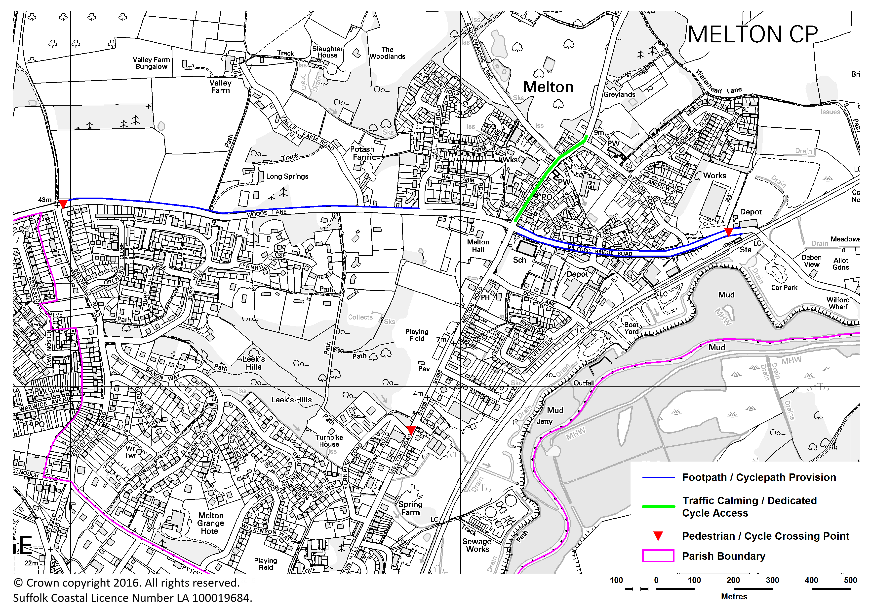

Views from footpaths and cyclepaths
- For many in the community of Melton as well as tourist visitors, the whole point of a footpath or cyclepath is so that the surrounding countryside can be enjoyed. Melton has a rich environment, particularly near the River Deben and in the Area of Outstanding Natural Beauty. Certain recent built developments have failed to preserve these views and so have fundamentally eliminated for many people the very point of having them in the first place.

- It is important that views of Melton’s most valued environmental assets are retained from footpaths and cyclepaths.

POLICY MEL3: VIEWS FROM FOOTPATHS AND CYCLEPATHS
Development proposals will be expected to be designed so that they do not have a significant impact on short distance views of the Area of Outstanding Natural Beauty and, in particular, the River Deben, from any footpath or cyclepath.

Public transport
- As stated earlier, a significant number of people highlighted the quality of the bus service as an issue. In particular the need to improve services to and from St Audrys and the Park-and-Ride at Martlesham Heath were identified as priorities.
- Whilst it is acknowledged that filling gaps in public bus services is costly, community transport services can often provide an effective alternative.
- In addition, improvements were identified as being needed to the provision of bus shelters and to information on timetables and routes at bus stops.
- Suffolk Coastal District Council introduced a Community Infrastructure Levy (CIL) charge in July 2015. Whilst the list of what these funds are to be spent on can be varied, it does not include transport projects such as new bus provision or bus infrastructure. Therefore it is possible to seek provision for such improvements through planning contributions. Alternatively, the share of CIL that is passed to Melton Parish Council can be used to address such needs arising from growth.

POLICY MEL4: BUS AND COMMUNITY TRANSPORT PROVISION
Proposals to provide new bus stops and shelters and improved information along existing bus routes will be supported.
New development proposals that contribute towards improvements in the quality of public and community transport services and/or supporting infrastructure serving the Neighbourhood Plan area will be strongly supported.

- In order to improve non-car movement to Melton Railway Station, particularly by bicycle, it is also important that the provision of bicycle racks is made. As with bus infrastructure, this can be sought either through planning contributions or through the use of CIL funds provided to the Parish Council.

POLICY MEL5: MELTON RAILWAY STATION
Proposals to provide new bicycle racks and provision for cyclists at Melton Railway Station will be strongly supported.
Proposals to provide dedicated access for cyclists and pedestrians will be encouraged

Parking

Parking standards

Policy justification
- It is considered that, with the levels of residential development in Melton, the increase in levels of car ownership has created significant issues with the levels of on-street parking. In particular, the high proportion of large family dwellings (4 bedrooms or larger) has seen the impact of the growing trend of grown-up children continuing to live in the family home well into adulthood because they are unable to afford to buy their own properties. This serves to increase car ownership as often there are four or more car owners looking to park their vehicles at a single residential property.
- The Census shows that car ownership levels are broadly in line with the district average. However, within the built-up areas of Melton this creates significant issues which it wouldn’t otherwise do in the predominantly rural areas of the district as a whole.
- Suffolk County Council Parking Guidance requires future parking designs to accommodate safe passage of highways users, including emergency services vehicles.
- Nevertheless, for the community of Melton, it is imperative that new development does not recreate and exacerbate the situation of unacceptable levels of on-street parking. New residential units will be expected to provide off-street parking based on the size of dwelling in question. This will help to underpin the Suffolk County Council guidance.
- It is also considered that there should be no reduction of existing parking provision, either off-street or on-street, unless it can be appropriately re-provided.
POLICY MEL6: PARKING STANDARDS
For new residential developments (Use Class C3), the following minimum parking standards shall apply for the provision of off-road parking:
- 1-bed house/flat 1 off-road car parking space
- 2-bed house/flat 2 off-road car parking spaces
- 3-bed house/flat 2 off-road car parking spaces
- 4-bed house/flat 3 off-road car parking spaces
- 5+ bed house/flat 4 off-road car parking spaces
Development that results in the loss of existing off- or on-street parking will generally be refused. The loss of any such spaces will only be permitted if at least the same number of parking spaces can be re-provided in the immediate proximity of where the spaces would be lost.
The provision of unallocated/visitor parking spaces and cycle parking spaces will be in addition to this and are expected to follow the Suffolk Advisory Parking Guidance.
All other types of development are expected to follow the Suffolk Advisory Parking Guidance.

Parking on The Street

Policy justification
- McColls convenience store on The Street is a key service for Melton Village. A little further along The Street are two take-away establishments. By their very nature, trips to these shops are often short and are simply to pick up one or two items. For motorists this often results in illegal parking and associated safety issues for other motorists, cyclists and pedestrians.
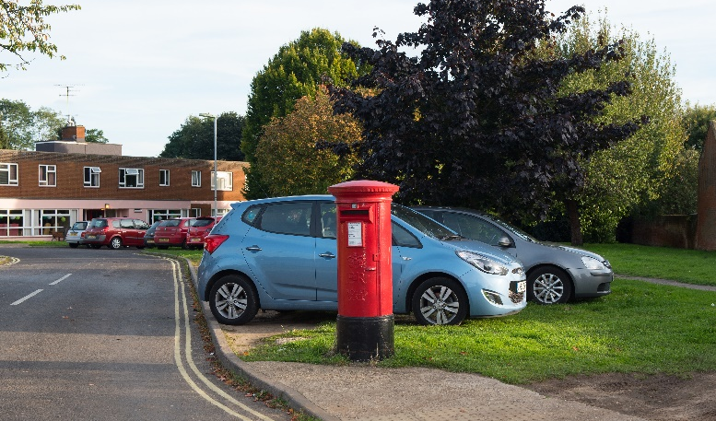

- There is an existing grassed area opposite McColls that could provide more parking bays for users of these shops. This also creates the opportunity for the remaining land to be re-landscaped with, for example, a low fence, trees and benches.

POLICY MEL7: LAND OPPOSITE McCOLLS CONVENIENCE STORE, THE STREET
Proposals for the provision of parking spaces and associated seating and landscaping on land opposite McColls convenience store, The Street, will be strongly supported.

community infrastructure
- This section seeks to address the provision of a range of infrastructure that the community considers is important. This consideration is both of existing shortfalls in provision that should be addressed and also of additional needs arising from growth in the population.

Retention of community facilities

Policy justification
- The community facilities within Melton, including local shops, are an important lifeline for many of its residents. This enables a range of activities and services to be run which are important for people’s wellbeing. The Neighbourhood Plan process reinforced the importance of protecting what Melton has. Therefore, the loss of an existing community facility to an alternative use will be strongly resisted. It may be possible for the community facility in question to be re-provided as part of a proposed development. However, this would have to provide the facility to at least the size and standard that it previously was and must be provided upfront as part of any development. This ensures that there is not a lengthy period between the demolition of the existing facility and its re-provision. The issue of the phasing arrangements between the availability of a new facility and the closure of the existing facility and the associated redevelopment of the site will be expected to be addressed either in a unilateral undertaking or a Section 106 agreement.
- Melton has recently lost an important community facility, The Lindos Centre having been sold. Throughout the community engagement to inform the Neighbourhood Plan, The Lindos Centre was identified as a key facility for Melton. It provided a place for sport, classes, events, meetings and other recreational activities. It was also, for a long time, the office for the Parish Council. The loss of other such facilities would be significant and therefore makes Policy MEL8 very important.
- This supports Local Plan Development Management Policies DM30 (Key Facilities), DM31 (Public Buildings) and DM32 (Sport and Play) but seeks to ensure that all types of community facility, in its broadest definition, are adequately protected and provided for. In other words, it protects all types of facilities and space that are provided for the benefit and enjoyment of the community.

POLICY MEL8: RETENTION OF COMMUNITY FACILITIES
Proposals that would result in the loss of community facilities, including small scale retail facilities (A-Class), will not be supported unless appropriate re-provision is made. Such re-provision will be required to demonstrate that the replacement facility is:
- At least of an equivalent scale to the existing facility; and
- is in a generally accessible location to the community of Melton;
- and is made available before the closure of the existing facility.
Proposals for new and/or improved community facilities will be supported subject to the following criteria:
- the proposal would not have significant harmful impacts on the amenities of surrounding residents and other activities; and
- the proposal would not have significant harmful impacts on the surrounding local environment; and
- the proposal would not have unacceptable impacts on the local road network; and
- the proposal would provide appropriate car parking facilities; and
- the proposal is located within or immediately adjacent to the physical limits boundaries as defined in Policy MEL1.

Provision of community facilities

Playing Fields, Melton Road
- Engagement with the community to inform the preparation of the Neighbourhood Plan highlighted how much the community of Melton values the playing fields on Melton Road. This is a key hub providing open space for formal and informal recreation, children’s play facilities and a village hall.
The existing pavilion
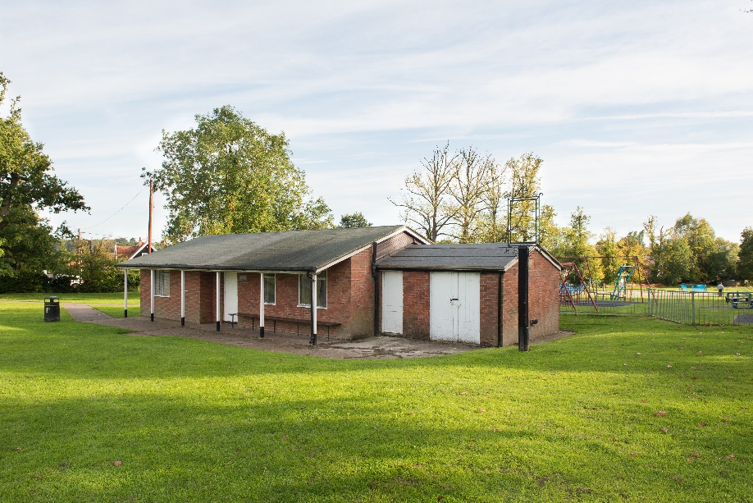

- Two main improvements were suggested to help support the users of this facility:
- The replacement of the existing pavilion with a modern village hall which incorporates public conveniences, a café and changing rooms for formal sports recreation users of the playing fields
- Outdoor gym equipment for people of all ages
- Creating a community centre in the form of a Village Hall close to a pub (the Coach & Horses) and to one of the shops (‘Springside’), along with the adjacent recreational facilities, will establish a hub of community activity in that location.
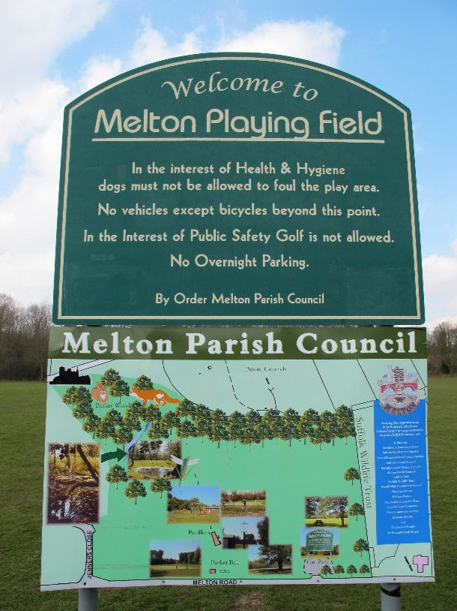

- The development of the new village hall would use the existing pedestrian and vehicular access off Melton Road to the playing field and the existing car park (enlarged and extended as required to provide a suitable number of parking spaces). The new building could then be located to the immediate north of the parking area. It will be important that the layout and design of development carefully considers the impact on any protected trees.
- Key requirements in terms of the new building are:
- It should be fully accessible to all in the community
- Its architectural style should be in keeping with its surroundings
- Its running and operating costs should be as low as possible
- It should be constructed of materials that are hard wearing and inexpensive to maintain
- It should meet the needs of potential users in a range of activities
- It should be flexible enough to meet the needs of a growing community
- It should be adaptable enough to meet changing requirements in terms of community use
- Its design should promote inclusivity and community cohesion by meeting the needs of all age groups and sections of society.
- The key requirements of the facility are as follows:
- A multifunction hall (seating up to 100 people for a formal meal and up to 150 in a lecture format)
- The hall should be provided with a stage, of modest but adequate proportions for amateur productions and stage lighting
- An underfloor heating system with flexibility to cater for diverse activities
- A fully fitted kitchen equipped and large enough for commercial catering fitted out accordingly. There should be a hatch through to the hall with provision for it to be used as a bar
- Adequate provision of WCs (including disabled) to meet potential user numbers at large events, together with baby changing facilities
- An entrance hall, with provision for notice boards for parish and club use, together with a cloakroom, and Hall Administrator’s office/reception facility
- One large meeting room (up to 30 people in a boardroom format)
- Two small meeting rooms (10/15 people)
- A Parish Council office (to accommodate 2-3 staff)
- Cycle rack
- Parking for between approximately 60-80 vehicles
- For both cost and sustainability the hall should be built to the highest energy conservation standards, with optimal use of natural lighting and heating from solar gain. In particular the multi-use hall will require flexibility in heating arrangements, so that some uses can benefit from higher levels of heating (e.g. conferences, seminars) than others (e.g. exercise classes). The building will need to be constructed in such a way as to possess very sound acoustics for both speech and music. All ground floor areas shall have full disability access. There is the potential for a second storey to accommodate meeting rooms, subject to impact on the amenity of neighbours. The building should ideally be constructed in such a way as to enable expansion at a future date.
- Contributions from development will be used to support the funding of these improvements, along with grant funding from sources such as the Heritage Lottery Fund, Suffolk Coastal District Council and Suffolk County Council. Suffolk Coastal District Council intends to put in place a Community Infrastructure Levy (CIL) charge which will ensure that 25% of all contributions from development from within the parish will go directly to Melton Parish Council to spend on such improvements.

POLICY MEL9: PROVISION OF COMMUNITY FACILITIES AT THE PLAYING FIELDS, MELTON ROAD
The provision of the following community facilities at the playing fields, Melton Road, will be strongly supported:
- Removal of the existing pavilion and development of a new village hall, incorporating:
- a main hall,
- three meeting rooms,
- an ancillary office, kitchen and WCs
- an ancillary café,
- changing room facilities
- appropriate levels of on-site parking provision
- the retention, where possible, of protected trees
- Outdoor gym equipment suitable for the needs of people of all ages

Allotments/Community Orchard
- There has been strong support for additional allotment land to be found in Melton. There are regular enquiries to the Parish Council regarding the availability of new allotment plots and the Neighbourhood Plan Questionnaire showed a significant number of people would be very keen on obtaining space for more allotments locally.
- In addition to this there has been a great deal of support for a community orchard.

Pitstop Community Farm
- Pitstop is an After-School and Holiday Club for 4-12 year olds which is currently located on the Hall Farm Estate in Melton. This highly regarded and valuable community asset is currently looking at moving to a new location in Melton where they will be able to continue running as a club but also add a community farm to the facilities on offer. The Parish Council has always strongly supported Pitstop and it has a great deal of local community support. Its relocation and expansion would be of great benefit to the community as a whole.
- There are proposals to relocate the allotments and orchard to a site on Saddlemakers Lane. The community farm project is proposed to be delivered on the land off Wilford Bridge Road as part of the site allocation in Policy MEL21. This would also incorporate the After-School and Holiday Club.

POLICY MEL10: PROVISION OF ALLOTMENTS, COMMUNITY ORCHARD AND A COMMUNITY FARM/EDUCATIONAL FACILITY
The provision of the following community facilities will be strongly supported:
- Further allotment space
- A community orchard
- A new location for ‘Pitstop’ and its expansion to include a community farm, preferably as part of the land off Wilford Bridge Road (Policy MEL21)

- Local Plan Policy DM33 already provides support for these policies.

environment
- Melton Parish, located on the River Deben, has a sensitive natural environment. A large part of the parish is designated as an Area of Outstanding Natural Beauty (AONB) which emphasises this.
- The community of Melton wants to protect these environmental assets that define the setting of Melton. At the same time it is important to retain the key green space into the built-up area which provide an formal alternative recreation space to the natural green spaces outside the built-up area.

Special Landscape Areas
- Suffolk Coastal Local Plan Saved Policy AP13 (Special Landscape Areas) protects areas within Suffolk with special landscape attributes, which are particularly vulnerable to change. They include some river valleys which still possess traditional grazing meadows and marshes, with their hedgerows, dykes and associated flora and fauna and Historic Parklands.
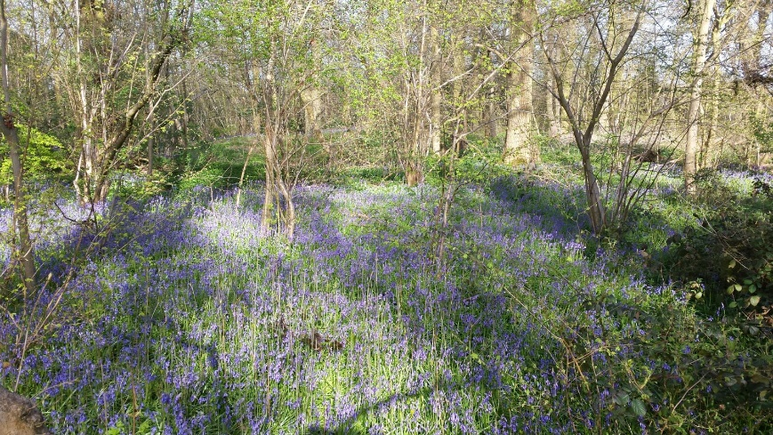

- The River Deben is one such Special Landscape Area which requires protection and the Neighbourhood Plan retains this policy.

POLICY MEL11: SPECIAL LANDSCAPE AREAS
The valleys and tributaries of the River Deben, as show on the Proposals Map, are designated as a Special Landscape Area. Development proposals must ensure that no development will take place which would be to the material detriment of, or materially detract from, the special landscape quality.

Local Green Spaces

Policy justification
- Under the NPPF, Neighbourhood Plans have the opportunity to designate Local Green Spaces which are of particular importance to them. This will afford protection from development other than in very special circumstances. Paragraph 77 of the NPPF says that Local Green Spaces should only be designated:
- “where the green space is in reasonably close proximity to the community it serves;
- where the green area is demonstrably special to a local community and holds a particular local significance, for example because of its beauty, historic significance, recreational value (including as a playing field), tranquillity or richness of its wildlife; and
- where the green area concerned is local in character and is not an extensive tract of land.”
- Whilst there are many smaller green spaces that create an open setting to some of the estates that have been developed, these do not fulfil all of the criteria of the NPPF. The only areas that do are:
- the playing fields on Melton Road
- Hall Farm play area
- St Andrews play area
- Hospital Grove woodland

Playing Fields, Melton Road
- This is the main public area that the community of Melton can congregate for informal and formal leisure pursuits. For this reason it is considered to be of considerable importance to the community and the engagement process showed a strong desire to retain it for this purpose.
Playing Fields, Melton Road
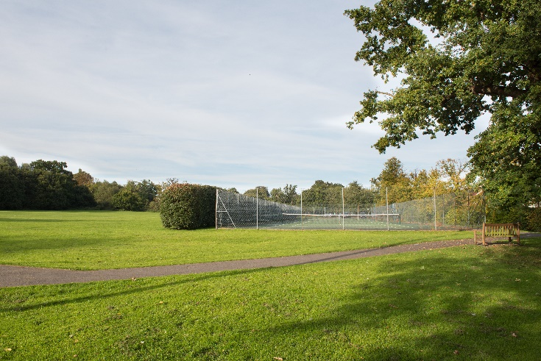

Hall Farm play area
- This play area is owned by SCDC and was provided as part of the section 106 agreement for the Hall Farm development. It is used as a play space by the many children who live on the estate and is the only open public space for them. It is also used for community activities, for example the Fun Day organised by the residents with the support of their housing association, Flagship Housing.
- It is very important to the residents as the playing fields on Melton Road are too far and unsafe for young children to access alone. It is also provides an essential meeting place and amenity for the community.
Hall Farm play area
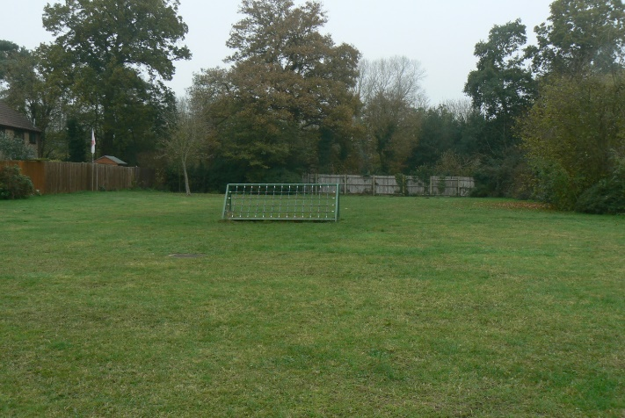

St Andrews play area
- It is owned by Flagship Housing and was provided as part of the section 106 agreement for the St. Andrews development.
- It is important as a play space used by the many children who live on the estate as it is the only public open space suitable for them due to traffic and parking issues on the roads.
St Andrews play area
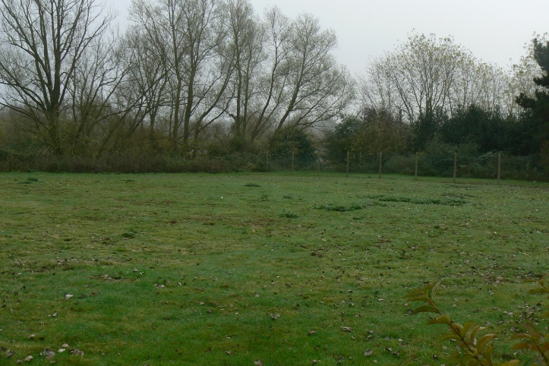

Hospital Grove woodland
- Hospital Grove is a valuable ancient woodland, rich in wildlife, covering approximately six hectares in the grounds of Melton Park, previously St. Audry’s Hospital.
- Cherished by residents, the woodland is considered to be more than four centuries old and offers high biodiversity for the naturalist.
- Hospital Grove is under the collective ownership and responsibility of the Melton Park Management Company Limited (MPMCL) with a board comprising volunteers from among the residents. The company is accountable for regular maintenance and conservation of the woodland and to provide safe and enjoyable access via waymarked paths.
- The woods are home to some of East Suffolk’s scarce and declining species of birds such as marsh tit, goldcrest, nuthatch and treecreeper. Historically sparrowhawks bred in the canopy treetops and current breeding species include Tawny owls and both great-spotted and green woodpeckers, also regular summer migrant species like blackcap and chiffchaff.
- A variety of mammals have been observed in Hospital Grove, including grey squirrel, muntjac deer, red fox, wood mouse, yellow-necked mouse, bank vole, common shrew and hedgehog.
- MPMCL has put in place a sustainable woodland management plan. Regular coppicing and maintenance by contractors ensures the health of the trees and all significant trees are covered by tree preservation orders. Trees in Hospital Grove include oak, ash, sycamore and wild cherry with an understorey made up of a scrub layer with hazel coppice, holly, field maple and encroaching bramble.
- Ground flora is extensive with a strong biodiversity of native woodland species such as yellow archangel. In early spring lesser celandine, dog violet, wood anemone and primrose can be seen. In April there is a wonderful carpet of bluebells and a display of early purple orchids.
- The woods are enjoyed by residents and local people alike, however there are pressures facing the woodland environment. Frequent visitors trampling underfoot can damage the herb layer and there is a risk that planning proposals to develop an adjacent site into a football complex could have a detrimental impact on the conservation and amenity value of this ancient woodland.
Hospital Grove woodland
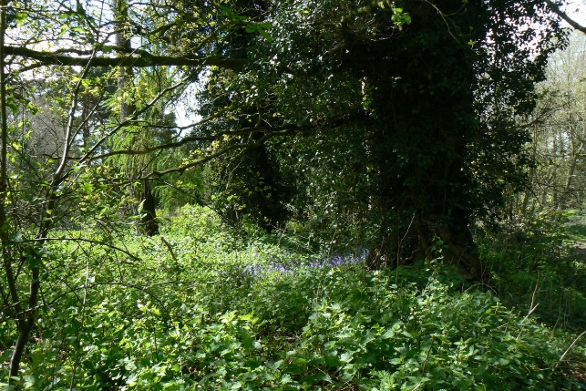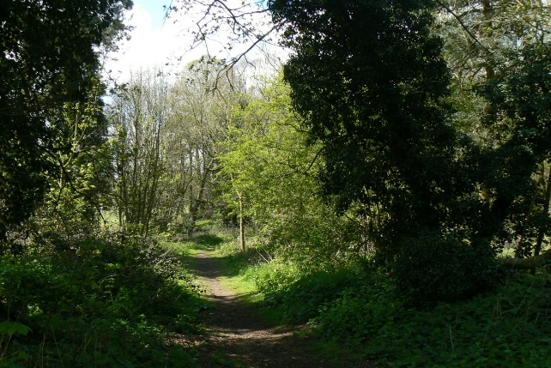

POLICY MEL12: PROTECTION AND MAINTENANCE OF LOCAL GREEN SPACES
The following areas shown on the Proposals Map are designated as a Local Green Spaces:
- Playing Fields on Melton Road
- Hall Farm play area
- St Andrew’s play area
- Hospital Grove woodland
Proposals for built development on these Local Green Spaces will not be permitted unless:
- the proposal is of a limited nature and it can be clearly demonstrated that it is required to enhance the role and function of an identified Local Green Space; or
- the proposal would result in the development of local community infrastructure as required by Policy MEL9.

Protection of trees and rural character
- Suffolk Coastal Local Plan Saved Policy AP237 (Melton – protection of tree cover) recognises the area forming the natural gap between the edge of the built-up part of Woodbridge and Melton village contains numerous trees and woodlands which, together with the undulating landform, are important components of distant views of the town from the AONB and elsewhere. Overall, the impression is one of an attractive, green backcloth.
- Even though quite large-scale development has taken place in this area, there are parts which still retain a significant proportion of trees, or retain their rural character, such as the grounds of Melton Grange and, in particular, the land around Melton Hall. The grounds of Melton Hall and properties adjacent to it, including the recreation ground, form part of the rural quality of the approach to Melton and separate it from the built-up part of Woodbridge. Development here would be detrimental to the overall character and cause further undesirable coalescence of the two communities. Woods Lane is also very rural in character and any new accesses onto it would, with resulting visibility splays and loss of trees, seriously damage the overall appearance.

- Elsewhere within the area, it is essential that remaining natural features should be retained and new landscaping carried out. In order to protect existing trees, extensions to the existing Tree Preservation Orders may be necessary.

POLICY MEL13: PROTECTION OF TREES AND RURAL CHARACTER
The area bounded by Woods Lane, Melton Road, Pytches Road and Bredfield Road, as shown on the Proposals Map, retains its rural and wooded character, and separates Melton Village from Woodbridge. Within this area there are parts where no further development will be permitted because of:
- their important contribution to the setting of Woodbridge and Melton, particularly from distant views;
- the need to preserve their natural features;
- their wildlife importance;
- their importance as settings for listed buildings;
- their rural character;
- the need to prevent the coalescence of Woodbridge and Melton Village;
- the need to preserve that part of the area within the designated Conservation Area.
Proposals for development must ensure that the design, density, scale and layout of any new development will not prejudice the protection of important trees and open spaces, and they will require additional tree planting and other landscaping where appropriate.

Retention of riverside qualities
- The environment of different parts of the riverside varies greatly and activities which would be damaging in one area may be entirely acceptable in another. There are also a number of conflicting demands being exerted within the area which need to be reconciled, including those of water-based recreation and other recreational pursuits - walking, for example; the need to conserve the area's outstanding landscape quality within the AONB and the need to preserve the river's attributes as a natural wetland habitat (recognised by its designation as an SSSI).
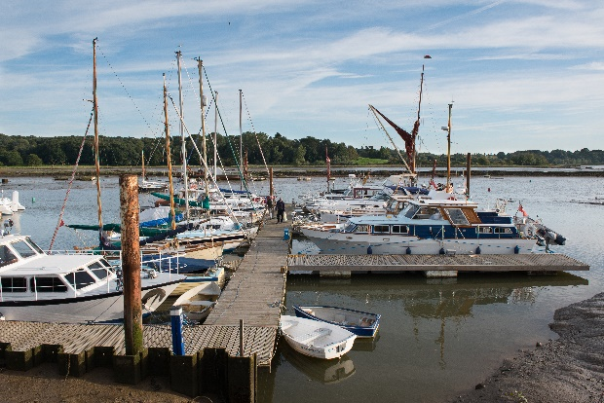 | 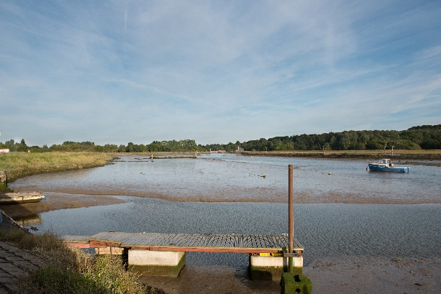

- With the development of the Tide Mill Yacht Harbour and the gradual build-up of craft in the Ferry Quay area, the character of this part of the riverside, moving north into the Melton Neighbourhood Plan area, has changed significantly in recent years. It takes its character not only from the river and riverside buildings, but also, from its setting, including attractive marshland lying between the river wall and the railway line. It will be most important to ensure that the gradual erosion of this traditional setting is stemmed.

POLICY MEL14: RETENTION OF RIVERSIDE QUALITIES
There will be a presumption against further expansion of riverside development into the areas shown on the Proposals Map.

Residential boats
- The term ‘residential boats’ is widely used, particularly by British Waterways to denote all manner of craft used as a ‘primary or temporary residence’. It is a more appropriate term than the more familiar ‘houseboat’ on the River Deben, since it acknowledges the high proportion of craft that are navigable and, in order to comply with their licence agreements with landowners, must remain so. However, just as houseboats, these are ‘floating decked structures without a permanent foundation that have been designed or adapted for use as a primary or secondary residence’ and vary in dimension, type and seaworthiness.
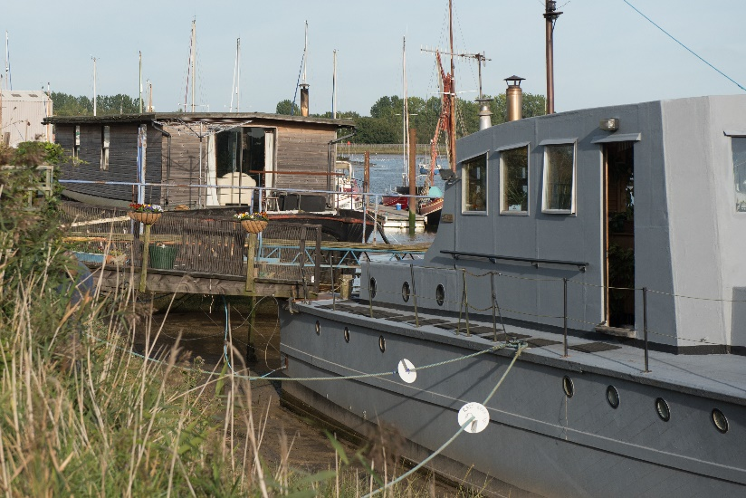

- At Woodbridge and Melton, a number of residential boats are moored alongside the stretch of river wall between Wilford Bridge at Melton and Sun Wharf in Woodbridge, both areas being within the AONB.
- A proliferation of residential boats in various states of repair and the associated facilities on the river wall, has an adverse impact on the area, which has been given national recognition for its landscape qualities. These boats do not have the benefit of planning permission and any application for consent would normally be refused, in accordance with long-established policies to resist development in the open countryside.
- Clearly, the presence of residential boats in this sensitive location runs contrary to the Neighbourhood Plan’s objectives for the protection of the countryside. However, as was recognised in Suffolk Coastal Local Plan Saved Policy AP241 (Woodbridge & Melton – houseboats), there may be other mitigating circumstances to take into account; the fact that a number of houseboats have been established for some years, they are the sole residence of the occupiers, and enforcement may merely move the ‘problem’ elsewhere. However, these factors should not be used as a precedent to allow further houseboats or very recent arrivals to become established.
- It is therefore considered appropriate to retain the wording of Saved Policy 241 which is in line with Appendix 3 of the Deben Estuary Plan 2015 which provides guidelines on residential boats on the Deben Estuary. Specifically, it states that:
- residential boats should not have a negative impact upon the natural environment and should respect the unique habitat within which they are situated; and
- areas of mixed moorings which include residential boats should still retain the open feel of the river, maintaining wide views across the estuary for, not only residential boat owners, but other residents and visitors to the river.
- These will be important considerations in assessing whether new residential boats (or applications for existing ones) would result in, or perpetuate, serious visual intrusion.

POLICY MEL15: RESIDENTIAL BOATS
Planning permission for the mooring of additional residential boats on the section of the River Deben between Wilford Bridge and the boundary of the Neighbourhood Plan area in the direction of Sun Wharf at Woodbridge will not be granted, and where planning permission falls to be considered for existing ones it will not be granted where it would result in, or perpetuate, serious visual intrusion.

heritage and character

Conservation Areas
- The Melton Conservation Area is extensive and protects not only the heritage value of Melton village but also an extensive area of largely open countryside to the north of the village incorporating Saddlemakers Lane, Lodge Farm Lane and Yarmouth Road. The Melton Conservation Area Appraisal Supplementary Planning Document 2010 notes that:
“…the principle aims of conservation area designation are to ensure that the surviving special qualities of the village are retained and that in the future, change and development serve only to preserve or enhance the area.”
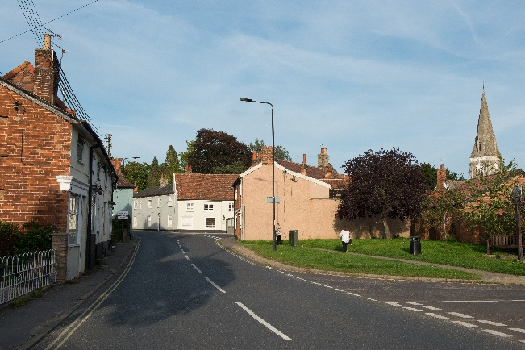
- Suffolk Coastal Local Plan Policy SP15 (Landscape and Townscape) generally seeks to enhance and preserve the attributes of historical and architectural value of its towns and villages. It is considered that more specific guidance is important the help guide development within the Melton Conservation Area.

POLICY MEL16: MELTON CONSERVATION AREA
To protect the character of the Conservation Areas, as shown on the Proposals Map, and to ensure that new buildings, alterations or other development preserve or enhance them, the District Council will, in the control of development within, or affecting, each Conservation Area, pay special attention to the following matters:
- the building materials used, to ensure that they are consistent with the general character of the area;
- the form, scale, design and detailing of new buildings, alterations to existing buildings, and the space around buildings (including landscape schemes, roads and fencing), which should be in harmony with, and relate satisfactorily to, their surroundings;
- other development, including street furniture, road, footpath and other surfaces, lighting and advertisement displays, should be in keeping with the Conservation Area; wherever practicable, electricity, telephone and other cable systems should be placed underground, or in suitably concealed locations;
- natural features, including trees, should be preserved wherever possible; schemes of landscaping and tree planting will normally be required;
- Supplementary Planning Guidance;
- the traffic implications arising from the proposed development.

Areas to be protected from development
- Suffolk Coastal Local Plan Saved Policy AP28 (Areas to be protected from development) rightly recognises that the inclusion of an area within a physical limits boundary does not mean that it will always be appropriate for development. Such an area may make an important contribution to the setting or character of a town, village or the surrounding countryside in an undeveloped form. It may also be necessary to resist any infilling or development because it would be detrimental to the character, spacing or density of a particular area.
- In ensuring an appropriate level of flexibility within the policy there will be a number of factors to which regard will be given. Notably this will include the scale and location of the proposed development and whether there is likely to be any materially detrimental effect on the character and appearance of a particular area. In this respect, modest extensions or other minor works may be acceptable, so long as they do not violate the overall policy objective.

POLICY MEL17: AREAS TO BE PROTECTED FROM DEVELOPMENT
Development will not normally be permitted where it would materially detract from the character and appearance of:
- those areas identified on the Proposals Map to be protected from development, or further development; and
- other sites, gaps, gardens and spaces which make an important contribution in their undeveloped form to a Town or Village, its setting, character, or the surrounding landscape or townscape.
Outside of the physical limits boundaries of Towns and Villages, the area is defined as Countryside.

Character Areas
- Particular issues raised by the community of Melton are the concern that infill development in particular could serve to inappropriately increase the density of development and harm the character of the neighbourhood plan area.
- Adverse impacts of inappropriate developments can include the following:
- Loss of significance to heritage assets, including impacts on setting
- Loss of the historic village character of Melton
- Changes to the grain and overall density which defines local character
- Loss of amenity, overshadowing, overlooking
- Loss of sunlight/ daylight
- Noise
- Loss of green links/ trees /hedgerows/vegetation
- Visual intrusion
- Visual separation
- Loss of parking
- Difficulties with recycling and waste collections/bin storage
- It is considered important that infill development, whilst generally acceptable within the physical limits boundaries, must be designed so that it sits appropriately within its surroundings. It is acknowledged that, if development is of a different mix of housing, e.g. 2- and 3-bed dwellings in a predominantly 4- and 5-bed dwelling area, then densities may differ slightly. However, it is vital that the design of such developments does not have a negative impact on the amenity of existing residents in the neighbouring properties.
- The objectives of this policy are to ensure that:
- infill development respects the existing street scene; and
- safe and attractive residential layouts are promoted.
- The particular issues that must be considered in demonstrating that a development scheme is acceptable are as follows:
- Plot width – plots must be of sufficient width to allow a building(s) to be sited with adequate separation between dwellings. The width of the remaining and the new plot should be similar to that prevailing in the immediate area.
- Building line – where the established building line of existing dwellings is a feature of the area, new development should respect that building line.
- Visual separation – new dwellings must have similar spacing between buildings to that commonly found on the street frontage. Where houses are terraced the new development should normally adjoin the adjacent property(s).
- Building height – new buildings should reflect the height of existing buildings. Where existing buildings are of a uniform height, new buildings should respect that height and vice versa.
- Daylight and sunlight – new buildings should not adversely affect neighbouring properties by seriously reducing the amount of daylight available through windows or by obstructing the path of direct sunlight to a once sunny garden or window. Blocking direct sunlight from reaching neighbouring properties can cause overshadowing and is not acceptable.
- Parking and access arrangements – satisfactory arrangements will be required for parking and access. Generally parking areas to the front of the property using the front garden will not be acceptable unless, this is the prevailing pattern of parking in the locality.
- Boundary treatment – boundary treatment along the frontage should reflect that prevailing in the area. Proposals for open frontages or the use of the frontage for parking will not be acceptable in areas where enclosed front boundaries prevail.
- The policy applies to the whole of the Neighbourhood Plan area rather than just within the physical limits boundaries.
- It is important that the guidance in the Melton Character Areas Assessment, or any successor document, is followed in respect of the different character areas in Melton. Six distinct character areas are identified:
- Melton Grange
- Melton Road
- Bury Hill and Fernhill
- Melton Riverside
- Melton Park
- Melton Village
- For each, their landscape character, townscape, built form, vegetation and hard landscape and boundary treatment described. It provides guidance in respect of each character area it is particularly important that this guidance is followed by development proposals.

POLICY MEL18: CHARACTER AREAS
All development shall protect the amenity of neighbours, and reflect the scale, mass, height and form of neighbouring properties. Development proposals must demonstrate how they contribute positively to the features of the respective character areas, as described in the Melton Character Area Assessment.
In particular, development proposals shall:
- retain historic buildings that contribute to the distinctive character and historic and architectural interest of the village; and
- ensure that they do not lead to over-development of a site; and
- avoid the appearance of cramming; and
- have a similar form of development to properties in the immediate surrounding area; (this is particularly the case for applications for two or more dwellings on a site currently or previously occupied by a single property); and
- ensure that new buildings do not adversely affect neighbouring properties by seriously reducing the amount of daylight available through windows or by obstructing the path of direct sunlight or window; and
- ensure that it does not unacceptably reduce the level of existing private amenity space provision for existing residential properties; and
- provide appropriate parking and access arrangements, both for the new development and existing properties where they would be affected; and
- reflect the prevailing boundary treatments.

commercial and retail
- It is important to retain and cultivate a vibrant business base in Melton. It performs a vital employment function, providing jobs for local people and those on the Deben Peninsula.
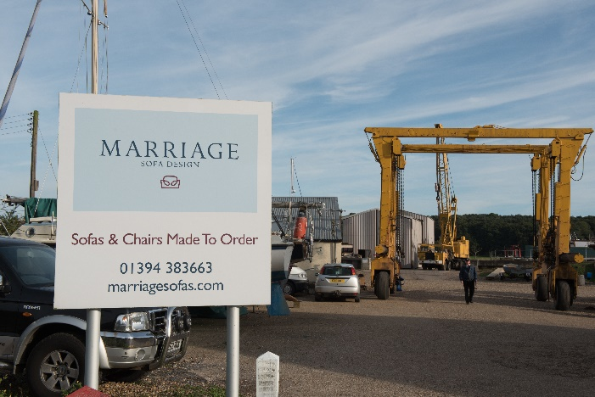

General employment areas

Policy justification
- Suffolk Coastal Local Plan Saved Policy AP51 (General Employment Areas) is relevant to Melton and it is proposed that the main existing employment area between Wilford Bridge Road and Dock Lane is retained, as per the wording of the saved policy. This reflects the fact that this area continues to provide a mixture of light industrial and office space. Some retail uses have taken over various industrial units but overall the area is predominantly an employment area and will continue to provide for the employment needs of the community of Melton and the area it serves.
- The other area that was covered by Saved Policy AP51 – the land north of Wilford Bridge Road – is partly being redeveloped to provide new offices for Suffolk Coastal District Council, with the remainder allocated for a mix of uses, including employment under Policy MEL21. This will help to ensure that a continued supply of small sites is provided to serve Melton or Woodbridge.
- One of the previous General Employment Areas accommodate the former GAH site off Melton Road. However, that site has since remained vacant and has subsequently been granted planning permission for a 68-bed care home. It is therefore not considered appropriate to retain it as a General Employment Area.

POLICY MEL19: GENERAL EMPLOYMENT AREAS
Unless otherwise stated in other policies of this Neighbourhood Plan or the Suffolk Coastal Local Plan, on the Industrial Estates identified as General Employment Areas and shown on the Proposals Map, planning permission will normally be granted for Classes B1, B2 and B8 development.

Deben Mill
- One site, to the north of Deben Mill, was developed in the early-2000s for employment (B1) use and has been included within the physical limits boundary. This development represented an intensification of the existing employment use of the site, extending it to include the whole curtilage. In order to protect that employment use from other uses, particularly residential, it is identified on the Proposals Map and covered by the following policy:

POLICY MEL20: DEBEN MILL
Land to the north of the Deben Mill, as shown on the Proposals Map, is suitable for development for employment (B1) use only.
A high standard of design, materials and landscaping will be required. The north-eastern part of the site, currently grassland, shall be used as an amenity/water-storage area and remain free of structures. The only exceptions would be part use for open space or parking, but not open storage.

land off wilford bridge road
- This site totals 9.7 hectares and is allocated for a mixed use development comprising residential, employment and community uses. It is a former employment site that has been vacant for a number of years. The western part of the site is currently being developed for a new headquarters for Suffolk Coastal District Council.
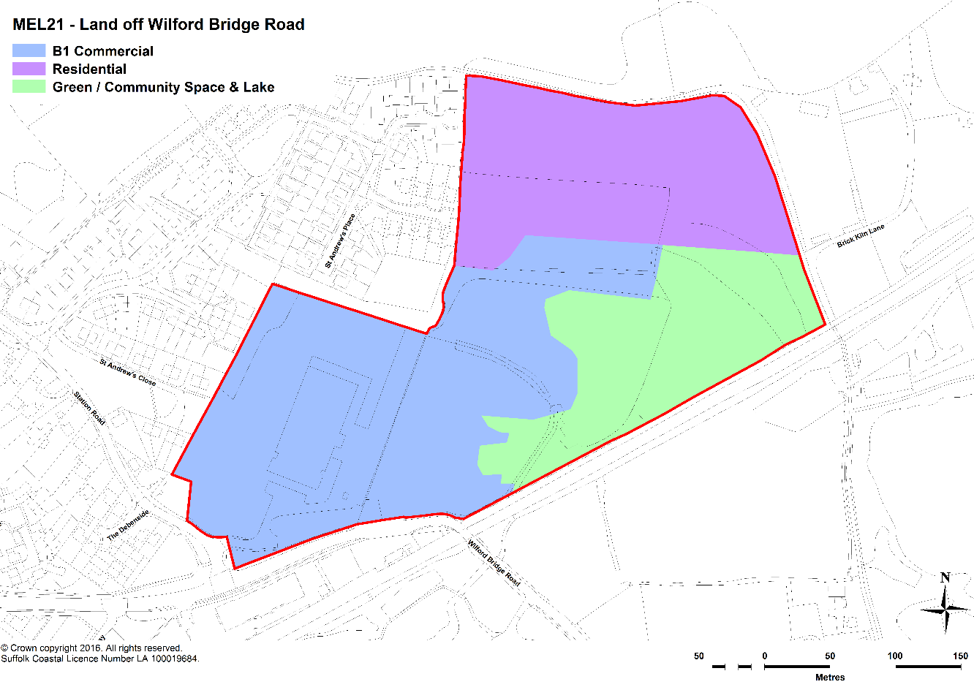

Housing and community uses
- Meeting housing needs, particularly needs for affordable housing, is a strategic objective in Suffolk Coastal district. Delivery of the new housing development in the quantity and form necessary is fundamental to the policies of the Suffolk Coastal Local Plan. Key drivers for these policies are the demographic trends at work in the district, the evidence of need for affordable housing set out in the strategic housing market assessment, and the needs of individual towns and villages for additional housing of a range of costs and tenures as part of their development as communities and more sustainable places.
- Suffolk Coastal District Council has undertaken further work on providing a more detailed indication of the housing requirements for each of the market towns and villages. In April and May 2016, it is consulting on its ‘Site Allocations and Area Specific Policies Local Plan’ Proposed Submission Document which contained these indicative figures. For Melton the figure given was 107 dwellings over the plan period 2010 to 2027. This includes completions and sites already in the planning pipeline and requires just 10 dwellings to be found on site allocations. However, its location adjacent to Woodbridge (as part of ‘Greater Woodbridge’ means that suitable sites should make a contribution towards addressing Woodbridge’s requirements, which are for allocations totalling 200 dwellings. It is important to understand that all figures represent a minimum of what must be planned for.
- The development of the Woods Lane site will provide 180 dwellings. As such, in combination with this allocation off Wilford Bridge Road will make a significant contribution towards delivering the housing requirements of the district.
- Objective Two of the Neighbourhood Plan seeks to ensure that development provides for the infrastructure needs of Melton and does not breach the capacity of the parish's infrastructure to properly support the population. The site is allocated to provide approximately 55 dwellings, a figure which is restricted by the fact that a large area of the eastern and southern part of the site is in Flood Zones 2 and 3 therefore is not appropriate for residential development. New housing should be located on the northern part of the site, which is also more distant from the sensitive environment of the Deben Estuary. Given this, it will be important that a flood risk assessment accompanies any planning application and that good practice, as provided by the Suffolk Flood Risk Management Strategy, is demonstrated in the approach taken to minimising the risk of flooding.
- The environmental constraints on development create the opportunity to bring forward a public green space for community use, a lake, communal gardens, allotments/community growing spaces and a children’s play area on the eastern part of the site. It could also incorporate the Pitstop community farm and After-School and Holiday Club (see policy MEL10).
- Given that the Deben Estuary is a European protected site, it is imperative that the new community uses – and specifically the numbers of users they attract - do not have a significant detrimental impact on it. Development proposals will be expected to consider carefully how to balance the opportunities that the new community facilities will provide with the need to minimise the number of additional visitors that may also use the Deben Estuary for activities such as do walking.

Employment
- In order to address the opportunity for providing or modern employment needs, it is proposed that the remainder of the western part of the site (i.e. excluding the land being developed for the SCDC headquarters) provides for flexible B1-class employment space (office and light industrial) uses. The demand for flexible workspace – to service the needs of the increasing number of micro-businesses, start-ups and self-employed workers – is growing.
- The promoters of the site specialise in providing serviced business space and their view is that this is a strong location for such uses, particularly given the site’s proximity to Melton railway station. It is envisaged that the site would mostly accommodate B1a (office) and B1b (research and development) floorspace. Any B1c (light industrial) floorspace would be mainly required by B1a/b businesses requiring a small amount of light assembly/repair activity to support their business. In general it is considered that traditional light industrial uses would be less desirable at this location because they would potentially impact on the amenity of the proposed residential and community uses.
- The Class B1 development would be complemented by a small amount of ancillary retail and restaurant/café uses. This would help to make this a more attractive employment location and would also provide useful services to the new and existing residential community.

Environment
- Objective Three of the Neighbourhood Plan is to protect and enhance the unique environment and heritage, particularly the rural, riverside and historical assets of Melton and its streetscape. This development will provide significant newly accessible green space, based around a lake. This creates the opportunity to provide new open space, allotments and communal gardens amongst other things. In total, these uses will occupy the majority of the overall site area.
- As noted above, it is vital that the new community opportunities that this will create for the community does not result in detrimental impacts on the Deben Estuary, a European protected site. The area currently already attracts visitors through the presence of the Five Winds shop, the Wilford Bridge pub and Melton Riverside Park. It will be important that the development is planned so that the additional visitors coming to use the community facilities do not put significant additional pressure on the sensitive environment of the Estuary.
- There are a number of Tree Preservation Orders (TPOs) on the site. Where possible, these trees should be retained.

Transport
- Objective One of the Neighbourhood Plan seeks to ensure that development does not worsen the detrimental impacts of traffic congestion (including air quality and safety) along the main routes in Melton, whilst encouraging safe movement on foot and by bicycle.
- The issue of traffic along the A1152 is a significant one that will be exacerbated by the Woods Lane development. Development of this site must ensure that the vehicular access and design of the transport infrastructure does not worsen this situation to any significant degree as it is likely to result in a severe cumulative impact on traffic congestion. This is a point recognised in the Site Allocations and Area Specific Policies Local Plan Proposed Submission document (paragraph 2.92). The design would need to consider options avoiding all traffic accessing the A1152 directly from a single entrance; an alternative solution could be for traffic to gain access through the existing industrial estate.
- Following discussions with Suffolk County Council (the highway authority), one possible solution that may be required would be potential road re-alignment over the level crossing to lengthen the bend and a pedestrian island opposite the Railway Station.
- In respect of the part of Objective One relating to walking and cycling, development of the SCDC headquarters building already requires Carters to put in pedestrian crossing to station. In addition, this highlights the need for the provision of dedicated footpaths/cyclepaths along the south and north sides of Wilford Bridge Road from the junction with Melton Road to Melton Railway Station, as required by Policy MEL2.

POLICY MEL21: LAND OFF WILFORD BRIDGE ROAD
Planning permission will be granted for a development on 9.4 hectares of land off Wilford Bridge Road, subject to the following criteria:
- the provision of at least 9,000m² of serviced B1 floorspace; and
- ancillary retail to support the B-class commercial development; and
- the provision of approximately 55 dwellings; and
- community uses, including a public green space for community use, a lake, communal gardens, allotments/community growing spaces, a children’s play area and potentially a community farm and After-School and Holiday Club (see policy MEL10); and
- landscaping; and
- access, ensuring that options are explored to avoid a single vehicular access onto the A1152 and
- the provision of a flood risk assessment;
- the retention where possible of protected trees.
the provision of a range of dwelling types and in accordance with Policy H1 of this Plan; and

non-land use issues
- There are a number of issues that have been raised through the process of preparing the Neighbourhood Plan that are not directly related to land-use matters (although several indirectly relate to the use of land in some form). As such, they are not matters that can be addressed directly by the provision of a planning policy in the Neighbourhood Plan. However, this is not to say that these are not important matters and it is important that a strategy for dealing with these matters is assembled and taken forward. In doing so, this will help to achieve the vision and objectives of the Neighbourhood Plan.

Transport
- Melton Parish Council and Suffolk County Council, as highways authority, have agreed to work together to address the issues relating to traffic congestion and safety in Melton. At this stage, possible solutions, in order of priority, are:
- A1152 by Melton Station: Measures to allow access to and from new development need to be put in place before the traffic starts to increase. This includes the potential road re-alignment over the level crossing to lengthen the bend and a pedestrian island opposite the Station to make crossing this road safer and traffic calming in Station Road.
- Solutions to alleviate problems in Station Road. These could include a one-way system and a pavement outside St Andrews Church for safe pedestrian access.
- Traffic and parking survey on Melton Road, with possible parking restrictions thereafter dependent on the findings of the survey. Also there is a need to ensure a safety ‘line of sight’ at the Fayrefield Road junction as parked cars currently restrict the view when vehicles are attempting to pull out into oncoming traffic.
- Address Wickham Market right turn onto A12 Southbound so that traffic from this direction is not funnelled through Ufford and Melton.
- Widen/lengthen right hand funnel into Woodbridge at the traffic lights.
- Saddlemakers Lane: Signage needs to be provided plus possibly digging out the bank slightly on very tight turns to stop collisions.
- Restrict HGV’s and heavy traffic through Woodbridge by encouraging them to use A12 as this is creating high air pollution at the Lime Kiln Quay traffic lights.
- In the longer term, potential actions to be explored are:
- If Melton Primary School is moved, a left hand turn funnel lane can be added from the southern side of the traffic lights to allow cars going into Woodbridge to drive straight through. This would potentially help alleviate the queues on one side of the road.
- Assessment of solutions to create a secondary access road off the Deben Peninsular. This would be difficult towards Bawdsey but there may be places where Rendlesham/Bentwaters traffic can be taken straight onto the A12 rather than through Eyke and Melton.

Other general issues
- The issues in priority order are as follows:
- 'Create more opportunities for young people in Melton to get work experience' - create better linkages between schools/colleges and local businesses.
- Better maintenance of green lungs and environmental assets where they are used by people
- Creating a 'local' listing of heritage assets
- More picnic tables, dog mess bins
- Getting assets of community value registered
- Additional play equipment on the green on Hall Farm Road
- Where possible the Parish Council will use Community Infrastructure Levy (CIL) money to try to achieve some of the above objectives.

proposals map
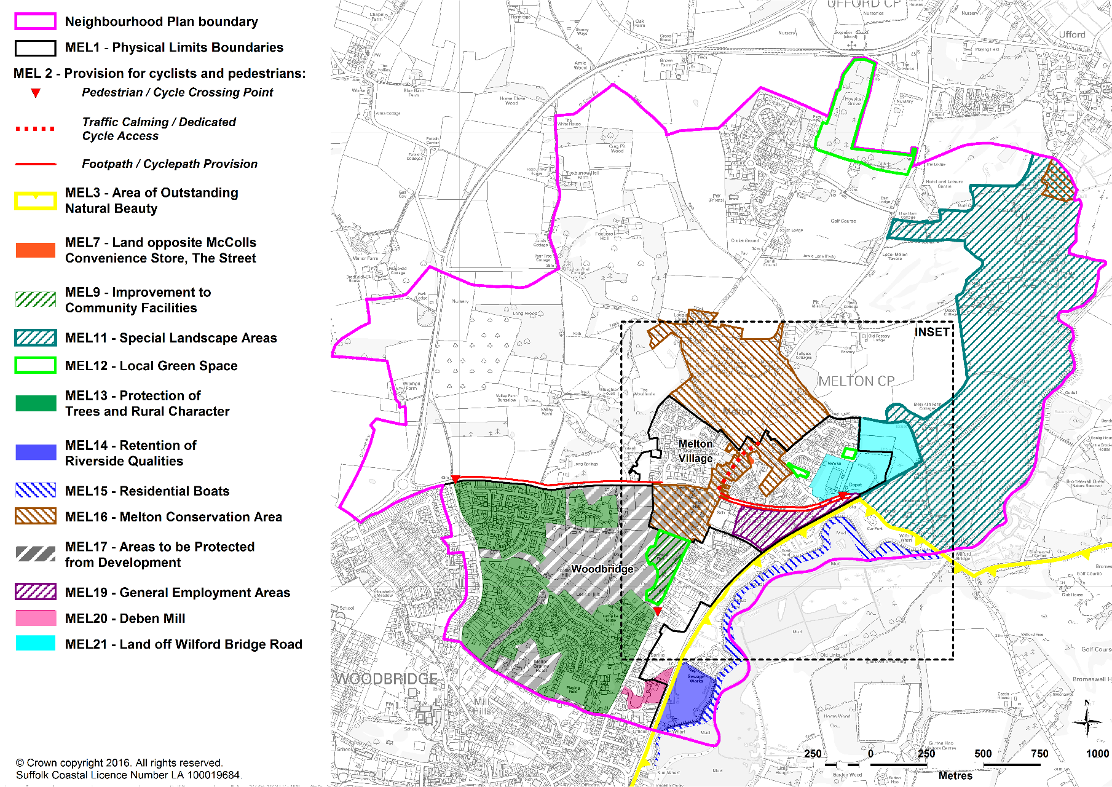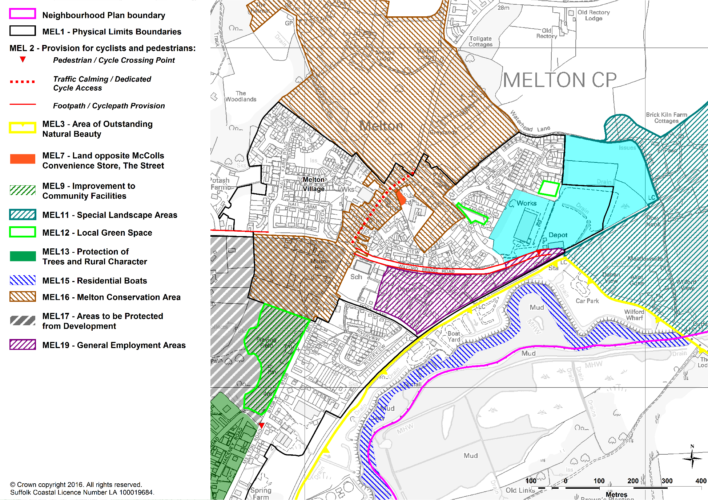

GLOSSARY
- Affordable housing - Social rented, affordable rented and intermediate housing, provided to eligible households whose needs are not met by the market

- Community Infrastructure Levy (CIL) – a fixed, non-negotiable contribution that must be made by new development. It is chargeable on each net additional square metre of development built and is set by the Suffolk Coastal District Council.

- Local Plan – the planning policy document adopted by Suffolk Coastal District Council in 2013, covering Melton parish. This addresses strategic planning matters and the Melton Neighbourhood Plan, as required by the National Planning Policy Framework, must be in general conformity with the adopted Local Plan.

- Intermediate tenure housing - Homes for sale and rent provided at a cost above social rent, but below market levels subject to the criteria in the Affordable Housing definition above. These can include shared equity (shared ownership and equity loans), other low cost homes for sale and intermediate rent, but not affordable rented housing.

- Lifetime Homes - dwellings that incorporate 16 design criteria which can be universally applied to new homes at minimal cost. Each design feature adds to the comfort and convenience of the home and supports the changing needs of individuals and families at different stages of life. In particular, it ensures that many disabled or older people are able to live within their own home as opposed to a care setting.

- National Planning Policy Framework (NPPF) – the national planning policy document which sets out the Government’s planning policies for England and how these are expected to be applied.

- Social rented housing - Housing owned by local authorities and private registered providers for which guideline target rents are determined through the national rent regime.

- Strategic Housing Land Availability Assessment (SHLAA) – an evidence base exercise undertaken by all local authorities to determine the amount of land that has theoretical potential for housing development. All sites put forward are considered for their availability, suitability and deliverability for housing. If a site addresses all of these requirements then it is considered to have theoretical potential for housing development; however this does not mean that the site will be brought forward for development or that a planning application will be granted planning permission. All sites for consideration are collated through a ‘Call for Sites’ exercise which invites anyone to put forward land for consideration through the SHLAA process.

Appendix A Socio-economic profile

- Unless stated otherwise, the profile of the community has come from the 2011 Census.

Population
- In 2011, the population of the parish was 3,741. Compared to Suffolk Coastal district, it has a higher proportion of older working people – over 33% were aged between 45 and 64 in Melton compared to 29% across the district (see Figure A1).
Figure A1: Population profile, 2011

Source: 2011 Census
- Since 2001, the population of the parish has only grown by 25 persons, a 0.7% change compared to 8.0% growth across Suffolk Coastal district as a whole. What is particularly interesting is the change in population by age group.
Figure A2: Change in population, 2001-2011

Source: 2011 Census
- Melton has experienced significant change in almost all of its age bands. In particular, the ‘older adult’ age band (45-64) grew by over 7%. By contrast, there has been a steep decline in children aged up to 15 of over 4% and of ‘younger adults’ (25-44) of nearly 6.5%. These two are linked as these young adults are the parents of the young children. This suggests that there is a declining base of young families in the parish, which, if the trend continued, could create long term structural problems for the local workforce and the community in general. This is shown in Figure A2.

Work
- Melton’s levels of economic activity are very closely aligned with the district figures. This is shown in Figure A3.
Figure A3: Economic activity, 2011

Source: 2011 Census
- Melton is comparatively strongly represented in public services (health and social work, education and public administration). It is also quite strongly represented in some of the higher value sectors such as professional, scientific and technical industries and IT services. This is shown in Figure A4.
Figure A4: Type of industry, 2011

Source: 2011 Census
- Figure A5 reinforces these strengths in higher value sectors, showing that 38% of the population have been educated to Level 4 or above, i.e. degree level, which is well above the district average. By contrast, those with low or no skills are below the district average.
Figure A5: Qualifications of residents aged 16 and over

Source: 2011 Census

Housing
- Melton is dominated by detached and semi-detached housing, representing nearly 72% of its housing stock. In particular, this is distinct from neighbouring Woodbridge which has much lower proportions of this type of housing and much higher proportions of terraced houses and flats.
- This reinforces the historic development of Melton as a low density Parish.
- This is shown in Figure A6.
Figure A6: Type of dwelling

Source: 2011 Census
- This is reinforced when looking at the number of bedrooms that properties in Melton have. Figure A7 shows that it has a higher proportion of 4-bed properties than Woodbridge or the district, but lower proportions of 1- and 2-bed properties. Perhaps surprisingly given the number of semi-detached properties, the proportion of 3-bed properties is below the average in both Woodbridge and the district.
Figure A7: Number of bedrooms

Source: 2011 Census
- Figure A8 shows the occupancy rating of property. A negative figure indicates that properties are overcrowded and a positive figure indicates that they are under-occupied, e.g. a couple with no children living in a four-bedroom house. This shows that Melton has a high level of under-occupancy, with nearly 50% of properties having an occupancy rating of 2 or more. This reinforces the picture of an ageing population living in a stock of mainly large houses.
Figure A8: Occupancy rating

Source: 2011 Census
- The ownership profile of these dwellings reinforces the profile of Melton as an area of predominantly private ownership. Figure A9 shows that the proportion of people owning their property is higher than the district average, whereas the proportion in social rented accommodation is low, at just over 10% (albeit that this is at the district average).
Figure A9: Ownership profile

Source: 2011 Census

Appendix B Suffolk Coastal Local Plan saved policies to be superseded by the Neighbourhood Plan

Policy AP241 (Woodbridge & Melton – houseboats)
Policy AP1 (Conservation area – control of development and enhancement)
Policy AP28 (Areas to be protected from development)
Policy AP242 (Melton-Wilford Bridge employment area)
Policy AP243 (Employment area off Melton Hill)

Suffolk County Council (2014) Suffolk Advisory Parking Guidance – Technical Guidance
Deben Estuary Partnership (2015) Deben Estuary Plan, Deben Estuary Partnership with the Environment Agency and the Suffolk Coast & Heaths Area of Outstanding Natural Beauty
The position as at 31st March 2015, including a list of sites with planning permission, is shown in the SCDC ‘Site Allocations and Area Specific Policies Local Plan’ Proposed Submission Document
Suffolk Flood Risk Management Partnership (2016) Suffolk Flood Risk Management Strategy 2016

